|  |  |
| --- | --- |
| logo ngan.png | **MINISTRY OF EDUCATION AND TRAINING** |

|  |
| --- |
| **FPT UNIVERSITY** |
| Capstone Project Document |
| Office Rental Service |
|  |
| |  |  | | --- | --- | | **Group 6** | | | **Group Members** | Lê Xuân Tiến – Team Leader – SE60897  Nguyễn Vũ Hoàng Quốc – Team Member – SE61112  Trương Tiến Thành – Team Member – SE61052  Trần Lê Tuấn – Team Member – 60350 | | **Supervisor** | Mr. Nguyễn Trọng Tài | | **Ext Supervisor** | N/A | | **Capstone Project Code** | ORS | |
| - Hồ Chí Minh City, May 2015 - |

*This page is intentionally left blank*

Table of Contents

A. Report No 1 - Introduction 1

1. Project Information 1

2. Introduction 1

3. Current Situation 1

4. Problem Definition 1

5. Proposed Solution 2

5.1 Feature functions 2

5.2 Advantage and disadvantage 2

6. Functional Requirements 2

6.1 Admin 2

6.2 Manager 2

6.3 Staff 3

6.4 Owner 3

6.5 Customer 3

6.6 Guest 3

7. Role and Responsibility 3

B. Project Management Plan (PMP) 4

1. Problem Definition 4

1.1 Name of this Capstone Project 4

1.2 Problem Abstract 4

1.3 Project Overview 4

2. Project organization 11

2.1 Software Process Model 11

2.2 Roles and Responsibilities 11

2.3 Tools and Techniques 12

3. Project management plan 13

3.1 Software development life cycle 13

3.2 Phase Detail 14

3.3 All Meeting Minutes 16

4. Coding Convention 16

C. Software Requirements Specifications (SRS) 17

1. User Requirement Specification 17

1.1 Guest requirement 17

1.2 Customer requirement 17

1.3 Owner requirement 17

1.4 Admin requirement 17

1.5 Manager requirement 17

1.6 Staff requirement 18

1.7 System requirement 18

2. System Requirement Specification 18

2.1 External Interface Requirements 18

2.2 List of Use Case: 21

3. Software System Attribute 67

3.1 Usability 67

3.2 Reliability 67

3.3 Availability 67

3.4 Security 67

3.5 Maintainability 67

3.6 Portability 67

3.7 Performance 67

4. Conceptual Diagram 68

D. Report 4: Software Design Description 72

1. Design Overview 72

2. System Architectural Design 73

3. Component Diagram 74

4. Detailed Description Explanation 74

4.1 Class Diagram 74

4.2 Interaction Diagram 89

5. User Interface Design 111

5.1 Guest Interface Design 111

5.2 Customer Interface Design 115

5.3 Admin Interface Design 122

5.4 Manager, Staff Interface Design 122

5.5 Mobile Interface Design 127

6. Database Design 128

6.1 Entity-Relationship Diagram 128

6.2 Data Dictionary 131

7. Algorithms 132

7.1 Clustering data 132

7.2 Matching data 133

E. System Implementation & Test (SIT) 134

1. Introduction 134

1.1 System Overview 134

1.2 Test Approach 134

2. Database Relationship Diagram 134

2.1 Physical Diagram 134

2.2 Data Dictionary 137

3. Performance Measures 151

3.1 Clustering Performance 151

3.2 Matching Performance 151

4. Test Plan 151

4.1 Features to be tested 151

4.2 Features not to be tested 151

5. System Testing Test Case 152

5.1 Guest Test Case 157

5.2 Customer Test Case 158

5.3 Owner Test Case 163

5.4 Manager Test Case 163

5.5 System 175

F. Software User’s Manual 177

1. Installation Guide 177

1.1 Setting up environment at server side 177

1.2 Deployment at server side 177

1.3 Client side environment setting 183

2. User Guide 185

2.1 Guide for customer 185

2.2 Guide for manager on web application 191

2.3 Guide for staff on mobile application 195

G. Appendix 199

**List of Figures**

Figure 1: Proposed System 5

Figure 2: Request appointment flow 6

Figure 3: Request office flow 7

Figure 4: Sign contract flow 8

Figure 5: Request repair flow 9

Figure 6: Request return contract flow 9

Figure 7: Software process model [1] 11

Figure 8: Use Case Overview 19

Figure 9: <Guest> Overview Use Case 21

Figure 10: <Guest, Customer> Search office 21

Figure 11: <Guest, Customer> View office detail 23

Figure 12: <Customer> Overview Use Case 25

Figure 13: <Customer> Create appointment request 25

Figure 14: <Customer> View rental request list 27

Figure 15: <Customer> Request return contract 28

Figure 16: <Customer> View contract 30

Figure 17: <Customer> Request repair 32

Figure 18: <Customer> Create office request 34

Figure 19: <Staff> Overview Use Case 36

Figure 20: <Admin> Overview Use Case 37

Figure 21: <Manager> Overview Use Case 38

Figure 22: <Manager> View Appointment Request List 39

Figure 23: <Manager> Assign Appointment 40

Figure 24: <Manager> Create Contract 42

Figure 25: <Manager> View Calendar 45

Figure 26: <Manager> Approve Office 47

Figure 27: <System> Mobile Overview Use Case 50

Figure 28: <Staff > View repair request list (mobile) use case diagram 50

Figure 29: <Staff > Accept/Reject rental request (mobile) use case diagram 52

Figure 30: <Staff > Confirm appointment request (mobile) use case diagram 54

Figure 31: <System> Overview Use Case 56

Figure 32: <System> Suggest Requested Office 56

Figure 33: <System> Check Contract Due Date 58

Figure 34: <System> Suggest Job Schedule 59

Figure 35: <System> Check Appointment Due Date 61

Figure 36: <Owner> Overview Use Case 62

Figure 37: <Owner> Create Office 62

Figure 38: <Owner> Check Request Repair 65

Figure 39: Conceptual Diagram 69

Figure 40: System architecture 73

Figure 41: Component Diagram 74

Figure 42: Class Diagram 75

Figure 2543: Register Sequence Diagram 89

Figure 44: Search Office Sequence Diagram 90

Figure 458: Create Office Request Sequence Diagram 91

Figure 46: Request Repair Sequence Diagram 92

Figure 478: View Result Request Office Sequence Diagram 94

Figure 48: Create New Office Sequence Diagram 95

Figure 49: Check Request Repair Sequence Diagram 96

Figure 50: Assign Appointment Sequence Diagram 98

Figure 51: Create Contract Sequence Diagram 99

Figure 52: View Calendar Sequence Diagram 100

Figure 53: Create Rental Item Sequence Diagram 101

Figure 54: Check Contract Due Date Sequence Diagram 104

Figure 55: Check Appointent Due Date Sequence Diagram 105

Figure 56: Check and send activate email 106

Figure 57: Send email 107

Figure 58: Suggest Request Office Sequence Diagram 108

Figure 59: Clustering Office Sequence Diagram 109

Figure 60: Suggest Assign Job Sequence Diagram 110

Figure 61: Home Page 111

Figure 62: Search office list 112

Figure 63: Office detail 114

Figure 64: Contract list 116

Figure 65: Contract detail 117

Figure 66: Rental page 119

Figure 67: Rental cart page 120

Figure 68: Result request office page 121

Figure 69: View appointment request list 123

Figure 70: View rental detail 124

Figure 71: View calendar 125

Figure 72: Login 127

Figure 73: Home 128

Figure 74: Entity-Relationship Diagram 129

Figure 75: Clustering data flow chart 133

Figure 76: Physical Database Diagram 135

Figure 77: Guest and Customer main flow 152

Figure 78: Manager main flow 153

Figure 80: Staff main flow 154

Figure 80: System main flow 154

Figure 80: System main flow 155

Figure 81: Extract Deployment Package (Windows) 177

Figure 82: Extract Deployment Package (Linux) 178

Figure 83: Extract Deployment Package (Linux) 178

Figure 84: Open database script 179

Figure 85: Configure Server (Windows) 179

Figure 86: Configure Server (Linux) 180

Figure 87: Configure hibernate.cfg.xml 180

Figure 88: Copy Unpacked Folder (Windows) 181

Figure 89: Copy Unpacked Folder (Linux) 181

Figure 90: Restart Server (Linux) 181

Figure 91: Restart Server (Linux) 182

Figure 92: Deploy Web Application On Server 182

Figure 93: Configure firewall setting 182

Figure 94: Enable install from Unknown sources 183

Figure 95: Enable install from Unknown sources 184

Figure 96: Enable install from Unknown sources 184

Figure 97: Customer Login Page 185

Figure 98 : Search office 185

Figure 99 : Search office 186

Figure 100 : View office detail 187

Figure 101 : View office detail 187

Figure 102 : Create appointment 188

Figure 103 : Create appointment 189

Figure 104 : Request Office – step 1 189

Figure 105 : Request Office – step 2 189

Figure 106: Request Repair UI 190

Figure 107 : Create Contract – step 1 191

Figure 108 : Create Contract – step 2 191

Figure 109 : Create Contract – step 3 192

Figure 110 : Create Contract – step 4 193

Figure 111 : Assign Appointment 194

Figure 112 : Assign Repair 194

Figure 113 : Login on mobile 195

Figure 114 : Check task list on mobile 196

Figure 115 : Change status of appoinment 197

Figure 116 : Change status of repair/rental 198

**List of Tables**

Table 1: Roles and Responsibilities 3

Table 2: Hardware Requirement for Server 10

Table 3: Hardware Requirement for Web User 10

Table 4: Requirement for mobile app 10

Table 5: Role and Responsibilities 12

Table 6: Software development lifecycle 14

Table 7: Phase 1: Requirement Analysis 14

Table 8: Phase 2: Design 14

Table 9: Phase 3: Implement 15

Table 10: Phase 4: Testing 15

Table 11: Phase 5: Operation and maintenance 16

Table 12: Overall user requirement specification 17

Table 13: <Guest, Customer> Search office 23

Table 14: <Guest, Customer> View office detail 24

Table 15: <Customer> Create appointment request 27

Table 16: <Customer> View rental request list 28

Table 17: <Customer> Request return contract 30

Table 18: <Customer> View contract 32

Table 19: <Customer> Request repair 33

Table 20: <Customer> Create office request 35

Table 21: <Manager> View Appointment request 40

Table 22: <Manager> Assign Appointment 42

Table 23: <Manager> Create Contract 44

Table 24: <Manager> View Calendar 46

Table 25: <Staff, Manager> Approve Office 49

Table 26: <Staff> View repair request list - mobile 51

Table 27: <Staff> Accept/Reject rental request - mobile 53

Table 28: <Staff> Accept/Reject rental request - mobile 55

Table 29: <System> Suggest requested office 57

Table 30: <System> Check contract due date 59

Table 31: <System> Suggest Job Schedule 60

Table 32: <System> Check Appointment due date 61

Table 33: <Owner> Create Office 64

Table 34: <Owner> Check Request Repair 66

Table 35: Search office Test Case 157

Table 36: Make appointment Test Case 158

Table 37: Request Return Contract Test Case 159

Table 38: Request Extend Contract Test Case 160

Table 39: Request Repair Test Case 161

Table 40: Request Rental Test Case 162

Table 41: Request Office Test Case 162

Table 42: Create Office Test Case 163

Table 43: Approve Office Test Case 164

Table 44: Create contract Test Case 165

Table 45: Edit contract Test Case 165

Table 46: Assign Appointment Test Case 167

Table 47: Cancel Appointment Test Case 167

Table 48: Assign Repair Test Case 169

Table 49: Cancel Repair Test Case 169

Table 50: Assign Rental Test Case 171

Table 51: Cancel Rental Test Case 172

Table 52: Extend Contract Test Case 172

Table 53: Return Contract Test Case 172

Table 54: Create Rental Item Test Case 173

Table 55: Income Statistic Test Case 173

Table 56: Staff Statistic Test Case 174

Table 57: Calendar Test Case 174

Table 58: Check request office 175

Table 59: Check contract due date 175

Table 60: Check send SMS 176

Table 61: Login Step 185

Table 62: Search office 186

Table 63: View office detail 187

Table 64: Create appointment 189

Table 65: Request Office – step 1 189

Table 66: Request Office – step 2 190

Table 67: Request Repair Step 190

Table 68: Create Contract – step 1 191

Table 69: Create Contract – step 2 191

Table 70: Create Contract – step 3 192

Table 71: Create Contract – step 4 193

Table 72: Assign Appointment 194

Table 73: Assign Repair 195

Table 74: Staff login on mobile 196

Table 75: Staff login on mobile 196

Table 76: Change status of appoinment 198

Table 77: Change status of repair/rental 198

**Definitions, Acronyms, and Abbreviations**

|  |  |
| --- | --- |
| **Name** | **Definition** |
| ORS | Office Rental Service |
| IDE | Integrated Development Environment |
| DBMS | Database Management System |
| WAP | Wireless Application Protocol |
| SRS | Software Requirement Specification |
| Admin | Administrator |
| SMS | Short message service |
| Info | Information |
| FE | Front-end |
| BE | Back-end |

*This page is intentionally left blank*

# Report No 1 - Introduction

## Project Information

* Project name: **Office Rental Service**
* Project Code: **ORS**
* Product Type: **Website Application**
* Start Date: **May 11th, 2015**
* End Date: **August 22nd, 2015**

## Introduction

Nowadays, a lot of companies are established every day. When new companies are established or some companies want to expand their companies, they need to find where they put their offices. To find a suitable office for them, they need you to add some equipment they need, repair some equipment… All of that thing will get you a lot of time to do it and it is very complex to make contract with those companies. With this system, you can easily to manage your offices, equipment and contracts and it takes you less time than now.

## Current Situation

In Vietnam, to find a suitable office, company would rather consider the following actions:

* If company has large resource, and require a specific requirement and equipment, they would build a new office. This will takes lots of time and money, only adapted for foreign companies.
* Go to a broker company, fill in the form and ask for help to find a suitable office. This usually takes some days to find and cost fee for broker companies.
* Search the internet for office. There are some website in Vietnam has information about the office for rent. But the information is usually not richly or sometimes outdated.

## Problem Definition

To build a new office requires a lot of time, effort, and spend a lot of costs. Besides, there are many new office building has been built recently, but had not been rented, and many company has unused office space. The matching between the demand and the supply is critical required. But using tradition approach for searching office, we have some limitations:

* There are some classifieds website that put the office information. However, the office information is lack, the search criteria is not very effective, and the information about the amenities is hardly found.
* Every company choose for themselves the best office suite with their company: location, area, office facilities, finding a best match will be take time, costs. This work usually made by a third party broker company, and it will take days to finish and we would pay a fee to that company.
* When company want to rent the office or have a rented office but conditions where infrastructure does not guarantee, the company business will be very difficult to contact the lessors to consider repairing office suite company conditions, causing company to consume resources.

## Proposed Solution

The website support customer to select appropriate and process office rental online. The website also support manager to track their business.

### Feature functions

* Our website offers many methods for customer to search office (by size, price, place, amenities…). When they find appropriate office, our staff will arrange to meet them at that office. After check around, we can make a contract right away. The contract will be tracked by our website for further support.
* If customers request repair something in their office, the website will notify our staff to make sure they will fix that problem as soon as possible.
* Our system also supports the addition of devices such as power sockets, fax machines… at the request of customers.

### Advantage and disadvantage

The advantages and disadvantages of the proposed solution:

* Advantages:
  + User friendly and specialized interface.
  + Providing search engines criteria: price, location, amenities...
  + Providing full information about the office. Support map for customers
  + Easy to make an appointment
  + When a deal is made, the contract is tracked by website, so the office state is update in real time for further search.
  + Can request for repair, or add new equipment based on the contract.
  + The repair request status will be update by notification system
  + The repair request is easily manage by automatic assign system
  + The contract making and repair status update is manage by mobile system so the staff will easy to update when go to the offices.
* Disadvantages:
  + The mobile system require internet connection.
  + The function of notification system is limited.
  + The matching solution based on location and needs will take more time than search by keyword in traditional approach

## Functional Requirements

The functional requirements of the system are based on six main actor as below:

### Admin

* + Manage account.
  + Ban/unban account

### Manager

* + Manage contract
  + Manage office
  + Manage item
  + Manage request
  + View Statistic

### Staff

* + Accept/Reject rental
  + Confirm appointment
  + Manage rental item

### Owner

* + Create/Delete office
  + Check request repair
  + View office statistic

### Customer

* + View office detail
  + Search for office base on places, price, amenities
  + View/Edit customer info
  + Create appointment
  + Request extend/return contract
  + Request repair/rental item
  + Create office request

### Guest

* + Search for office base on places, price, amenities
  + Register/Login

View office detail

## Role and Responsibility

|  |  |  |  |  |
| --- | --- | --- | --- | --- |
| **No** | **Full Name** | **Role** | **Position** | **Contact** |
| 1 | Nguyễn Trọng Tài | Project Manager | Instructor | [taint@fpt.edu.vn](mailto:taint@fpt.edu.vn) |
| 2 | Lê Xuân Tiến | Developer | Team Leader | [tienlxse60897@fpt.edu.vn](mailto:tienlxse60897@fpt.edu.vn) |
| 3 | Nguyễn Vũ Hoàng Quốc | Developer | Team Member | [quocnvhse61112@fpt.edu.vn](mailto:quocnvhse61112@fpt.edu.vn) |
| 4 | Trương Tiến Thành | Developer | Team Member | [thanhttse61052@fpt.edu.vn](mailto:thanhttse61052@fpt.edu.vn) |
| 5 | Trần Lê Tuấn | Developer | Team Member | [tuantl60350@fpt.edu.vn](mailto:tuantl60350@fpt.edu.vn) |

Table : Roles and Responsibilities

# Project Management Plan (PMP)

## Problem Definition

### Name of this Capstone Project

* **Official name**: Office Rental Service
* **Vietnamese name:** Dịch vụ cho thuê văn phòng
* **Abbreviation:** ORS

### Problem Abstract

Nowadays, the way companies find and rent an office, is complex and hard to find a suitable office. It means they need to do many steps before they can rent a suitable office. About the office owner, they have to contact with customer, manage contract, manage repair request… on the paper. It means there is human mistake.

To solve those problems already mentioned above, we need to make the way customer find an office and the way customer manage their request effectively. About the office owner, their contracts, requests for their office… are easy to manage.

### Project Overview

#### Current Situation

There are some current websites such as vanphongthue.com.vn, rongbay.com, timvanphong.vn, etc. All of them have some advantages and disadvantages.

* Advantages:
  + Friendly and specialized interface.
  + Direct consultation with the manager.
* Disadvantages:
  + Only supply direct meeting, not arrange for a meeting.
  + Not regularly updated information.
  + Not support map.
  + Not provide additional equipment and maintenance.

#### The Proposed System

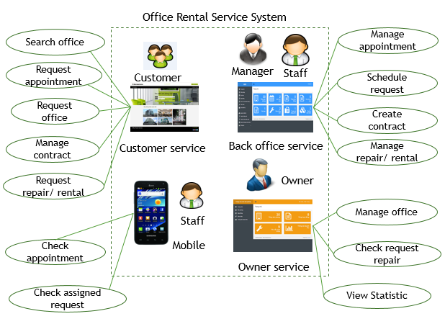Figure : Proposed System

In more detail, the system would contain following features:

##### Website

* Guess can search office and view detail. If they want to make appointment, they need to register.
* Customer can review office, request appointment, request office (if they can’t find ones), request rental equipment and request repair.
* Owner can manage their office, and accept/request repair request.
* Admin can manage staff and manager, and ban/unban customer
* Manager can create and delete contract. They also can assign staff for appointment, repair or rental request for customer and view statistic of system.
* Staff can view list, create, update and delete office. When staff finish repair for customer, they can report to manager. They also can approve or delete rental equipment.

##### Mobile Application

* Staff can check appointment task and update status request repair/ rental.

**Main flow of the system:**

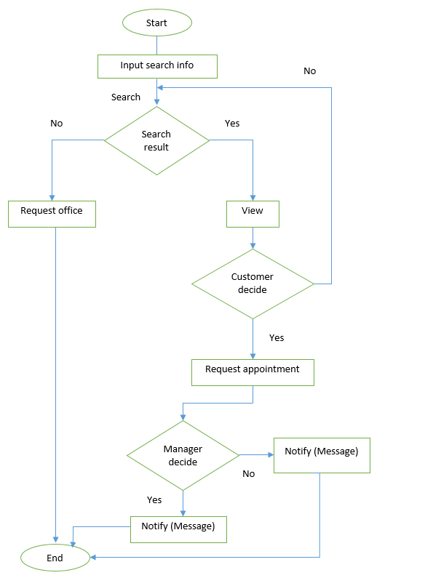

Figure : Request appointment flow

Send email

Customer decide

Remove Request Office

Unsubscribe

Accept

Check requested office

Found

Request appointment

(Refer request appointment flow)

Figure : Request office flow

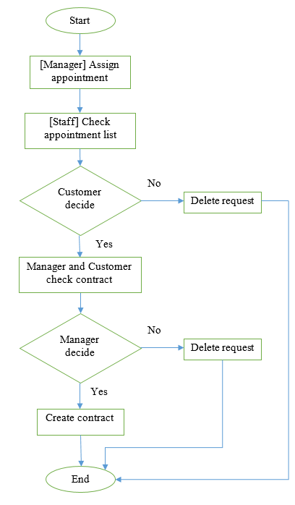

Figure : Sign contract flow

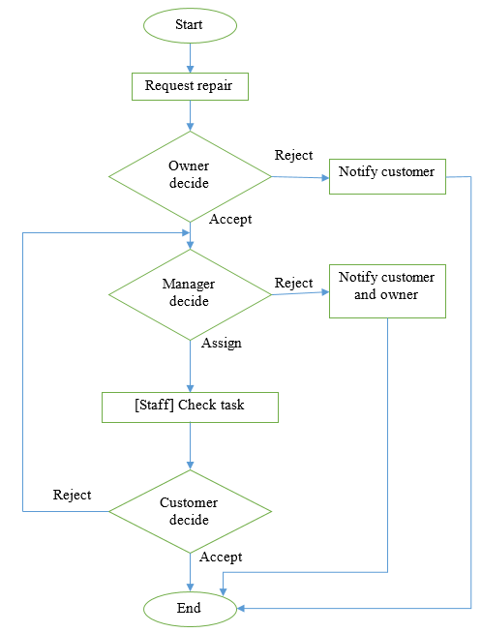

Figure : Request repair flow

Update office status

Staff confirm

[Customer]Cancel contract

Figure : Request return contract flow

#### Boundaries of the System

* The system is intended for customers who want to rent office (such as businessman, medium or small company,…).
* The language of the system is Vietnamese
* The complete product includes:
* The website, for admin, manager, staff, customers, guest and owner to interactive with the system.
  + Mobile application for staff to check task and update status request repair.
  + All the process involved document.

#### Development Environment

* **Hardware requirement for server computer**

|  |  |  |
| --- | --- | --- |
| Windows | Minimum Requirements | Recommended |
| Internet Connection | Cable, Wi-Fi (2Mbps) | Cable, Wi-Fi (8 Mbps) |
| Operating System | Window Server 2008, Ubuntu Server 12 LTS | Window Server 2012, Ubuntu Server 14.04.2 LTS |
| Computer Processor | Intel Pentium IV | Intel Core i5 |
| Computer Memory | 1GB RAM | 4GB or more |

Table : Hardware Requirement for Server

* **Hardware Requirement for Web User**

|  |  |  |
| --- | --- | --- |
| **Web** | **Minimum Requirements** | **Recommended** |
| **Internet Connection** | 2Mbps | 4Mbps |
| **Web Browser** | Firefox, Chrome, IE 8 | Firefox, Chrome, IE 9 |

Table : Hardware Requirement for Web User

All computers must be connected to the Internet.

* **Hardware requirement for mobile app**

|  |  |  |
| --- | --- | --- |
| Windows | Minimum Requirements | Recommended |
| Internet Connection | Wifi (2Mbps) | Wifi (4Mbps) |
| Operating System | Android 4.0 | Android 4.2 |
| Hardware | Touchscreen | Touchscreen |
| Memory | 512 MB or more | 1 GB or more |

Table : Requirement for mobile app

* **Software requirements**
  + Operating system: Windows 7, or above;
  + Framework: Hibernate with Java Persistence;
  + Modeling Tool: Visual Paradigm Community;
  + IDE: Intellji Idea;
  + DBMS: Microsoft SQL Server;
  + Source Control: GitHub, Git for windows, Tortoise Git.

## Project organization

### Software Process Model

We choose waterfall model.



Figure : Software process model [1]

[1]Reference: Modelling and System Design. [Online] http://www.pling.org.uk/cs/msd.html

This model is easy to manage and understand. For our project, we don’t have a lot of time so we use this model to help us release our project on time. This model uses for short project and it suitable for our project, which is small with 4 months and requirements are easy to clear.

### Roles and Responsibilities

|  |  |  |  |
| --- | --- | --- | --- |
| **No** | **Full name** | **Role in Group** | **Responsibilities** |
| **1** | Nguyễn Trọng Tài | Supervisor/ Project manager | * Specify user requirement. * Control the development process. * Support technical and business analysis. * Review document and product application. |
| **2** | Lê Xuân Tiến | Team Leader, Developer, Tester | * Monitor process * Create project plan and distribute tasks * Clarify requirements. * Design database. * Prepare documents. * GUI Design. * Create code guide and form. * Coding. * Testing. * Deploy final product. |
| **3** | Nguyễn Vũ Hoàng Quốc | Developer, Tester | * Clarify requirements. * Prepare documents. * Review Database. * GUI Design. * Create test cases. * Coding. * Testing. |
| **4** | Trương Tiến Thành | Developer, Tester | * Clarify requirements. * Prepare documents. * Review Database. * GUI Design. * Create test cases. * Coding. * Testing. |
| **5** | Trần Lê Tuấn | Developer, Tester | * Clarify requirements. * Prepare documents. * Review Database. * GUI Design. * Create test cases. * Coding. * Testing. |

Table : Role and Responsibilities

### Tools and Techniques

* *Front-end*: CSS3, HTML5, JavaScript, JQuery, Ajax, AngularJS, Java Android, PhoneGap.
* *Back-end*: Java 1.7, Hibernate, Java Persistence.
* *Web Server*: Tomcat 7.
* *Developing Tool*: JetBrains IntelliJ IDEA 14, Android Studio.
* *Database Management System:* Microsoft SQL Server 2008.
* *Source Control:* Git-1.9.5-preview, TortoiseGit-1.8.14.0.
* *Modeling Tool*: Visual Paradigm 12.0 Community.
* *Document Tool*: Microsoft Office 2013.

## Project management plan

### Software development life cycle

|  |  |  |  |  |  |
| --- | --- | --- | --- | --- | --- |
| **Phase** | **Description** | **Deliverables** | **Resource**  **needed** | **Dependencies**  **and Constrains** | **Risks** |
| **Requirement**  **Analysis** | - Collect requirements.  - Analyze requirements  -Identify and clarify requirements for the system in general. | -Introduction of proposed system. (report 1)  -Project Task Plan. (report 2)  -Software requirement specification. (report 3) | 40 man-days | N/A | - Missing requirement  - Unclear scope of project  - Lack of member share  - Time resource not well managed |
| **Design** | - Design database  - Architecture design for the system  - Detail design using top-down break down  - Choose Architecture style | - Software Design Document  - Base code structure  - Architecture notes  (report 4) | 74 man-days | Depend on “Requirement Analysis” | - Lack of experience.  - Not fulfil requirement. |
| **Implement** | - Implement all system functions | - Source code  - Final deploy packet | 120 man-days | - Software requirement specification.  - Software Design Document | - Lack of member experience.  - Different of member skill |
| **Testing** | - Create test plan  - Create test cases  - Perform unit test cases and system integration test | - Test plan  - Test cases  - Test report  (report 5) | 80 man-days | - Coding is finished  - Based on SRS | - Lack of experience leads to lack of test cases  - Time schedule |
| **Operation and maintenance** | - Create user’s manual, includes server deployment and end-user manual | - Report 6: System User’s Manual | 20 man-days | - Testing is finished  - Based on SRS | - Lack of experience can lead to hard-to-understand document for user  - Time deadline |

Table : Software development lifecycle

### Phase Detail

Below are all the major tasks that need to be performed sequentially during the development of the system.

#### Phase 1: Requirement Analysis

|  |  |  |
| --- | --- | --- |
| **Task** | **Description** | **Author** |
| **1. Collect and analyze requirements** | Find the traditional approach for the service, and current IS system for office rental services. Analyze their strengths and weaknesses | TienLX, QuocNVH, ThanhTT, TuanTL |
| **2. Identify and clarify main functions.** | Define main flows which system will build to adapt, and main functions for system. | TienLX, QuocNVH, ThanhTT, TuanTL |
| **3. Create project management plan** | Define the overview of the project  Create project plan | TienLX, QuocNVH |

Table : Phase 1: Requirement Analysis

#### Phase 2: Design

|  |  |  |
| --- | --- | --- |
| **Task** | **Description** | **Author** |
| **1. Defined overall system design** | Design basis system architecture design | TienLX |
| **2. Create entity-relationship diagram** | From the defined use cases, create the ERD for the system | TienLX, QuocNVH |
| **3. Create logical database diagram** | Define the logical database diagram based on ERD | ThanhTT, TuanTL |
| **4. Create class diagrams and definition** | Create the classes with attributes and functions, along with its definition | TienLX, QuocNVH, ThanhTT, TuanTL |
| **5. Create interaction diagrams** | Include sequences diagrams and activity diagrams | TienLX, QuocNVH, ThanhTT, TuanTL |
| **6. Create interface design** | Design the user interface for the system applications | TienLX, QuocNVH, ThanhTT, TuanTL |
| **7. Define main algorithms** | Analyze and define the required algorithms for the system | TienLX, QuocNVH, ThanhTT, TuanTL |

Table : Phase 2: Design

#### Phase 3: Implement

|  |  |  |
| --- | --- | --- |
| **Task** | **Description** | **Author** |
| **1. Design physical database** | Define the physical database design on SQL Server, and create database dictionary | TienLX, QuocNVH, ThanhTT, TuanTL |
| **2. Define base structure** | Define the base structure for the program | TienLX |
| **3. Coding admin functions** | Include manage account | TuanTL |
| **4. Coding manager functions** | Include manage repair list and manage contract list | ThanhTT, QuocNVH |
| **5. Coding staff functions** | Include manage office | TienLX |
| **6. Coding customer functions** |  |  |
| **6.1. Coding request office flow** | Include search office, request office, request appointment | BE: QuocNVH  FE: TienLX |
| **6.2. Coding contract signing flow** | Include the assign flow for manager and view assigned flow for staff | ThanhTT |
| **6.3. Coding contract extend/cancel flow** | Include request extend contract and cancel contract | QuocNVH |
| **6.4. Coding request repair flow** | Include request repair office for customers | TuanTL |
| **7. Coding additional mobile app** | Include view assigned job for staff, view assigned and update the repair job for staff | BE: QuocNVH, TuanTL  FE: TienLX, ThanhTT |
| **8. Coding additional functions** |  |  |
| **8.1. Change create office flow** | Owner create office, manager approve office | TienLX |
| **8.2. Handle conflict** | Handle conflict when assign appointment, repair, rental | TienLX |
| **8.3. Change repair flow** | Owner accept repair, manager assign repair for staff | ThanhTT |
| **8.4. Export contract** | Export contract to PDF file | QuocNVH |
| **8.5. Check for appointment due date** | Schedule check appointment due date to cancel appointment | QuocNVH |
| **8.6. Other validation** |  | ThanhTT |

Table : Phase 3: Implement

#### Phase 4: Testing

|  |  |  |
| --- | --- | --- |
| **Task** | **Description** | **Author** |
| **1. Create test plan** | Create the test plan document for the system | TienLX |
| **2. Create unit testing** | Create the test cases for each functions describe in the implementation |  |
| **2.1. For admin functions** | Create test cases for functions in manage account | TienLX |
| **2.2. For manager functions** | Create test cases for functions in manage repair and contract | TuanTL |
| **2.3. For staff functions** | Create test cases for functions in manage office | ThanhTT |
| **2.4. For customer functions** | Create test cases for functions for customer | QuocNVH |
| **2.5. For mobile app** | Create test cases for functions for mobile app | TuanTL |
| **3. Testing and fix bugs** | Base on the test cases, test the functions and fix bugs | TienLX, QuocNVH, ThanhTT, TuanTL |
| **4. System integration test** | Test the overall of the system, measure the performance of the system | TienLX, QuocNVH, ThanhTT, TuanTL |

Table : Phase 4: Testing

#### Phase 5: Operation and maintenance

|  |  |  |
| --- | --- | --- |
| **Task** | **Description** | **Author** |
| **1. Create installation guide** | Define the system requirement for the server and client. document installation guild | TienLX, QuocNVH |
| **2. Create User guide** | Define the user manual for operating the system | TienLX, QuocNVH, ThanhTT, TuanTL |
| **3. Maintenance and fix bugs** | Tracking the system and fix the remains bugs while installation | ThanhTT, TuanTL |

Table : Phase 5: Operation and maintenance

<Refer CD:\Capstone_ORS\Project management plan.xlsx>

### All Meeting Minutes

<Refer CD:\Capstone_ORS\Meeting_Minutes.docx>

## Coding Convention

**Indentation:**

* Four spaces should be used as the unit of indentation
* Tabs must be set exactly every 8 spaces
* Avoid lines longer than 80 characters
* Break after a comma.

**Declarations:**

* One declaration per line
* Put declarations only at the beginning of blocks
* No space between a method name and the parenthesis "(" starting its parameter list
* Open brace "{" appears at the end of the same line as the declaration statement
* Closing brace "}" starts a line by itself indented to match its corresponding opening statement, except when it is a null statement the "}" should appear immediately after the "{"

**White Space:**

* Between sections of a source file
* Between class and interface definitions
* Between methods

**Naming Conventions:**

* Class names should be noun
* Methods should be verbs

Reference: <http://www.oracle.com/technetwork/java/codeconvtoc-136057.html>

# Software Requirements Specifications (SRS)

## User Requirement Specification

The system has seven actors including: guest, customer, owner, manager, staff, admin and system.

|  |  |
| --- | --- |
| **Actor** | **Description** |
| Guest | Person join to website but not login into system. |
| Customer | Person who want to rent offices and logged into system |
| Owner | Person who own the offices, and create a office on website for rent |
| Admin | Person who manage account and ban/ unban account |
| Manager | Person who manage request, contact customer, schedule staff…. |
| Staff | Person who in charge of create office, receive and process the appointment/ repair/ rental/ extend/ return office request |
| System | System will manage the schedule to process contract time, send notification, suggest office for customer |

Table : Overall user requirement specification

### Guest requirement

* **Register:** guest need to register to become member of system.
* **Search office:** guest can search suitable office by criteria such as price and location.
* **Login**: guest uses email and password to login into the system to search or request office.

### Customer requirement

* **Search office:** customer can search suitable office by criteria such as price and location.
* **Send request:** customer can send request about book appointment, repair something in office, rental, request cancel before expire or request extend the contract.
* **Request office:** customer can send request office if they don’t find a suitable office.

### Owner requirement

* **Manage office:** owner can create and delete their own office.
* **Manage repair:** owner can approve/ cancel customer repair request, or check for its status

### Admin requirement

* **Logout:** when finish all activities at website they can log out of system.
* **Manage account:** admin can add, edit, remove or ban/ unban account.

### Manager requirement

* **Manage office:** manager can edit, approve or delete office.
* **Contact with customer:** manager can notify customer when task is done.
* **Manage contract:** manager can create, edit contract.
* **Manage request:** manager can confirm about request repair, rental and appointment.
* **Assign staff:** manager can assign staff to contact with customer when request has been approved by manager.

### Staff requirement

* **Logout:** when finish all activities at website they can log out of system.
* **Contact with customer:** staff have to check task list about the appointment with customer and change status of the appointment when finish his task.
* **Check assign request:** staff have to check task list about the request repair amenities and change status of that request after repair complete.

### System requirement

* **Send notification mail:** system will send notification mail to customer when appointment has been approved and scheduled or request repair has been accepted.
* **Send notification SMS (short message service):** system will send notification mail to customer when their contract will be expired in one month.
* **Suggest office:** system will suggest some offices which is nearly suitable with what customer searching.
* **Schedule request:** system will auto schedule all request about appointment and repair when those request has been approved by manager.

## System Requirement Specification

### External Interface Requirements

#### User Interfaces

* User interface must be friendly, simple, display in Vietnamese.
* All functions should be showed clearly and don’t make user confuse.

#### Hardware Interfaces

* The system will use the standard hardware and data communications resources of a standard computer.

#### Software Interfaces

* The website run in Firefox and Chrome browsers.

#### Communications Protocol

* The website uses:
* HTTP/HTTPS protocol for communication between the web browser and the web server.
* TCP/IP network protocol for communication with HTTP protocol.
* WAP protocol for sending message for customer.

#### System Overview Use Case:

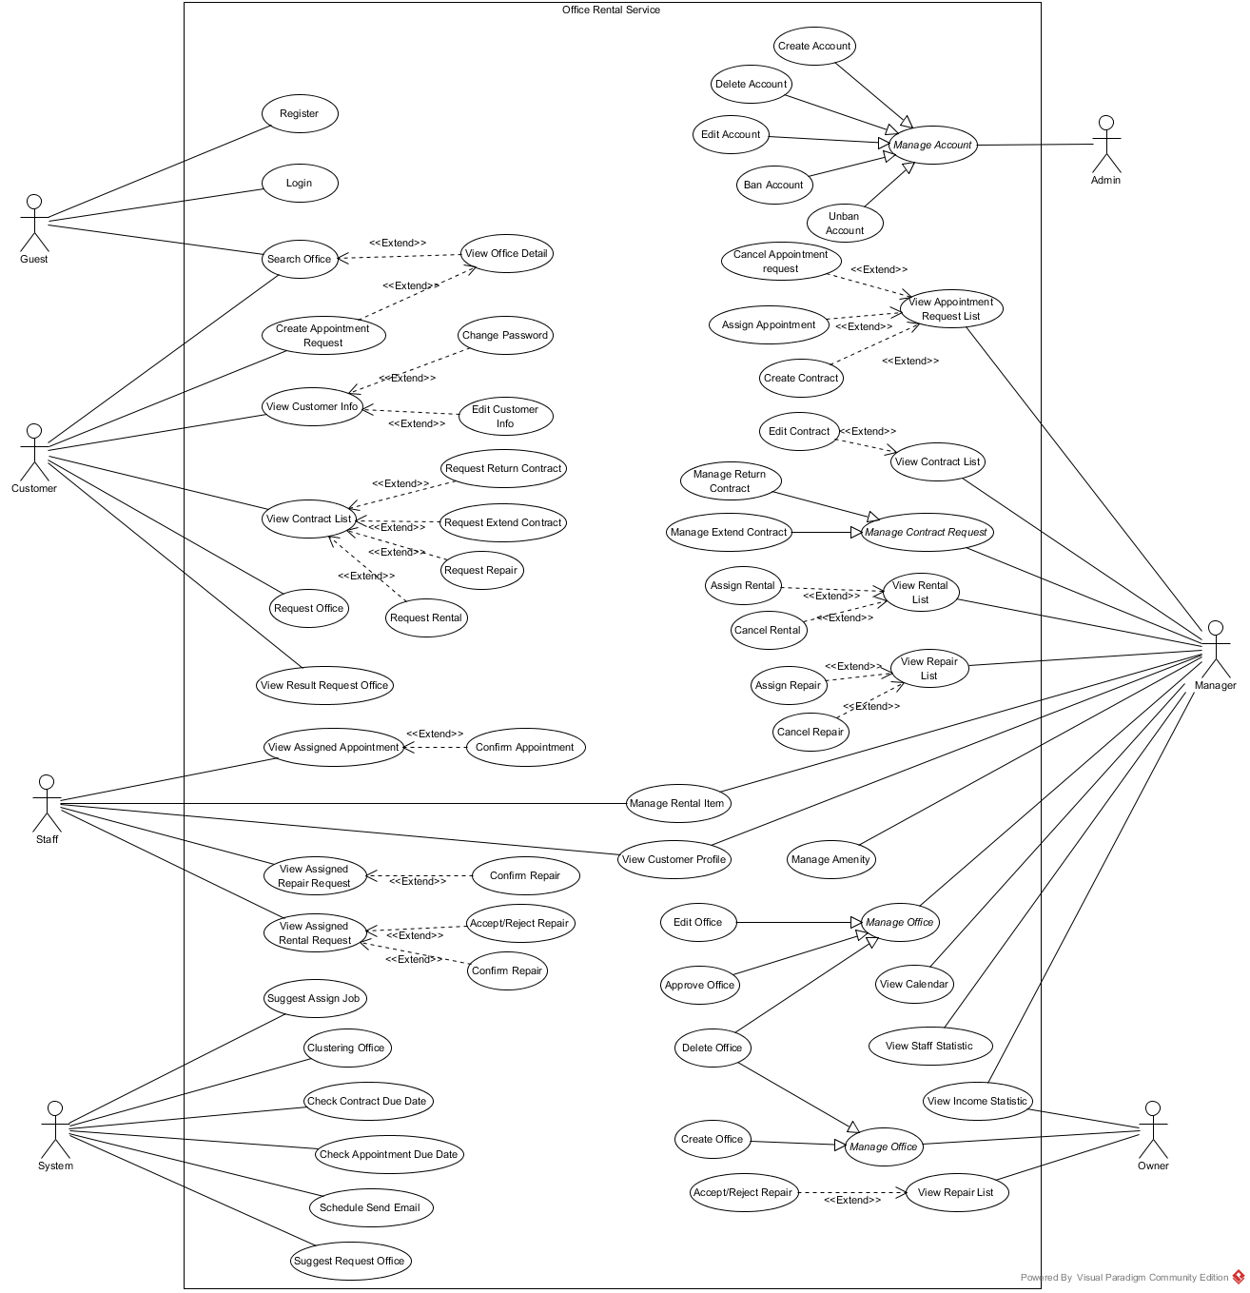

Figure : Use Case Overview

*This page is intentionally left blank*

### List of Use Case:

#### <Guest>Overview Use Case

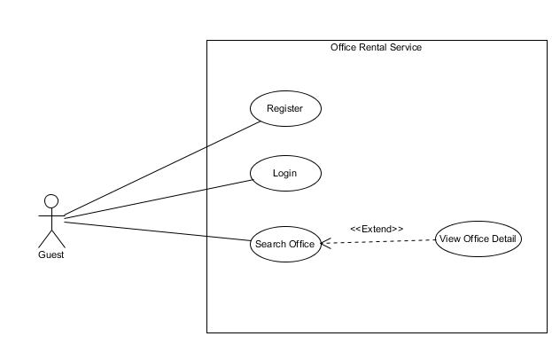

Figure : <Guest> Overview Use Case

##### <Guest> Register

<Refer CD:\Capstone_ORS\Full_report.docx>

##### <Guest> Login

<Refer CD:\Capstone_ORS\Full_report.docx>

##### <Guest, Customer> Search office

**Use Case Diagram**

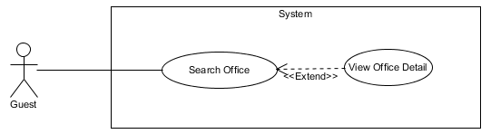

Figure : <Guest, Customer> Search office

**Use Case Specification**

|  |  |  |  |  |
| --- | --- | --- | --- | --- |
| **USE CASE – SEARCH OFFICE** | | | | |
| **Use-case No.** | UC003 | **Use-case Version** | | 3.0 |
| **Use-case Name** | Search office | | | |
| **Author** | Lê Xuân Tiến | | | |
| **Date** | 14/09/2015 | **Priority** | Normal | |
| **Actor:**   * Guest, Customer   **Summary:**   * This use case allows guest and customer search office.   **Goal:**   * Customer can find an office match their condition.   **Trigger:**   * Fill information in text fill or choice some available information. * Click “Tìm kiếm” in home page.   **Pre-conditions:** N/A  **Post conditions:**   * **Success:** Search office successful. * **Fail:** Show message error and show which information error.   **Main Success Scenario:**   |  |  |  | | --- | --- | --- | | Step | Actor Action | System Response | | 1 | Go to home page. | Show the search fields:   * Địa chỉ: auto complete text box of address * Khoảng giá: Number text box * Tìm theo danh sách tiện nghi: List of amenity, each with a check box * Tìm kiếm: button | | 2 | Click “Tìm kiếm” button. | [Exceptions 1, 2]  Show result page, each office include:4   * Image of office * Office name * Short description * Amenity list * Price and price term * Link to office detail |   **Alternative Scenario:** N/A  **Exceptions:**   |  |  |  | | --- | --- | --- | |  | Actor Action | System Response | | 1 | The address is invalid | Show error message: “Xin nhập vào địa chỉ.” | | 2 | No office can be found | Show message: “Không tìm thấy văn phòng phù hợp” and a link to Request Office page | | 3 | Cannot load search result due to database connection | Show error message: “Có lỗi xảy ra, xin thử lại sau.” |   **Relationships:** View Office Detail  **Business Rules**:   * The search will perform by relative matching. First based on group of relative place and price. * After get result offices, then filter relatively by amenity by amenity weight. If the match amenity is above 70%, display the result | | | | |

Table : <Guest, Customer> Search office

##### <Guest, Customer> View office detail

**Use Case Diagram**



Figure : <Guest, Customer> View office detail

**Use Case Specification**

|  |  |  |  |  |
| --- | --- | --- | --- | --- |
| **USE CASE – VIEW OFFICE DETAIL** | | | | |
| **Use-case No.** | UC004 | **Use-case Version** | | 2.0 |
| **Use-case Name** | View Office Detail | | | |
| **Author** | Lê Xuân Tiến | | | |
| **Date** | 25/05/2015 | **Priority** | Normal | |
| **Actor:**   * Guest, Customer   **Summary:**   * This use case allows guest and customer view office detail.   **Goal:**   * Display office detail page   **Triggers:**   * Click on the office in office search result * Or click on the office in home page * Or click on the office in relative offices in office detail page   **Preconditions:** N/A  **Post Conditions:**   * **Success**: Display office information. * **Fail:** Cannot show office information.   **Main Success Scenario:**   |  |  |  | | --- | --- | --- | | Step | Actor Action | System Response | | 1 | Click on an office. | Show office information include:   * Office name: text field. * Type of office: text field * “Số tầng”: number of floor, text field * “Diện tích”: area of office, text field * “Địa chỉ”: address of office, text field * “Tiện nghi”: list of amenity, text field * List of office images * “Mô tả”: description of office, text field * Office address map * “Văn phòng tương tự”: list of relative office with link to office detail * “Đặt lịch hẹn xem văn phòng”: button   [Exception 1] |   **Alternative Scenario:** Search Office  **Exceptions:**   |  |  |  | | --- | --- | --- | | No. | Actor Action | System Response | | 1 | Cannot load office detail due to database connection | Show error message: “Không thể xem thông tin, vui lòng thử lại sau.” |   **Relationships:** N/A  **Business Rules:**   * Relative office is suggest based on the office has the relate place and price of current office | | | | |

Table : <Guest, Customer> View office detail

#### <Customer>Overview Use Case

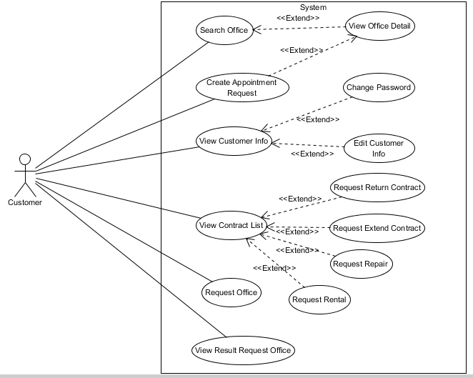

Figure : <Customer> Overview Use Case

##### <Customer> View customer info

<Refer CD:\Capstone_ORS\Full_report.docx>

##### <Customer> Edit customer info

<Refer CD:\Capstone_ORS\Full_report.docx>

##### <Customer> Change password

<Refer CD:\Capstone_ORS\Full_report.docx>

##### <Customer> Create appointment request

**Use Case Diagram**

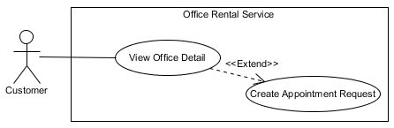

Figure : <Customer> Create appointment request

**Use Case Specification**

|  |  |  |  |  |
| --- | --- | --- | --- | --- |
| **USE CASE – CREATE APPOINTMENT REQUEST** | | | | |
| **Use-case No.** | UC008 | **Use-case Version** | | 2.0 |
| **Use-case Name** | Create appointment request | | | |
| **Author** | Trương Tiến Thành | | | |
| **Date** | 27/05/2015 | **Priority** | Normal | |
| **Actor:**   * Customer.   **Summary:**   * This use case allows customer request appointment.   **Goal:**   * Customer can request appointment after they found suitable office.   **Trigger:**   * After choosing suitable office, click “Đặt lịch hẹn xem văn phòng”.   **Pre-conditions:**   * User must login in customer role. * User at least chooses one suitable office.   **Post conditions:**   * **Success:** Request appointment successful. * **Fail:** Show message error and can’t send request.   **Main Success Scenario:**   |  |  |  | | --- | --- | --- | | Step | Actor Action | System Response | | 1 | Click “Đặt lịch hẹn xem văn phòng” button. | Redirect to [Request page], contain:   * Thời gian [?]: Date time picker. * Đặt lịch hẹn: Button.   [Exception 1] | | 2 | Input date and time.  Click “Đặt lịch hẹn” button. | Return to [Detail office page] and displays message:”Đặt lịch hẹn thành công”. |   **Alternative Scenario:** N/A  **Exceptions:**   |  |  |  | | --- | --- | --- | |  | Actor action | System Response | | 1 | “Thời gian” is empty | Displays error message:”Thời gian hẹn không hợp lệ”. |   **Relationships:** View office detail  **Business Rules**:   * Customer can request appointment which offices have status available. * Valid time from 8 am to 6 pm. * Valid date from Monday to Saturday. | | | | |

Table : <Customer> Create appointment request

##### <Customer> View rental request list

**Use Case Diagram**

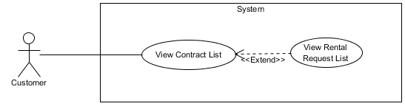

Figure : <Customer> View rental request list

**Use Case Specification**

|  |  |  |  |  |
| --- | --- | --- | --- | --- |
| **USE CASE – VIEW RENTAL REQUEST LIST** | | | | |
| **Use-case No.** | UC009 | **Use-case Version** | | 2.0 |
| **Use-case Name** | View rental request list | | | |
| **Author** | Trương Tiến Thành | | | |
| **Date** | 27/05/2015 | **Priority** | Normal | |
| **Actor:**   * Customer.   **Summary:**   * This use case allows customer view list rental request.   **Goal:**   * Show information about request rental of customer.   **Triggers:**   * Click “Hợp đồng của bạn” in menu bar. * Then click “Danh sách thuê thiết bị”.   **Preconditions:**   * User must login in customer role. * Customer at least has one contract and one request rental.   **Post Conditions:**   * **Success**: List request rental is showed successfully. * **Fail:** Cannot view list rental request.   **Main Success Scenario:**   |  |  |  | | --- | --- | --- | | Step | Actor Action | System Response | | 1 | Click “Danh sách thuê thiết bị” on the screen. | Show list rental request information, includes:   * Thiết bị: Text. * Ngày tạo yêu cầu: Text. * Tình trạng: Text. * Ngày giao thiết bị: Text. * Mô tả yêu cầu: Text. * Xem chi tiết: Button. |   **Alternative Scenario:**   * N/A   **Exceptions:**   * N/A   **Relationships:** View list contract  **Business Rules:**   * Only show request has status “Đang xử lý” and “Chờ khách hàng xác nhận”. * Can’t view rental request list of other customer. | | | | |

Table : <Customer> View rental request list

##### <Customer> View repair request list

<Refer CD:\Capstone_ORS\Full_report.docx>

##### <Customer> View repair request history

<Refer CD:\Capstone_ORS\Full_report.docx>

##### <Customer> Request extend contract

<Refer CD:\Capstone_ORS\Full_report.docx>

##### <Customer> Request return contract

**Use Case Diagram**

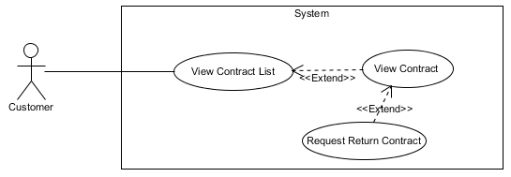

Figure : <Customer> Request return contract

**Use Case Specification**

|  |  |  |  |  |
| --- | --- | --- | --- | --- |
| **USE CASE – REQUEST RETURN CONTRACT** | | | | |
| **Use-case No.** | UC013 | **Use-case Version** | | 2.0 |
| **Use-case Name** | Request return contract | | | |
| **Author** | Trương Tiến Thành | | | |
| **Date** | 27/05/2015 | **Priority** | Normal | |
| **Actor:**   * Customer.   **Summary:**   * This use case allows customer request return the contract.   **Goal:**   * Customer can request return the contract if they want to stop hiring.   **Triggers:**   * Click “Hợp đồng của bạn” in menu bar. * Click “Chi tiết”. * Then click “Hủy hợp đồng trước hạn”   **Preconditions:**   * User must login in customer role. * Customer at least has one effective contract. * The status of contract cannot be expire or in the condition of being requested for extend.   **Post Conditions:**   * **Success**: Send request return successfully. * **Fail:** Cannot send request return.   **Main Success Scenario:**   |  |  |  | | --- | --- | --- | | Step | Actor Action | System Response | | 1 | Click “Hủy hợp đồng trước hạn”. | System show [Contract return pop-up], contain:   * Bạn đang yêu cầu hủy hợp đồng trước hạn. Chúng tôi sẽ liên lạc với bạn để xác nhận và bàn giao văn phòng trong thời gian sớm nhất. Nhấn "Đồng ý" để xác nhận: Text. * Đồng ý: Button. * Hủy: Button. | | 2 | Click “Đồng ý” button.  [Alternative 1] | Close [Contract return pop-up] and show message: “Đã gửi yêu cầu hủy hợp đồng trước hạn”. |   **Alternative Scenario:**   |  |  |  | | --- | --- | --- | | No. | Actor Action | System Response | | 1 | Click “Hủy” button. | Close [Contract return pop-up] and return to [Contract detail page] |   **Exceptions:**   * N/A   **Relationships:** View contract  **Business Rules:**   * If customer send request return, they can’t send other request until manager check. * Customer can only send request return when contract still has effect. | | | | |

Table : <Customer> Request return contract

##### <Customer> View list contract

<Refer CD:\Capstone_ORS\Full_report.docx>

##### <Customer> View contract

**Use Case Diagram**

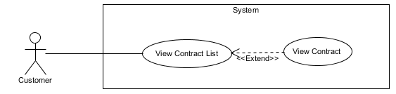

Figure : <Customer> View contract

**Use Case Specification**

|  |  |  |  |  |
| --- | --- | --- | --- | --- |
| **USE CASE – VIEW CONTRACT** | | | | |
| **Use-case No.** | UC015 | **Use-case Version** | | 2.0 |
| **Use-case Name** | View contract | | | |
| **Author** | Trương Tiến Thành | | | |
| **Date** | 27/05/2015 | **Priority** | Normal | |
| **Actor:**   * Customer.   **Summary:**   * This use case allows customer view detail contract.   **Goal:**   * Show information about contract of customer.   **Triggers:**   * Click “Hợp đồng của bạn” in menu bar. * Click “Chi tiết” button.   **Preconditions:**   * User must login in customer role. * Customer at least has one contract.   **Post Conditions:**   * **Success**: Contract information is showed successfully. * **Fail:** Cannot view list contract.   **Main Success Scenario:**   |  |  |  | | --- | --- | --- | | Step | Actor Action | System Response | | 1 | Click “Chi tiết” in the screen. | Show contract information, includes:   * Bên cho thuê văn phòng (Bên A): Label   Ông (Bà): Text  Địa chỉ: Text  Số điện thoại: Text  Là chủ của văn phòng: Text   * Bên cho thuê văn phòng (Bên B): Label   Ông (Bà): Text  Địa chỉ: Text  Số điện thoại: Text   * File hợp đồng: Label * Thông tin thuê: Label   Tên văn phòng: Text  Loại văn phòng: Text  Địa chỉ văn phòng: Text  Diện tích thuê: Text  Giá thuê: Text  Ngày bắt đầu hợp đồng: Text.  Ngày kết thúc hợp đồng: Text.  Các tiện nghi đi kèm văn phòng: List   * Thông tin thanh toán: Label   Số tiền đặt cọc: Text  Kỳ hạn thanh toán: Text  Số tiền thanh toán mỗi kỳ: Text  Tổng giá trị hợp đồng: Text   * Tình trạng hợp đồng: Label * Phụ lục hợp đồng: Label   Tên thiết bị: Text.  Mô tả: Text.  Giá thuê (VNĐ): Text.  Số lượng (cái): Text.  Thành tiền (VNĐ): Text.  Tổng cộng (VNĐ): Text.   * Yêu câu thuê thiết bị: Button. * Yêu cầu sửa chữa: Button. * Hủy hợp đồng trước hạn: Button. * Gia hạn hợp đồng: Button. |   **Alternative Scenario:**   * N/A   **Exceptions:**   * N/A   **Relationships:** View list contract  **Business Rules:**   * Can’t view contract of other customer. * If contract expire, customer can’t view it. | | | | |

Table : <Customer> View contract

##### <Customer> Request repair

**Use Case Diagram**

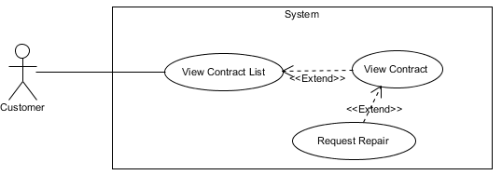

Figure : <Customer> Request repair

**Use Case Specification**

|  |  |  |  |  |
| --- | --- | --- | --- | --- |
| **USE CASE – REQUEST REPAIR** | | | | |
| **Use-case No.** | UC016 | **Use-case Version** | | 2.0 |
| **Use-case Name** | Request repair | | | |
| **Author** | Trương Tiến Thành | | | |
| **Date** | 27/05/2015 | **Priority** | Normal | |
| **Actor:**   * Customer   **Summary:**   * This use case allows customer to send request repair.   **Goal:**   * Customer can send request repair.   **Triggers:**   * Click “Hợp đồng của bạn” in menu bar. * Click “Chi tiết” button. * Then click “Yêu cầu sửa chữa” button.   **Preconditions:**   * User must login in customer role. * Customer at least has one effective contract. * The status of contract cannot be expire or in the condition of being requested for return (or requested for extend)   **Post Conditions:**   * **Success**: Request repair is sent successfully. * **Fail:** Cannot send request repair.   **Main Success Scenario:**   |  |  |  | | --- | --- | --- | | Step | Actor Action | System Response | | 1 | Click “Yêu cầu sửa chữa” on the screen. | Show [Request repair page], includes:   * Tên văn phòng: Text. * Địa chỉ văn phòng: Text. * Chủ văn phòng: Text. * Điện thoại: Text. * Sữa chữa: List checkbox. * Mô tả yêu cầu sửa chữa/Yêu cầu sửa chữa khác: Text area. * Gửi yêu cầu: Button.   [Exception 1] | | 2 | Click “Gửi yêu cầu” button on screen. | Show message “Thành công. Đã gửi yêu cầu sửa chữa” and return to [Contract list page]. |   **Alternative Scenario:**   * N/A   **Exceptions:**   |  |  |  | | --- | --- | --- | | No. | Actor Action | System Response | | 1 | “Mô tả yêu cầu sửa chữa/Yêu cầu sửa chữa khác” is empty. | Button “Gửi yêu cầu” is disable. |   **Relationships:** View contract  **Business Rules:**   * Status of request repair is “Chờ xử lý”. | | | | |

Table : <Customer> Request repair

##### <Customer> Request rental

<Refer CD:\Capstone_ORS\Full_report.docx>

##### <Customer> Create office request

**Use Case Diagram**

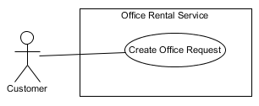

Figure : <Customer> Create office request

**Use Case Specification**

|  |  |  |  |  |
| --- | --- | --- | --- | --- |
| **USE CASE – CREATE OFFICE REQUEST** | | | | |
| **Use-case No.** | UC018 | **Use-case Version** | | 2.0 |
| **Use-case Name** | Create office request | | | |
| **Author** | Trương Tiến Thành | | | |
| **Date** | 27/05/2015 | **Priority** | Normal | |
| **Actor:**   * Customer.   **Summary:**   * This use case allows customer request office.   **Goal:**   * Customer can request office if they can’t find suitable office.   **Trigger:**   * Click “Đặt văn phòng” at home page.   **Pre-conditions:**   * User must login in customer role.   **Post conditions:**   * **Success:** Request office successful. * **Fail:** Show message error and can’t send request.   **Main Success Scenario:**   |  |  |  | | --- | --- | --- | | Step | Actor Action | System Response | | 1 | Click “Đặt văn phòng” button. | Redirect to [Request office page], contain:   * Loại văn phòng: Drop-down list. * Giá (VNĐ/m2/tháng): Number.   [Exception 1]   * Diện tích (m2): Number.   [Exception 1]   * Quận: Drop down box.   [Exception 1]   * Danh sách tiện nghi: Textbox. * Thêm: Button. * Đặt văn phòng: Button.   [Exception 2] | | 2 | Input information and click “Đặt văn phòng” button. | Return to [Home page] and displays message:”Đặt lịch hẹn thành công”. |   **Alternative Scenario:**   * N/A   **Exceptions:**   |  |  |  | | --- | --- | --- | |  | Actor action | System Response | | 1 | “Giá”, “Diện tích” and “Quận” are empty. | Display error message “Bắt buộc”. | | 2 | “Giá”, “Diện tích”, “Quận” và “Loại văn phòng” is empty | Button “Đặt văn phòng” is disable. |   **Relationships:**   * N/A   **Business Rules**:   * “Loại văn phòng”, “Giá”, “Diện tích” and “Quận” can’t empty. * Customer can only choose amenity and district that system suggest. | | | | |

Table : <Customer> Create office request

##### <Customer> View Result Request Office

<Refer CD:\Capstone_ORS\Full_report.docx>

##### <Customer> Log out

<Refer CD:\Capstone_ORS\Full_report.docx>

#### <Staff> Overview Use Case

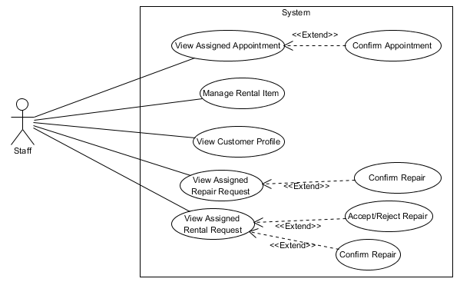

Figure : <Staff> Overview Use Case

##### <Staff> View Assigned Appointment

<Refer CD:\Capstone_ORS\Full_report.docx>

##### <Staff> Confirm Appointment

<Refer CD:\Capstone_ORS\Full_report.docx>

##### <Staff>View Assigned Repair Request

<Refer CD:\Capstone_ORS\Full_report.docx>

##### <Staff> Confirm Repair

<Refer CD:\Capstone_ORS\Full_report.docx>

##### <Staff> Accept/Reject Rental

<Refer CD:\Capstone_ORS\Full_report.docx>

##### <Staff> Confirm Rental

<Refer CD:\Capstone_ORS\Full_report.docx>

##### <Staff, Manager, Admin> Logout

<Refer CD:\Capstone_ORS\Full_report.docx>

##### <Staff, Manager> View rental item list

<Refer CD:\Capstone_ORS\Full_report.docx>

##### <Staff, Manager> Edit rental item

<Refer CD:\Capstone_ORS\Full_report.docx>

##### <Staff, Manager> Create rental item

<Refer CD:\Capstone_ORS\Full_report.docx>

##### <Staff, Manager> View customer profile

<Refer CD:\Capstone_ORS\Full_report.docx>

#### <Admin> Overview Use Case

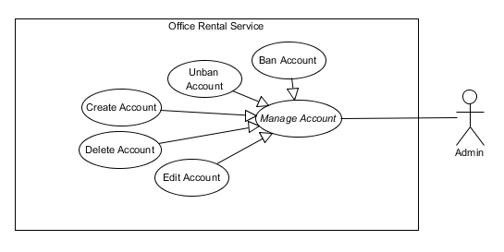

Figure : <Admin> Overview Use Case

##### <Admin> View account list

<Refer CD:\Capstone_ORS\Full_report.docx>

##### <Admin> Ban account

<Refer CD:\Capstone_ORS\Full_report.docx>

##### <Admin> Create account

<Refer CD:\Capstone_ORS\Full_report.docx>

##### <Admin> Delete account

<Refer CD:\Capstone_ORS\Full_report.docx>

##### <Admin> Update account

<Refer CD:\Capstone_ORS\Full_report.docx>

##### <Admin> Unban account

<Refer CD:\Capstone_ORS\Full_report.docx>

#### <Manager> Overview Use Case

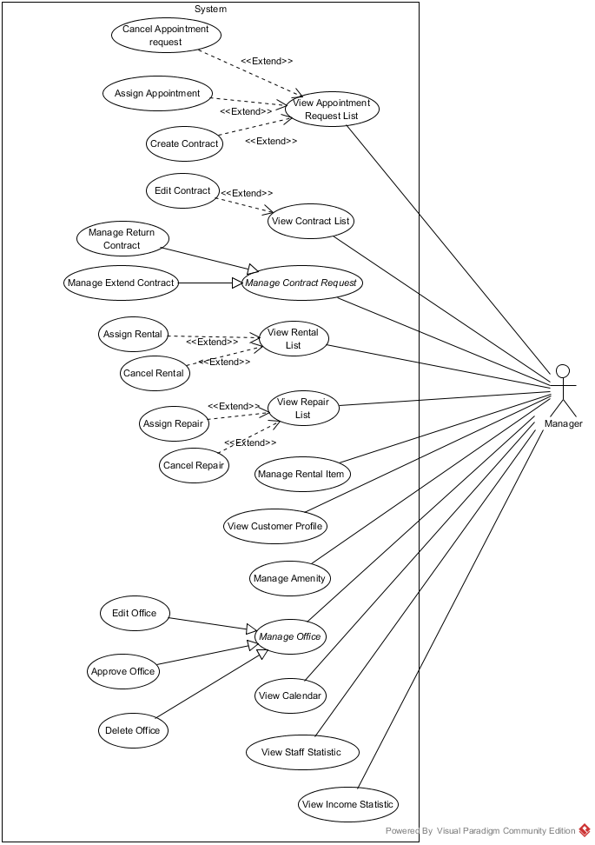

Figure : <Manager> Overview Use Case

##### <Manager> View request extend contract

<Refer CD:\Capstone_ORS\Full_report.docx>

##### <Manager> Cancel extend request

<Refer CD:\Capstone_ORS\Full_report.docx>

##### <Manager> Accept extend request

<Refer CD:\Capstone_ORS\Full_report.docx>

##### <Manager> View request return contract

<Refer CD:\Capstone_ORS\Full_report.docx>

##### <Manager> Cancel return request

<Refer CD:\Capstone_ORS\Full_report.docx>

##### <Manager> Accept return request

<Refer CD:\Capstone_ORS\Full_report.docx>

##### <Manager> View Appointment Request List

**Use Case Diagram**

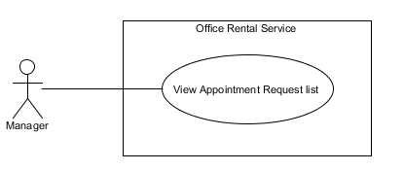

Figure : <Manager> View Appointment Request List

**Use Case Specification**

|  |  |  |  |
| --- | --- | --- | --- |
| **USE CASE VIEW APPOINTMENT REQUEST LIST** | | | |
| **Use Case No.** | UC043 | **Use Case Version** | 1.0 |
| **Use Case Name** | View Appointment Request List | | |
| **Author** | Nguyễn Vũ Hoàng Quốc | | |
| **Date** | 31/05/2015 | **Priority** | Normal |
| **Actor:**   * Manager   **Summary:**   * This use case allows manager see all appointment request   **Goal:**   * Show all appointment request   **Triggers:**   * From the menu bar on admin page:   + Select “Lịch hẹn” menu.   **Preconditions:**   * There are at least request appointment from customer * Requests from customers are valid and send successful   **Post Conditions:**   * **Success:** All appointment request are shown * **Fail:** Cannot get appointment list from database.   **Main Success Scenario:**   |  |  |  | | --- | --- | --- | | Step | Actor Action | System Response | | 1 | Click “Appointment” button from menu bar on admin page | * Show all request appointment list in which includes:   + Khách hàng   + Văn phòng   + Thời gian gặp   + Đề xuất nhân viên   [Exception 1] |   **Alternative Scenario:** N/A  **Exceptions:**   |  |  |  | | --- | --- | --- | | No | Actor Action | System Response | | 1 | Cannot load appointment list from database | Display error message: “Không lấy được lịch hẹn.” |   **Relationships:** N/A  **Business Rules:**   * Manager can view all list appointment from customer’s request. * On list appointment system will suggest staff suitable. | | | |

Table : <Manager> View Appointment request

##### <Manager> Cancel Appointment request

<Refer CD:\Capstone_ORS\Full_report.docx>

##### <Manager> Assign Appointment

**Use Case Diagram**

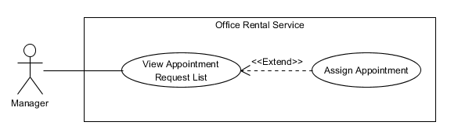

Figure : <Manager> Assign Appointment

**Use Case Specification**

|  |  |  |  |
| --- | --- | --- | --- |
| **USE CASE ASSIGN APPOINTMENT** | | | |
| **Use Case No.** | UC045 | **Use Case Version** | 1.0 |
| **Use Case Name** | Assign Appointment | | |
| **Author** | Nguyễn Vũ Hoàng Quốc | | |
| **Date** | 31/05/2015 | **Priority** | Normal |
| **Actor:**   * Manager   **Summary:**   * This use case allows manager assign appointment request to staff   **Goal:**   * Assign appointment to staff successful   **Triggers:**   * From the menu bar:   + Select “Lịch hẹn” menu.   + Click “Giao việc”   **Preconditions:**   * There are request appointment from customer * Requests from customers are valid and send successful * Manager checked the appointment is suitable   **Post Conditions:**   * **Success:** Appointment request is assign successful * **Fail:** Assign error.   **Main Success Scenario:**   |  |  |  | | --- | --- | --- | | Step | Actor Action | System Response | | 1 | Click “Lịch hẹn” button from menu bar on admin page | * Schedule staff who suitable * Show all request appointment list   + Khách hàng   + Văn phòng   + Thời gian gặp   + Đề xuất nhân viên   [Exception 1] | | 2 | Click “Giao việc” button on each row of appointment | [Exception 2] |   **Alternative Scenario:**   |  |  |  | | --- | --- | --- | | No | Actor Action | System Response | | 1 | Click “close” button on list staff | * Show appointment detail page |   **Exceptions:**   |  |  |  | | --- | --- | --- | | No | Actor Action | System Response | | 1 | Cannot load appointment list from database | Display error message: “Không lấy được lịch hẹn.” | | 2 | Cannot get detail of chosen appointment from database | Display error message: “Không thể lấy được thông tin lịch hẹn.” | | 3 | Assign error | Display error message: “Giao việc không thành công.” |   **Relationships:** View Appointment Request List  **Business Rules:**   * Manager can assign appointment from customer’s request to staff if the request is suitable. * When assign, system will send email to staff’ and add the request to staff’s task list. | | | |

Table : <Manager> Assign Appointment

##### <Manager> View Contract List

<Refer CD:\Capstone_ORS\Full_report.docx>

##### <Manager> View Contract Detail

<Refer CD:\Capstone_ORS\Full_report.docx>

##### <Manager> Create Contract

**Use Case Diagram**

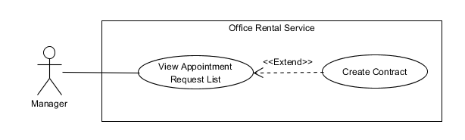

Figure : <Manager> Create Contract

**Use Case Specification**

|  |  |  |  |
| --- | --- | --- | --- |
| **USE CASE CREATE CONTRACT** | | | |
| **Use Case No.** | UC049 | **Use Case Version** | 1.0 |
| **Use Case Name** | Create Contract | | |
| **Author** | Nguyễn Vũ Hoàng Quốc | | |
| **Date** | 31/05/2015 | **Priority** | Normal |
| **Actor:**   * Manager   **Summary:**   * This use case allows manager create contract   **Goal:**   * Contract is create and add to database   **Triggers:**   * From the menu bar:   + Click “Lịch hẹn” on menu.   + On “Chấp nhận” tab click “Đến kí/ hủy hợp đồng”   + Click “Tạo hợp đồng” button   + Click “Tạo mới” button after input information   **Preconditions:**   * Appointment has been accepted by customer and status is accepted   **Post Conditions:**   * **Success:** Contract is saved to database * **Fail:** Create fail   **Main Success Scenario:**   |  |  |  | | --- | --- | --- | | Step | Actor Action | System Response | | 1 | Click “Lịch hẹn” on menu | * Show all appointment list   [Exception 1] | | 2 | On “Chấp nhận” tab click “Đến kí/ hủy hợp đồng” | * Show detail of the appointment   + Khách hàng [text]   + Văn phòng [text]   + Nhân viên được giao [text]   + Thời gian gặp [Date]   + Tình trạng [Text] * Group button:   + Tạo hợp đồng   + Hủy lịch hẹn [Alternative 1]   + Quay về [Alternative 2] | | 3 | Click “Tạo hợp đồng” | * Show detail of office, customer and owner. * Show input field and detail of contract:   + Khách hàng [text]   + Văn phòng [text]   + Thời gian thuê [number]   + Ngày bắt đầu [Date]   + Ngày kết thúc [Date]   + Giá [Number]   + Tiền đặt cọc [Number]   + Thời hạn thanh toán [text]   + Thời gian thanh toán kỳ đầu[Number]   + Thời gian thanh toán các kỳ tiếp theo[Number]   + Thời gian thanh toán tiền đặt cọc[Number]   + Phí phụ trội[Number] * Button “Tạo mới” | | 4 | Input information and click “Tạo mới” button | * Validate input data [Exception 2] * Show successful message [Exception 3] |   **Alternative Scenario:**   |  |  |  | | --- | --- | --- | | No | Actor Action | System Response | | 1 | Click “Hủy lịch hẹn” button | * Show popup input comment and return to appointment list page after manager input comment | | 2 | Click “Quay về” button | * Return to appointment list page |     **Exceptions:**   |  |  |  | | --- | --- | --- | | No | Actor Action | System Response | | 1 | Cannot load contract list from database | Display error message: “Không lấy được danh sách hợp đồng.” | | 2 | Payment Term > time | Display error message: “Thời hạn thanh toán không thể lớn hơn thời gian thuê” | | 3 | Cannot save new contract to database | Display error message: “Không thể tạo hợp đồng” |   **Relationships:** View Appointment Request List  **Business Rules:**   * Manager will meet customer after customer decide to rent office * Manager will create contract after the meeting | | | |

Table : <Manager> Create Contract

##### <Manager> Edit Contract

<Refer CD:\Capstone_ORS\Full_report.docx>

##### <Manager> View Repair Request List

<Refer CD:\Capstone_ORS\Full_report.docx>

##### <Manager> Assign Repair

<Refer CD:\Capstone_ORS\Full_report.docx>

##### <Manager> Cancel Repair

<Refer CD:\Capstone_ORS\Full_report.docx>

##### <Manager> View Rental Request List

<Refer CD:\Capstone_ORS\Full_report.docx>

##### <Manager> Assign Rental

<Refer CD:\Capstone_ORS\Full_report.docx>

##### <Manager> Cancel Rental Request

<Refer CD:\Capstone_ORS\Full_report.docx>

##### <Manager> View amenity list

<Refer CD:\Capstone_ORS\Full_report.docx>

##### <Manager> Create amenity

<Refer CD:\Capstone_ORS\Full_report.docx>

##### <Manager> View amenity detail

<Refer CD:\Capstone_ORS\Full_report.docx>

##### <Manager> Edit amenity

<Refer CD:\Capstone_ORS\Full_report.docx>

##### <Manager> View amenity group list

<Refer CD:\Capstone_ORS\Full_report.docx>

##### <Manager> Create amenity group

<Refer CD:\Capstone_ORS\Full_report.docx>

##### <Manager> Edit amenity group

<Refer CD:\Capstone_ORS\Full_report.docx>

##### <Manager> View Customer Info

<Refer CD:\Capstone_ORS\Full_report.docx>

##### <Manager> View Calendar

**Use Case Diagram**

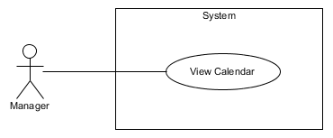

Figure : <Manager> View Calendar

**Use Case Specification**

|  |  |  |  |
| --- | --- | --- | --- |
| **USE CASE VIEW CALENDAR** | | | |
| **Use Case No.** | UC065 | **Use Case Version** | 1.0 |
| **Use Case Name** | View Calendar | | |
| **Author** | Lê Xuân Tiến | | |
| **Date** | 31/05/2015 | **Priority** | Normal |
| **Actor:**   * Manager   **Summary:**   * This use case allows manager to overview of staff’s job by calendar view   **Goal:**   * View the calendar with job overview   **Triggers:**   * From the menu bar:   + Select “Calendar” menu.   **Preconditions:**   * There are available appointments, rentals or repairs that has been assigned to staff   **Post Conditions:**   * **Success:** Show calendar with job information by date * **Fail:** Show error.   **Main Success Scenario:**   |  |  |  | | --- | --- | --- | | Step | Actor Action | System Response | | 1 | Click “Calendar” button on menu bar of manager role | * Show the calendar with following fields   + Legends: color and username of staff   + Calendar view with staff’s job. Each job display by date in calendar as a frame which has the color of staff, the name of job and the time of job.   + The calendar can be transfer between months   [Exception 1] | | 2 | Click an job | * Show the job detail |   **Alternative Scenario:**N/A  **Exceptions:**   |  |  |  | | --- | --- | --- | | No | Actor Action | System Response | | 1 | Cannot load job list from database | Display error message: “Không tải được lịch lúc này. Xin thử lại” |   **Relationships:** Appointment detail, Repair detail, Rental detail  **Business Rules:**   * The job in calendar is the job in “Assigned” status * Manager can change the job’s assigner and date base on the overview which show on calendar page when go to job detail page | | | |

Table : <Manager> View Calendar

##### <Manager, Owner> View Income Stastisic

<Refer CD:\Capstone_ORS\Full_report.docx>

##### <Manager> View Staff Stastisic

<Refer CD:\Capstone_ORS\Full_report.docx>

##### <Manager> Approve Office

**Use Case Diagram**

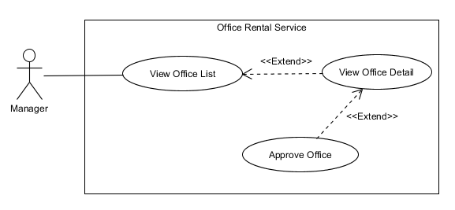

Figure : <Manager> Approve Office

**Use Case Specification**

|  |  |  |  |
| --- | --- | --- | --- |
| **USE CASE EDIT OFFICE DETAIL** | | | |
| **Use Case No.** | UC027 | **Use Case Version** | 3.0 |
| **Use Case Name** | Approve Office | | |
| **Author** | Lê Xuân Tiến | | |
| **Date** | 14/08/2015 | **Priority** | Normal |
| **Actor:**   * Manager   **Summary:**   * This use case is used to edit information of office and approve office.   **Goal:**   * Manager can edit information of an office. The edited office can be view/search/create appointment...   **Triggers:**   * In “Quản lí văn phòng” page * Select “Văn phòng mới tạo” tab * Click “Xem chi tiết văn phòng” button.   **Preconditions:**   * User must be logged in the system with Manager role. * At least there is one office in newly created by owner status in database.   **Post Conditions:**   * **Success:** New information of office is updated. The office status is Available * **Fail:** Cannot update information of office.   **Main Success Scenario:**   |  |  |  | | --- | --- | --- | | Step | Actor Action | System Response | | 1 | Clicks “Cập nhật văn phòng” button on the row of office that he/she wants to edit. | Redirect to update office page. It includes:   * Tên văn phòng: Text box (Name, length [3, 50], required) * Địa chỉ: Text box (Address, min length: 6, required) * Detail of address, include district and city, and the map of current adress * Hình ảnh: Add image button * List of image, each of image added has the “Xóa” button * Mô tả văn phòng: Text area (Description, length [3, 500], required) * Loại văn phòng: Drop down list (Category, read only) * Đơn vị giá: Drop down list (PriceTerm, require) * Số tầng: Text box (Floor, type number, required) * Tiện ích: Tags with typeahead input * Tổng diện tích: Text box (Area, type number, min: 10, required) * Thời gian thuê tối thiểu (tháng): Text box (area, type number, min 0, required) * Diện tích thuê tối thiểu: Text box (Min area, type number, min 0, max equal Area, required) * Giá thuê gốc: text box, base price, number input, read only * Lợi nhuận tính theo hoa hồng: check box, checked. If unchecked display:   + Giá thuê: Text box (Price, type number, required)   If checked display:   * + Input for percent of commission, required * Xác nhận văn phòng: button   [Exception 1, 2, 3, 4]   * Hủy: button | | 3 | Edit information and clicks on “Cập nhật” button.  [Alternative 1] | * Redirect to office detail page. |   **Alternative Scenario:**   |  |  |  | | --- | --- | --- | | No | Actor Action | System Response | | 1 | Clicks on “Hủy” button | Redirect to office detail page. |   **Exceptions:**   |  |  |  | | --- | --- | --- | | No | Actor Action | System Response | | 1 | The required input fields null | Shows error message “Mời nhập vào trường này” beside the input field | | 2 | The input length is not match | Shows error message “Mời nhập vào từ x tới y kí tự” beside the input field (x, y is min and max length) | | 3 | The input is not a valid number | Shows error message “Mời nhập vào số” beside input field | | 4 | The address selected is not from drop down list | Shows error message “Mời chọn địa chỉ từ danh sách” beside input field |   **Relationships:** View Office Detail, View Office List  **Business Rules:**   * The input number fields cannot input non-number characters * The “Lợi nhuận tính theo hoa hồng” and relative fields used to calculate the income for system. If it is checked, they income will be a percent of contract price, else the income will be the different between base price and office rental price. * When select office type “Văn phòng nguyên căn”, the price term in “Giá thuê gốc” is “Nguyên căn/ tháng” and “Liên hệ”, while type “Tòa nhà văn phòng”, the price term is: “m2 / tháng” and “Liên hệ” * The amenity can be created freely by input field, but user can only search from pre-created amenity * After approve this office, the status will change to “Available”, and the office can be search, create appointment request, create contract | | | |

Table : <Staff, Manager> Approve Office

##### <Manager> Edit Office

<Refer CD:\Capstone_ORS\Full_report.docx>

##### <Manager, Owner> Delete Office

<Refer CD:\Capstone_ORS\Full_report.docx>

#### <Staff> Mobile Overview Use Case

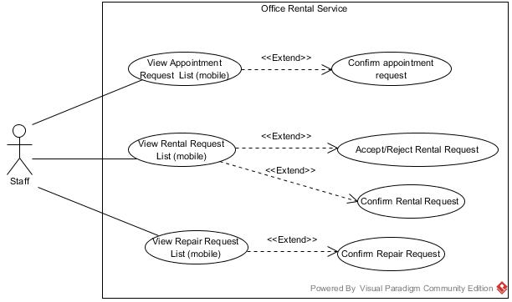

Figure : <System> Mobile Overview Use Case

##### <Staff> View appointment request list (mobile)

<Refer CD:\Capstone_ORS\Full_report.docx>

##### <Staff> View repair request list (mobile)

**Use case diagram**

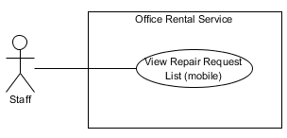

**Figure 28: <Staff > View repair request list (mobile) use case diagram**

**Use Case Specification**

|  |  |  |  |  |
| --- | --- | --- | --- | --- |
| **USE CASE – VIEW REPAIR REQUEST LIST (mobile)** | | | | |
| **Use-case No.** | UC073 | **Use-case Version** | | 2.0 |
| **Use-case Name** | View repair request list (mobile) | | | |
| **Author** | Trương Tiến Thành | | | |
| **Date** | 17/09/2015 | **Priority** | Normal | |
| **Actor:**   * Staff   **Summary:**   * This use case allows staff to view repair request list   **Goal:**   * Staff can view repair request list successful.   **Triggers:**   * Staff touch “Danh sách sửa chữa”.   **Preconditions:**   * User must login in system.   **Post Conditions:**   * **Success**: Show repair request list successfully. * **Fail:** Cannot show repair request list.   **Main Success Scenario:**   |  |  |  | | --- | --- | --- | | Step | Actor Action | System Response | | 1 | Touch “Danh sách sửa chữa” on screen. | Show repair request list, includes:   * Image office * Name of office: Text * Address of office: Text * Description: Text * Repair time: Text |   **Alternative Scenario:**   * N/A   **Exceptions:**   * N/A   **Relationships:**   * N/A   **Business Rules:**   * Repair request information must exist in database system. * Repair request list are sorted by repair time. * If request is on current day, it changes status to “Việc hôm nay”. | | | | |

Table : <Staff> View repair request list - mobile

##### <Staff> View rental request list (mobile)

<Refer CD:\Capstone_ORS\Full_report.docx>

##### <Staff> View appointment request detail (mobile)

<Refer CD:\Capstone_ORS\Full_report.docx>

##### <Staff> View repair request detail (mobile)

<Refer CD:\Capstone_ORS\Full_report.docx>

##### <Staff> View rental request detail (mobile)

<Refer CD:\Capstone_ORS\Full_report.docx>

##### <Staff> Confirm appointment request (mobile)

<Refer CD:\Capstone_ORS\Full_report.docx>

##### <Staff> Accept/Reject rental request (mobile)

**Use case diagram**

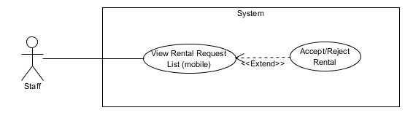

**Figure 29: <Staff > Accept/Reject rental request (mobile) use case diagram**

**Use Case Specification**

|  |  |  |  |  |
| --- | --- | --- | --- | --- |
| **USE CASE – ACCEPT/REJECT RENTAL REQUEST (mobile)** | | | | |
| **Use-case No.** | UC073 | **Use-case Version** | | 2.0 |
| **Use-case Name** | Accept/Reject rental request (mobile) | | | |
| **Author** | Trương Tiến Thành | | | |
| **Date** | 17/09/2015 | **Priority** | Normal | |
| **Actor:**   * Staff   **Summary:**   * This use case allows staff to accept/reject rental request   **Goal:**   * Staff can accept/reject rental request successful.   **Triggers:**   * Staff touch “Danh sách thuê thiết bị”. * Touch on task. * Then touch “Đồng ý giao” or “Không đồng ý”   **Preconditions:**   * User must login in system. * Staff at least has one rental request.   **Post Conditions:**   * **Success**: Accept/Reject rental request successfully. * **Fail:** Cannot accept/reject rental request.   **Main Success Scenario:**   |  |  |  | | --- | --- | --- | | Step | Actor Action | System Response | | 1 | Touch “Danh sách thuê thiết bị” on screen. | Show rental request list, includes:   * Image office * Name of office: Text * Address of office: Text * Rental time: Text | | 2 | Touch on task. | Show page rental detail, includes:   * Image * Tên văn phòng: Text * Địa chỉ: Text   Mở trên ứng dụng bản đồ: Link   * Khách hàng: Text * Chi tiết thuê thiết bị: Text * Thời gian: Text * Danh sách thuê thiết bị: List * Trạng thái: Label * “Đồng ý giao hàng”: Button * “Không đồng ý”: Button | | 3 | Click “Đồng ý giao hàng”  [Alternative 1] | Show successful message. |   **Alternative Scenario:**   |  |  |  | | --- | --- | --- | | No. | Actor Action | System Response | | 1 | Click “Không đồng ý” button | Show successful message. |   **Exceptions:**   * N/A   **Relationships:**   * N/A   **Business Rules:**   * Rental request information must exist in database system. * Staff cannot accept/reject rental request of other staff. | | | | |

Table : <Staff> Accept/Reject rental request - mobile

##### <Staff> Confirm rental request (mobile)

<Refer CD:\Capstone_ORS\Full_report.docx>

##### <Staff> Confirm repair request (mobile)

<Refer CD:\Capstone_ORS\Full_report.docx>

##### <Staff> Confirm appointment request (mobile)

**Use case diagram**

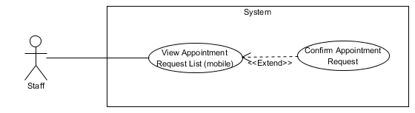

**Figure 30: <Staff > Confirm appointment request (mobile) use case diagram**

**Use Case Specification**

|  |  |  |  |  |
| --- | --- | --- | --- | --- |
| **USE CASE – CONFIRM APPOINTMENT REQUEST (mobile)** | | | | |
| **Use-case No.** | UC073 | **Use-case Version** | | 2.0 |
| **Use-case Name** | Confirm appointment request (mobile) | | | |
| **Author** | Trương Tiến Thành | | | |
| **Date** | 17/09/2015 | **Priority** | Normal | |
| **Actor:**   * Staff   **Summary:**   * This use case allows staff to confirm appointment request   **Goal:**   * Staff can confirm appointment request successful.   **Triggers:**   * Staff touch “Danh sách lịch hẹn”. * Touch on task. * Then touch “Muốn ký hợp đồng” or “Không đồng ý”   **Preconditions:**   * User must login in system. * Staff at least has one appointment request.   **Post Conditions:**   * **Success**: Confirm appointment request successfully. * **Fail:** Cannot confirm appointment request.   **Main Success Scenario:**   |  |  |  | | --- | --- | --- | | Step | Actor Action | System Response | | 1 | Touch “Danh sách lịch hẹn” on screen. | Show appointment request list, includes:   * Image office * Name of office: Text * Address of office: Text * Name of customer: Text * Appointment time: Text | | 2 | Touch on task. | Show page rental detail, includes:   * Image * Tên văn phòng: Text * Địa chỉ: Text   Mở trên ứng dụng bản đồ: Link   * Khách hàng: Text * Thời gian: Text * Trạng thái: Label * “Đồng ý giao hàng”: Button * “Không đồng ý” Button | | 3 | Click “Đồng ý giao hàng”  [Alternative 1] | Show successful message. |   **Alternative Scenario:**   |  |  |  | | --- | --- | --- | | No. | Actor Action | System Response | | 1 | Click “Không đồng ý” button | Show pop-up “Nhập lý do hủy” |   **Exceptions:**   * N/A   **Relationships:**   * N/A   **Business Rules:**   * Appointment request information must exist in database system. * Button “Đồng ý giao hàng” and “Không đồng ý” only show when appointment time is after current time. The screen will show “Chưa tới thời gian lịch hẹn” | | | | |

Table : <Staff> Accept/Reject rental request - mobile

#### <System>Overview Use Case

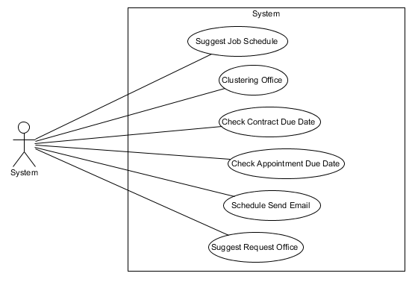

Figure : <System> Overview Use Case

##### <System> Suggest Requested Office

**Use Case Diagram**

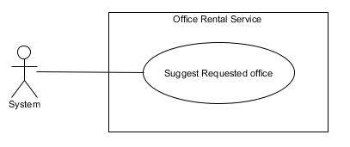

Figure : <System> Suggest Requested Office

**Use Case Specification**

|  |  |  |  |
| --- | --- | --- | --- |
| **USE CASE SUGGEST REQUESTED OFFICE** | | | |
| **Use Case No.** | UC077 | **Use Case Version** | 1.0 |
| **Use Case Name** | Suggest Requested Office | | |
| **Author** | Nguyễn Vũ Hoàng Quốc | | |
| **Date** | 31/05/2015 | **Priority** | Normal |
| **Actor:**   * System   **Summary:**   * This use case show system find offices that suitable with customer’s requests.   **Goal:**   * Find offices that suitable with customer’s requests.   **Triggers:**   * Schedule start   **Preconditions:**   * There are at least one request office from customer * There are at least one office in database   **Post Conditions:**   * **Success:** Office that suitable with customer’s requests is saved to database. * **Fail:** Cannot find office although there is the office suitable.   **Main Success Scenario:**   |  |  |  | | --- | --- | --- | | Step | Actor Action | System Response | | 1 | Start schedule | * Find all office in database * Find all request office in database * Check office with request * Find office that suitable * Save id of office to request office |   **Alternative Scenario: N/A**  **Exceptions:** N/A  **Relationships:** RequestOffice, Office, EmailQueue, Account  **Business Rules:**   * System will automatic check all requests office of customer and find which office in database suitable. * System will check 5 criteria:   + Amenity:     - If there is one request amenity in request, system will find if office which has that amenity will be suitable.     - If there are two or more request amenities, system will find if office which has two or more amenities in request will be suitable.   + Category:     - System will find which office suitable with request’s category.   + Price:     - System will find which office’s price is in range of request’s price: from (request’s price * 80%) to (request’s price * 120%)   + Area:     - If request category is “Văn phòng nguyên căn”: office’s area in range is suitable: from (request’s area * 80%) to (request’s area * 120%)     - If request category is “Tòa nhà văn phòng”: office’s area is larger than request’s area is suitable   + District:     - System will check which office in district of customer’s request | | | |

Table : <System> Suggest requested office

##### <System> Check Contract Due Date

**Use Case Diagram**

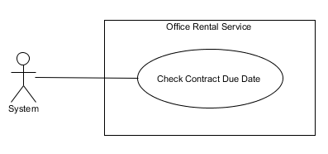

Figure : <System> Check Contract Due Date

**Use Case Specification**

|  |  |  |  |
| --- | --- | --- | --- |
| **USE CASE CHECK CONTRACT DUE DATE** | | | |
| **Use Case No.** | UC078 | **Use Case Version** | 1.0 |
| **Use Case Name** | Check Contract Due Date | | |
| **Author** | Nguyễn Vũ Hoàng Quốc | | |
| **Date** | 31/05/2015 | **Priority** | Normal |
| **Actor:**   * System   **Summary:**   * This use case show system check contract and send notification mail to customer.   **Goal:**   * Find contract which nearly expired and contract is expired in day and send mail to customer.   **Triggers:**   * Schedule start   **Preconditions:**   * There are at least one contract in database   **Post Conditions:**   * **Success:** Customer receive mail that notify about their contract will be expired of expired. * **Fail:** Send mail failed.   **Main Success Scenario:**   |  |  |  | | --- | --- | --- | | Step | Actor Action | System Response | | 1 | Start schedule | * Find all contract in database * Check contract which is nearly or expired in day * Send notification mail to customer |   **Alternative Scenario: N/A**  **Exceptions:** N/A  **Relationships:** Contract, account, Office, RentalItem  **Business Rules:**   * System check if contract has 7 days before expired will send mail to customer base on customer info. * If contract is due date it will auto change status to expired and send mail to customer. | | | |

Table : <System> Check contract due date

##### <System> Suggest Job Schedule

**Use Case Diagram**

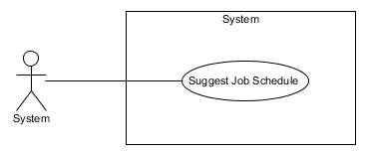

Figure : <System> Suggest Job Schedule

**Use Case Specification**

|  |  |  |  |
| --- | --- | --- | --- |
| **USE CASE SUGGEST JOB SCHEDULE** | | | |
| **Use Case No.** | UC079 | **Use Case Version** | 3.0 |
| **Use Case Name** | Suggest Job Schedule | | |
| **Author** | Lê Xuân Tiến | | |
| **Date** | 31/05/2015 | **Priority** | Normal |
| **Actor:**   * System   **Summary:**   * This use case show system suggest staff with available for the job (appointment/ repair/ rental).   **Goal:**   * Suggest staff and time in appointment/ repair/ rental page.   **Triggers:**   * View the appointment/ repair/ rental list   **Preconditions:**   * There are jobs in the job list page   **Post Conditions:**   * **Success:** Display suggest staff and date for each job in job list page. * **Fail:** Display “Không có đề xuất” in job list page.   **Main Success Scenario:**   |  |  |  | | --- | --- | --- | | Step | Actor Action | System Response | | 1 | Go to job list page | * If the page is appointment, suggest the staff only * If the page is repair and rental, suggest the staff and assign time * The suggestion will remove the staff which has the job less than 1 hour compare to current job, or the staff which has more than 5 job in date, which user can’t select the staff * If system cannot suggest, output “Không có đề xuất” as response   [Exception 1] |   **Alternative Scenario:** N/A  **Exceptions:**   |  |  |  | | --- | --- | --- | | Step | Actor Action | System Response | | 1 | Cannot load job from database | * “Không có đề xuất” as response |   **Relationships:** Appointment List, Repair List, Rental List  **Business Rules:**   * Step 1: suggest the assign time (repair and rental only) base on:   + If the repair has the amenity that have high priority (example electricity, internet…), the system will suggest the date after the current time   + Else the system will suggest the time on the weekend   + If the type is appointment, suggest date is the appointment date * Step 2: suggest the staff   + Step 2.1: Calculate number of job of each staff in the suggest date. If staff has less than 4 jobs, the staff is in suggest list. If there is no staff available in suggest list, repeat step 1 with the date after last suggest date   + Step 2.2: If there is staff in suggest date, system will suggest the staff which has least job in week. If they has same number of job, suggest first staff. The suggest staff is also add to the temporary job list to calculate at step 1 and 2 * Step 3: remove unavailable staff: For each staff in the system, system will check for 2 condition:   + 3.1: if the staff has more than 5 jobs, the system will not allow manager to assign. If the job has from 4 to 5 jobs, the system will warn the manager when assign that the staff has had 4 (or 5 job) in day.   + 3.2: if the staff has a job less than 1 hour from current job, system will not allow manager to assign. If the staff has a job less than 2 hours from current job, the system will warn the manager that the staff has had the job at that time. | | | |

Table : <System> Suggest Job Schedule

##### <System> Check Appointment Due Date

**Use Case Diagram**

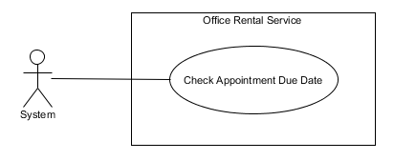

Figure : <System> Check Appointment Due Date

**Use Case Specification**

|  |  |  |  |
| --- | --- | --- | --- |
| **USE CASE CHECK CONTRACT DUE DATE** | | | |
| **Use Case No.** | UC078 | **Use Case Version** | 1.0 |
| **Use Case Name** | Check Apponitment Due Date | | |
| **Author** | Nguyễn Vũ Hoàng Quốc | | |
| **Date** | 13/09/2015 | **Priority** | Normal |
| **Actor:**   * System   **Summary:**   * This use case show system check appointment and send sms to customer.   **Goal:**   * Find appointment which is due date and send sms to customer   **Triggers:**   * Schedule start   **Preconditions:**   * There are at least one appointment in database   **Post Conditions:**   * **Success:** Customer sms that notify about their appointment. * **Fail:** Send mail failed.   **Main Success Scenario:**   |  |  |  | | --- | --- | --- | | Step | Actor Action | System Response | | 1 | Start schedule | * Find all appointment in database which has status “1”. * Check those appointments which is due date * Send notification sms to customer * Change status of those appointments |   **Alternative Scenario: N/A**  **Exceptions:** N/A  **Relationships:** Account, Office  **Business Rules:**   * System check if appointment is due date will automatically change the appointment’s status and notify to customer by sms | | | |

Table : <System> Check Appointment due date

##### <System> Schedule Send Email

<Refer CD:\Capstone_ORS\Full_report.docx>

#### <Owner>Overview Use Case

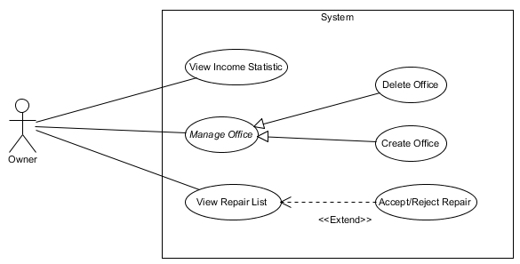

Figure : <Owner> Overview Use Case

##### <Owner> Create office

**Use Case Diagram**

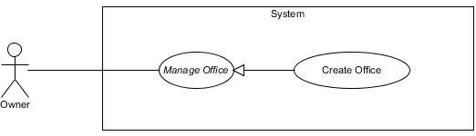

Figure : <Owner> Create Office

**Use Case Specification**

|  |  |  |  |  |
| --- | --- | --- | --- | --- |
| **USE CASE – CREATE OFFICE** | | | | |
| **Use-case No.** | UC025 | **Use-case Version** | | 2.0 |
| **Use-case Name** | Create Office | | | |
| **Author** | Lê Xuân Tiến | | | |
| **Date** | 25/05/2015 | **Priority** | Normal | |
| **Actor:**   * Owner   **Summary:**   * This usecase allow owner to create a new office.   **Goal**:   * Owner can add new office to system.   **Triggers:**   * Click “Thêm mới văn phòng” button.   **Preconditions:**   * User logged in successfully with Owner role.   **Post Conditions:**   * **Success:** A successful message will be displayed, new office will be added but can’t be access yet. Manager must improve to make office available * **Fail:** Display error message and cannot add new office to database.   **Main Success Scenario:**   |  |  |  | | --- | --- | --- | | Step | Actor Action | System Response | | 1 | Clicks “Thêm mới văn phòng” button on staff page. | Show the page with title “Thêm mới văn phòng”. The create office page includes 3 step:   * Step 1: Thông tin cơ bản, include: * Tên văn phòng: Text box (Name, length [3, 50], required) * Địa chỉ: Text box (Address, min length: 6, required) * Detail of address, include district and city, and the map of current address * Tiếp tục: button   [Exception 1, 2, 4] | | 2 | Enter information and click “Tiếp tục” | Display step 2:   * Step 2: Mô tả văn phòng * Mô tả văn phòng: Text area (Description, length [3, 500], required) * Hình ảnh: Add image button * List of image, each of image added has the “Xóa” button * Danh sách tiện nghi: Text box (amenities, tags with typeahead input * Loại văn phòng: Drop down list (Category, include “Văn phòng nguyên căn” and “Tòa nhà văn phòng”, required) * Số tầng: Text box (Floor, type number, required) * Tiện ích: Tags with typeahead input * Tổng diện tích: Text box (Area, type number, min: 10, required) * Thời gian thuê tối thiểu (tháng): Text box (area, type number, min 0, required) * Diện tích thuê tối thiểu: Text box (Min area, type number, min 0, max equal Area, required if category is “Tòa nhà văn phòng”) * “Tiếp tục” and “Quay lại” button   [Exception 1, 2, 3] | | 3 | Enter information and click “Tiếp tục”  [Alternative 1] | Display step 3:   * Step 3: Mô tả văn phòng   + Giá thuê gốc: text box, base price, number input, required * Tạo mới: button * Quay lại, Hủy: button   [Exception 1, 3] | | 2 | Inputs information and clicks “Tạo mới” button.  [Alternative 1] | Redirect office detail page. |   **Alternative Scenario:**   |  |  |  | | --- | --- | --- | | No | Actor Action | System Response | | 1 | Owner clicks “Quay lại” button | Go back to previous page | | 2 | Owner clicks “Hủy” button. | The data in all fields will be reset and redirect to staff page. |   **Exceptions:**   |  |  |  | | --- | --- | --- | | No | Actor Action | System Response | | 1 | The required input fields null | Shows error message “Mời nhập vào trường này” beside the input field | | 2 | The input length is not match | Shows error message “Mời nhập vào từ x tới y kí tự” beside the input field (x, y is min and max length) | | 3 | The input is not a valid number | Shows error message “Mời nhập vào số” beside input field | | 4 | The address selected is not from drop down list | Shows error message “Mời chọn địa chỉ từ danh sách” beside input field |   **Relationships:** Manage Office  **Business Rules:**   * The input number fields cannot input non-number characters * When select office type “Văn phòng nguyên căn”, the price term in “Giá thuê gốc” is “Nguyên căn/ tháng”, while type “Tòa nhà văn phòng”, the price term is: “m2 / tháng” * The amenity can be created freely by input field, but user can only search from pre-created amenity * The newly created office will in pending status, where user can’t search and view this office * Manager must review and accept this office for user available to view office | | | | |

Table : <Owner> Create Office

##### <Owner> Check Request Repair

**Use Case Diagram**

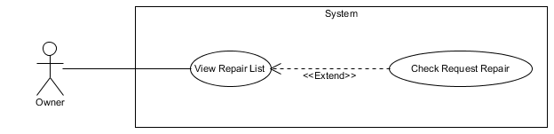

Figure : <Owner> Check Request Repair

**Use Case Specification**

|  |  |  |  |
| --- | --- | --- | --- |
| **USE CASE CHECK REQUEST REPAIR** | | | |
| **Use Case No.** | UC031 | **Use Case Version** | 1.0 |
| **Use Case Name** | Check Request Repair | | |
| **Author** | Trương Tiến Thành | | |
| **Date** | 13/09/2015 | **Priority** | Normal |
| **Actor:**   * Owner   **Summary:**   * This use case allows owner to accept or reject request repair of customer.   **Goal:**   * Owner can accept or reject the request repair.   **Triggers:**   * Click “Sửa chữa mới” in menu. * Choose one request and click “Chi tiết” icon.   **Preconditions:**   * User must log in the system with owner role. * At least there is one request repair.   **Post Conditions:**   * **Success:** The request has been accept or reject. * **Fail:** Cannot accept or reject the request.   **Main Success Scenario:**   |  |  |  | | --- | --- | --- | | Step | Actor Action | System Response | | 1 | Choose one request in the list and click “Chi tiết” icon. | Display information about the customer and detail of the request repair, include:   * Thông tin khách hàng: Label * Tên khách hàng: Text * Số điện thoại: Text. * Văn phòng đang thuê: Text * Địa chỉ văn phòng: Text * Ngày bắt đầu hợp đồng: Text * Ngày kết thúc hợp đồng: Text * Chi tiết yêu cầu sửa chữa: Label * Ngày tạo yêu cầu: Text * Mô tả yêu cầu: Text * Cần sửa chữa: List * Tình trạng: Text * Đồng ý sửa chữa: Button * Từ chối sửa chữa: Button | | 2 | Click “Đồng ý sửa chữa” button.  [Alternative 1] | Return to [Request repair list page] |   **Alternative Scenario:**   |  |  |  | | --- | --- | --- | | No | Actor Action | System Response | | 1 | Click “Từ chối sửa chữa” button. | Return to [Request repair list page] |   **Exceptions:** N/A  **Relationships:** View repair list  **Business Rules:**   * Customer can reject if the request repair of customer effect to his office. | | | |

Table : <Owner> Check Request Repair

## Software System Attribute

### Usability

* All the user interface will be display in Vietnamese
* Staff should need less than one training week to interact with system.

### Reliability

* Mean Time Between Failures is more than 6 months.
* Critical bugs: not any.
* SMS fail send rate should be less than 2 fail SMS per 100 sent.
* E-mail fail send rate should be less than 2 fail email per 1000 sent.
* Schedule should run every day since the web started

### Availability

* System has to run 24/7 to accept all request, so there will be recovery and backup for any exception.

### Security

* All input data should be validated before saving to database.
* User should be authenticated and authorized when accessing to the system.

### Maintainability

* The system should be divided into modules and code. It would be easy to maintain and upgrade.

### Portability

* The web page should be used on most browser on most OS
* The mobile application for staff can run on most Android smartphone which has version after 4.0

### Performance

* All requests should be response in no more than 1 minute.

## Conceptual Diagram

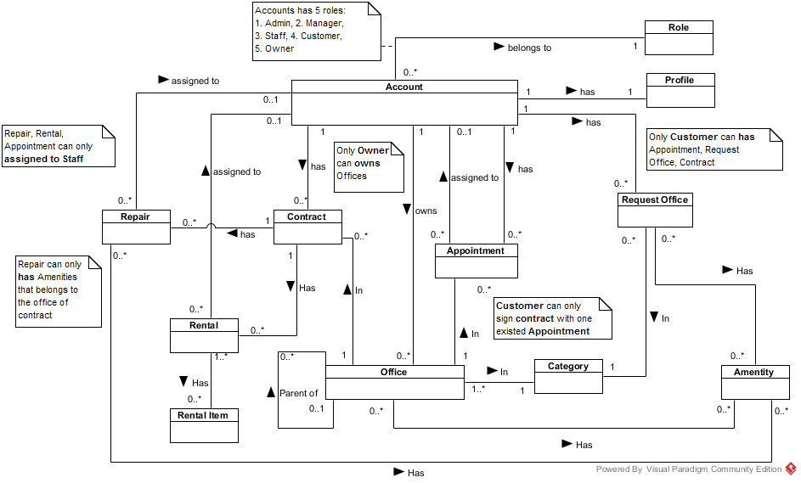

Figure : Conceptual Diagram

*This page is intentionally left blank*

**Data dictionary:**

|  |  |
| --- | --- |
| **Entity Data dictionary: describe content of all entities** | |
| **Entity Name** | **Description** |
| Account | Describe account of user of system. |
| Role | Describe account types of role |
| Profile | Describe the contact information for customer |
| Office | Describe information of the office |
| Category | Describe the category of the office |
| Amenity | Describe the amenities of the office |
| Appointment | Describe the information of the appointment of customer for the office |
| Contract | Describe the information of contract between customer and office |
| Request Office | Describe the stored office request of customer |
| Repair | Describe the repair request for each contract |
| Rental | Describe the rental request for contract |
| Rental Item | Describe the rental items which available for rental request |

# Report 4: Software Design Description

## Design Overview

This document describes the technical and user interface design of ORS System. It includes the architectural design, the detailed design of common functions and business functions and the design of database model.

The architectural design describes the overall architecture of the system and the architecture of each main component and subsystem.

The detailed design describes static and dynamic structure for each component and functions. It includes class diagrams, class explanations and sequence diagrams for each use cases.

The database design describes the relationships between entities and details of each entity.

Document overview:

* Section 2: gives an overall description of the system architecture design.
* Section 3: gives component diagrams that describe the connection and integration of the system.
* Section 4: gives the detail design description which includes class diagram, class explanation, and sequence diagram to details the application functions.
* Section 5: overview some main user interface of system.
* Section 6: describe fully attributed ERD.
* Section 7: describe in details all algorithms used in the system.

## System Architectural Design

The system is developed using MVC architecture, combine with front end – back end RESTful Web service interface architecture.

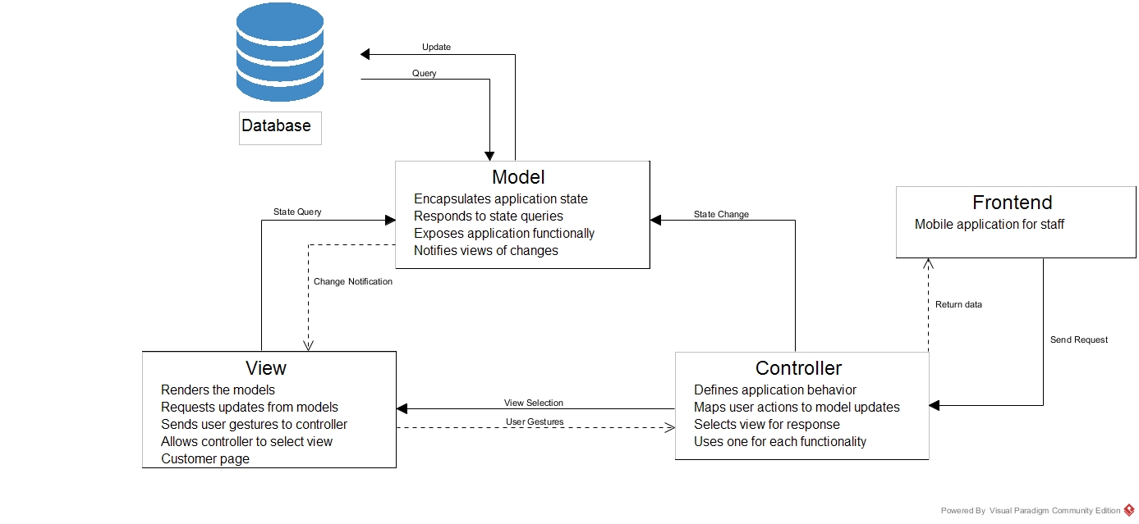

Figure : System architecture

* **Model:** The model manages the behavior and data of the application domain, responds to requests for information about its state (usually from the view), and responds to instructions to change state (usually from the controller).
* **View:** The view manages the display of information.
* **Controller**: The controller interprets the mouse and keyboard inputs from the user, informing the model and/or the view to change as appropriate.
* **Frontend**: Mobile application for staffs send and receive request through controller.

[<http://msdn.microsoft.com/en-us/library/ff649643.aspx> ]

## Component Diagram

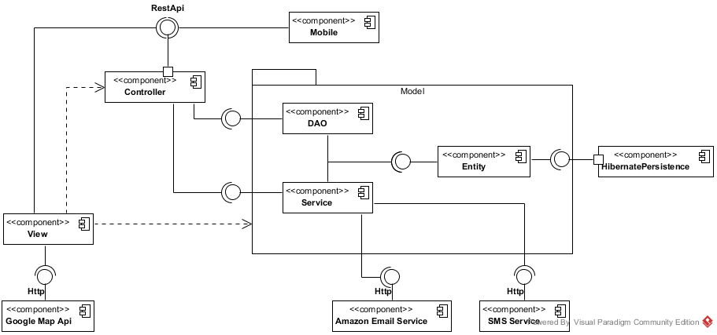

Figure : Component Diagram

|  |  |
| --- | --- |
| **Component dictionary: describe component** | |
| **Component Name** | **Description** |
| HibernatePersistence | Component provide by Hibernate to establish database connection |
| Entity | The database mapping classes component |
| DAO | Data Access Classes component, provide function to manipulate data |
| Service | Provide additional data manipulation and external data manipulation |
| Controller | Receive and handle the request from View, then call DAO/ Service to manipulate |
| View | Render the view for user |
| Mobile | The mobile application component |
| Google Map Api | The map component provide by Google |
| Amazon Email Service | The email service component provide by Amazon |
| SMS Service | The SMS service component provide by ESMS (<http://esms.vn/>) |

## Detailed Description Explanation

### Class Diagram

#### Entity Package Class Diagram

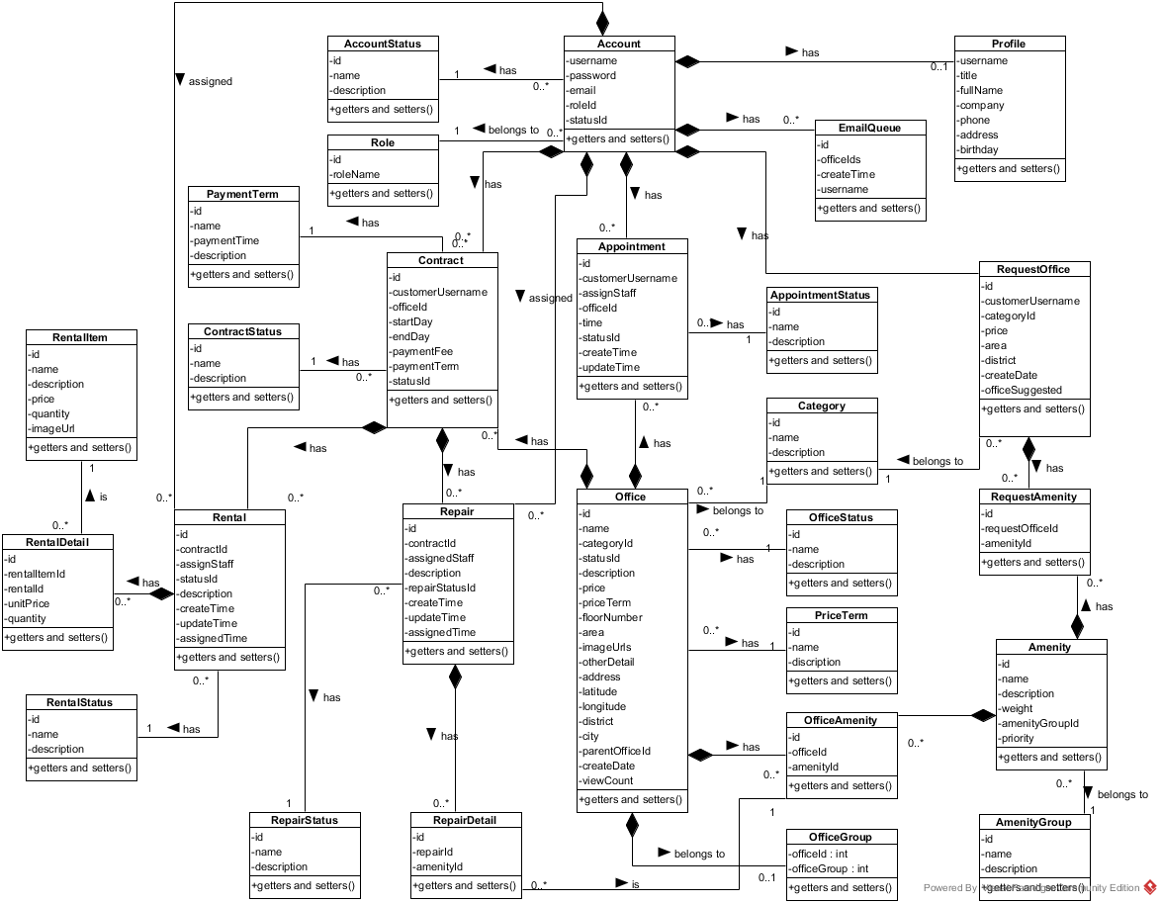

Figure : Class Diagram

*This page is intentionally left blank*

|  |  |
| --- | --- |
| **Class dictionary: describe Class** | |
| **Class Name** | **Description** |
| Account | Describe all accounts of users in the system. |
| AccountStatus | Describe status of account. One account has only one status. |
| Amenity | Describe all amenities in system. |
| AmenityGroup | Describe groups of amenity. One amenity is only in one group. |
| Appointment | Describe all appointment requests of customer. |
| AppointmentStatus | Describe status of appointment request. One appointment has only one status. |
| Category | Describe category of office. One office is only in one category. |
| Contract | Describe all contracts in the system. |
| ContractStatus | Describe status of contract. One contract has only one status. |
| EmailQueue | Describe all emails have to send to customer in the system. |
| Office | Describe all offices in the system. |
| OfficeAmenity | Describe all amenities in one office. One office can have more than one amenity. |
| OfficeGroup | Describe group of the office for searching office. One office is only in one group |
| OfficeStatus | Describe status of the office. One office has only one status. |
| PaymentTerm | Describe time for the payment |
| Price Term | Describe the way that money is calculated base on. |
| Profile | Describe information of the account |
| Rental | Describe all rental requests from customer |
| RentalDetail | Describe all rental items for one rental request |
| RentalItem | Describe all rental items in system |
| RentalStatus | Describe status of rental request. One rental request has only one status. |
| Repair | Describe all repair requests from customer |
| RepairDetail | Describe all amenities need to repair for one repair request |
| RepairStatus | Describe status of repair request. One repair request has only one status. |
| RequestAmenity | Describe all amenities in one request office |
| RequestOffice | Describe all requests office from customer |
| Role | Describe role of account. One account has only one role. |

**Status Explanation**

**Account Status**

|  |  |  |
| --- | --- | --- |
| **Id** | **Status** | **Description** |
| 1 | Normal | A normal account which can login and interact with the system |
| 2 | Banned | An account has been banned by admin, and cannot interact with the system, but can be unban to normal status |
| 3 | Deleted | An account has been deleted from the system, and no longer be accessed |
| 4 | Created | A newly register account. Can only interact with the system after confirm email |

**Appointment Status**

|  |  |  |
| --- | --- | --- |
| **Id** | **Status** | **Description** |
| 1 | Pending | A newly created appointment by customer |
| 2 | Assigned | The pending appointment has been assigned to a staff by manager |
| 3 | Accepted | The assigned appointment has been accepted by customer |
| 4 | Done | The accepted appointment has been created a contract by manager |
| 5 | Rejected | The assigned appointment has been rejected by customer, or the accepted appointment has not been created a contract |

**Appointment Status**

|  |  |  |
| --- | --- | --- |
| **Id** | **Status** | **Description** |
| 1 | Pending | A newly created appointment by customer |
| 2 | Assigned | The pending appointment has been assigned to a staff by manager |
| 3 | Accepted | The assigned appointment has been accepted by customer |
| 4 | Done | The accepted appointment has been created a contract by manager |
| 5 | Rejected | The assigned appointment has been rejected by customer, or the accepted appointment has not been created a contract |

**Rental Status**

|  |  |  |
| --- | --- | --- |
| **Id** | **Status** | **Description** |
| 1 | Requested | A newly created rental request by customer |
| 2 | Assigned | The requested rental has been assigned to a staff by manager |
| 3 | Done | The rental has been confirm by customer |
| 4 | Rejected | The rental has been rejected by manager |
| 5 | Waiting Confirm | The assigned rental has been accepted by staff and wait for customer confirm |

**Repair Status**

|  |  |  |
| --- | --- | --- |
| **Id** | **Status** | **Description** |
| 1 | Requested | A newly created repair request by customer |
| 2 | Accepted | The repair has been accepted by owner |
| 3 | Done | The repair has been confirm by customer |
| 4 | Rejected | The repair has been rejected by owner or manager |
| 5 | Waiting Confirm | The assigned rental has been assign to staff and wait for customer confirm |

**Office Status**

|  |  |  |
| --- | --- | --- |
| **Id** | **Status** | **Description** |
| 1 | Available | An office has not been rented by customer |
| 2 | Occupied | An office has been rented by customer |
| 3 | Deleted | An office has been deleted by owner or manager |
| 4 | Created | The newly created office by owner, and wait for manager confirm |

**Contract Status**

|  |  |  |
| --- | --- | --- |
| **Id** | **Status** | **Description** |
| 1 | Available | An contract has been created and available for use |
| 2 | Extend Requested | An contract has a extend request from customer |
| 3 | Cancel Requested | An contract has a cancel request from customer |
| 4 | Expire | An contract has been expired or canceled |

**Class Diagram Explanation**

##### RepairStatus

Attribute

|  |  |  |  |
| --- | --- | --- | --- |
| **Attribute** | **Type** | **Visibility** | **Description** |
| id | int | private | The id of the status of repair |
| name | String | private | The name of the status of repair |
| description | String | private | The description of the status of repair |

Method

|  |  |  |  |
| --- | --- | --- | --- |
| **Attribute** | **Type** | **Visibility** | **Description** |
| getters | attribute type | public | Get the respective attribute value |
| setters | void | public | Set the respective attribute with the value |

##### RepairDetail

Attribute

|  |  |  |  |
| --- | --- | --- | --- |
| **Attribute** | **Type** | **Visibility** | **Description** |
| id | int | private | The id of the repair detail |
| repairId | int | private | The id of the repair |
| amenityId | int | private | The id of the amenity |

Method

|  |  |  |  |
| --- | --- | --- | --- |
| **Attribute** | **Type** | **Visibility** | **Description** |
| getters | attribute type | public | Get the respective attribute value |
| setters | void | public | Set the respective attribute with the value |

##### Repair

Attribute

|  |  |  |  |
| --- | --- | --- | --- |
| **Attribute** | **Type** | **Visibility** | **Description** |
| id | int | private | The id of the repair |
| contractId | int | private | The id of the repair |
| assignedStaff | String | private | Username of staff who responsibility for this repair request |
| repairStatusId | int | private | The id of the status of repair |
| description | String | private | The description of the repair request |
| createTime | Timestamp | private | Time when customer create this repair request |
| updateTime | Timestamp | private | Time when manger or staff change status |
| assignedTime | Timestamp | private | Time when manager assign to staff |

Method

|  |  |  |  |
| --- | --- | --- | --- |
| **Attribute** | **Type** | **Visibility** | **Description** |
| getters | attribute type | public | Get the respective attribute value |
| setters | void | public | Set the respective attribute with the value |

##### PaymentTerm

Attribute

|  |  |  |  |
| --- | --- | --- | --- |
| **Attribute** | **Type** | **Visibility** | **Description** |
| id | int | private | The id of the payment term |
| name | String | private | The name of the payment term |
| paymentTime | int | private | Number months of the payment |
| description | String | private | The description of payment term |

Method

|  |  |  |  |
| --- | --- | --- | --- |
| **Attribute** | **Type** | **Visibility** | **Description** |
| getters | attribute type | public | Get the respective attribute value |
| setters | void | public | Set the respective attribute with the value |

##### ContractStatus

Attribute

|  |  |  |  |
| --- | --- | --- | --- |
| **Attribute** | **Type** | **Visibility** | **Description** |
| id | int | private | The id of the contract status |
| name | String | private | The name of the contract status |
| description | String | private | The description of the contract status |

Method

|  |  |  |  |
| --- | --- | --- | --- |
| **Attribute** | **Type** | **Visibility** | **Description** |
| getters | attribute type | public | Get the respective attribute value |
| setters | void | public | Set the respective attribute with the value |

##### Contract

Attribute

|  |  |  |  |
| --- | --- | --- | --- |
| **Attribute** | **Type** | **Visibility** | **Description** |
| id | int | private | The id of the contract |
| customerUsername | String | private | Username of customer |
| officeId | int | private | The id of the office |
| startDate | date | private | Date when contract starts |
| endDate | date | private | Date when contract ends |
| paymentFee | int | private | Payment fee for the contract |
| paymentTerm | int | private | Payment term for the contract |
| statusId | int | private | The id of contract status |

Method

|  |  |  |  |
| --- | --- | --- | --- |
| **Attribute** | **Type** | **Visibility** | **Description** |
| getters | attribute type | public | Get the respective attribute value |
| setters | void | public | Set the respective attribute with the value |

##### OfficeStatus

Attribute

|  |  |  |  |
| --- | --- | --- | --- |
| **Attribute** | **Type** | **Visibility** | **Description** |
| id | int | private | The id of the office status |
| name | String | private | The name of the office status |
| description | String | private | The description of the office status |

Method

|  |  |  |  |
| --- | --- | --- | --- |
| **Attribute** | **Type** | **Visibility** | **Description** |
| getters | attribute type | public | Get the respective attribute value |
| setters | void | public | Set the respective attribute with the value |

##### OfficeGroup

Attribute

|  |  |  |  |
| --- | --- | --- | --- |
| **Attribute** | **Type** | **Visibility** | **Description** |
| officeId | int | private | The id of the office |
| officeGroup | int | private | Group of office for searching |

Method

|  |  |  |  |
| --- | --- | --- | --- |
| **Attribute** | **Type** | **Visibility** | **Description** |
| getters | attribute type | public | Get the respective attribute value |
| setters | void | public | Set the respective attribute with the value |

##### PriceTerm

Attribute

|  |  |  |  |
| --- | --- | --- | --- |
| **Attribute** | **Type** | **Visibility** | **Description** |
| id | int | private | The id of the price term |
| name | String | private | The name of the price term |
| description | String | private | The description of the price term |

Method

|  |  |  |  |
| --- | --- | --- | --- |
| **Attribute** | **Type** | **Visibility** | **Description** |
| getters | attribute type | public | Get the respective attribute value |
| setters | void | public | Set the respective attribute with the value |

##### EmailQueue

Attribute

|  |  |  |  |
| --- | --- | --- | --- |
| **Attribute** | **Type** | **Visibility** | **Description** |
| id | int | private | The id of the email queue |
| username | String | private | Username of the customer |
| officeIds | String | private | The id of list office that system suggests to customer |
| createTime | date | private | Time when customer create request |

Method

|  |  |  |  |
| --- | --- | --- | --- |
| **Attribute** | **Type** | **Visibility** | **Description** |
| getters | attribute type | public | Get the respective attribute value |
| setters | void | public | Set the respective attribute with the value |

##### Office

Attribute

|  |  |  |  |
| --- | --- | --- | --- |
| **Attribute** | **Type** | **Visibility** | **Description** |
| id | int | private | The id of the office |
| name | String | private | The name of the office |
| categoryId | int | private | The id of the category |
| statusId | int | private | The id of the status office |
| description | String | private | The description of the office |
| price | long | private | The price of the office |
| priceTerm | int | private | The price term of the office |
| floorNumber | int | private | The number of floor in the office |
| area | double | private | The area of the office |
| imageUrls | String | private | Link of the images of office |
| otherDetail | String | private | Some detail of the office |
| address | String | private | The address of the office |
| latitude | Double | private | Latitude of the office |
| longitude | Double | private | Longitude of the office |
| district | String | private | The district of the office |
| city | String | private | The city of the office |
| parentOfficeId | int | private | The parent office id of the office |
| createDate | Timestamp | private | Date when office create in database |
| viewCount | int | private | Number views when customer see detail of office |

Method

|  |  |  |  |
| --- | --- | --- | --- |
| **Attribute** | **Type** | **Visibility** | **Description** |
| getters | attribute type | public | Get the respective attribute value |
| setters | void | public | Set the respective attribute with the value |

##### Appointment

Attribute

|  |  |  |  |
| --- | --- | --- | --- |
| **Attribute** | **Type** | **Visibility** | **Description** |
| id | int | private | The id of the appointment |
| customerUsername | String | private | The username of customer |
| assignedStaff | String | private | Staff who is responsibility for the appointment |
| officeId | int | private | Office where customer want to make appointment |
| time | Timestamp | private | Time for appointment |
| statusId | int | private | The status of the appointment |
| createTime | Timestamp | private | Time when customer create appointment |
| updateTime | Timestamp | private | Time when manager update the appointment |

Method

|  |  |  |  |
| --- | --- | --- | --- |
| **Attribute** | **Type** | **Visibility** | **Description** |
| getters | attribute type | public | Get the respective attribute value |
| setters | void | public | Set the respective attribute with the value |

##### Account

Attribute

|  |  |  |  |
| --- | --- | --- | --- |
| **Attribute** | **Type** | **Visibility** | **Description** |
| username | String | private | Unique identifier of an account |
| password | String | private | Password for login to system |
| email | String | private | Email of this account |
| roleId | int | private | Role of this account |
| statusId | int | private | Status of this account |

Method

|  |  |  |  |
| --- | --- | --- | --- |
| **Attribute** | **Type** | **Visibility** | **Description** |
| getters | attribute type | public | Get the respective attribute value |
| setters | void | public | Set the respective attribute with the value |

##### AccountStatus

Attribute

|  |  |  |  |
| --- | --- | --- | --- |
| **Attribute** | **Type** | **Visibility** | **Description** |
| id | int | private | The id of an account status |
| name | String | private | The name of this status |
| description | String | private | The description for this status |

Method

|  |  |  |  |
| --- | --- | --- | --- |
| **Attribute** | **Type** | **Visibility** | **Description** |
| getters | attribute type | public | Get the respective attribute value |
| setters | void | public | Set the respective attribute with the value |

##### Role

Attribute

|  |  |  |  |
| --- | --- | --- | --- |
| **Attribute** | **Type** | **Visibility** | **Description** |
| id | int | private | The id of a role |
| roleName | String | private | The name of role |

Method

|  |  |  |  |
| --- | --- | --- | --- |
| **Attribute** | **Type** | **Visibility** | **Description** |
| getters | attribute type | public | Get the respective attribute value |
| setters | void | public | Set the respective attribute with the value |

##### Profile

Attribute

|  |  |  |  |
| --- | --- | --- | --- |
| **Attribute** | **Type** | **Visibility** | **Description** |
| username | String | private | The id of an account |
| title | String | private | Gender of the profile |
| fullName | String | private | Full name of this profile |
| company | String | private | Company of this profile |
| phone | String | private | Phone of this profile |
| address | String | private | Address of this profile |
| birthday | Timestamp | private | Birthday of this profile |

Method

|  |  |  |  |
| --- | --- | --- | --- |
| **Attribute** | **Type** | **Visibility** | **Description** |
| getters | attribute type | public | Get the respective attribute value |
| setters | void | public | Set the respective attribute with the value |

##### AppointmentStatus

Attribute

|  |  |  |  |
| --- | --- | --- | --- |
| **Attribute** | **Type** | **Visibility** | **Description** |
| id | int | private | The id of an appointment status |
| name | String | private | The name of appointment status |
| description | String | private | The description for appointment status |

Method

|  |  |  |  |
| --- | --- | --- | --- |
| **Attribute** | **Type** | **Visibility** | **Description** |
| getters | attribute type | public | Get the respective attribute value |
| setters | void | public | Set the respective attribute with the value |

##### Category

Attribute

|  |  |  |  |
| --- | --- | --- | --- |
| **Attribute** | **Type** | **Visibility** | **Description** |
| id | int | private | The id of category |
| name | String | private | The name of category |
| description | String | private | The description of category |

Method

|  |  |  |  |
| --- | --- | --- | --- |
| **Attribute** | **Type** | **Visibility** | **Description** |
| getters | attribute type | public | Get the respective attribute value |
| setters | void | public | Set the respective attribute with the value |

##### OfficeAmentity

Attribute

|  |  |  |  |
| --- | --- | --- | --- |
| **Attribute** | **Type** | **Visibility** | **Description** |
| id | int | private | The id of office amenity |
| officeId | int | private | The id of office |
| amentityId | int | private | The id of amenity |

Method

|  |  |  |  |
| --- | --- | --- | --- |
| **Attribute** | **Type** | **Visibility** | **Description** |
| getters | attribute type | public | Get the respective attribute value |
| setters | void | public | Set the respective attribute with the value |

##### Rental

Attribute

|  |  |  |  |
| --- | --- | --- | --- |
| **Attribute** | **Type** | **Visibility** | **Description** |
| id | int | private | The id of rental |
| contractId | int | private | The id of contract |
| assignStaff | String | private | Username of staff who responsibility for this rental request |
| statusId | int | private | The status id of this rental request |
| description | String | private | The description of rental |
| createTime | Timestamp | private | Time when customer create this rental request |
| updateTime | Timestamp | private | Time when manger or staff change status |
| assignedTime | Timestamp | private | Time when manager assign to staff |

Method

|  |  |  |  |
| --- | --- | --- | --- |
| **Attribute** | **Type** | **Visibility** | **Description** |
| getters | attribute type | public | Get the respective attribute value |
| setters | void | public | Set the respective attribute with the value |

##### RequestOffice

Attribute

|  |  |  |  |
| --- | --- | --- | --- |
| **Attribute** | **Type** | **Visibility** | **Description** |
| id | int | private | The id of the request office |
| customerUsername | String | private | Username of customer |
| categoryId | int | private | The id of category |
| price | int | private | Price of the office |
| area | int | private | Area of the office |
| district | int | private | District of the office |
| createTime | Timestamp | private | Time when customer create this rental request |
| scheduleDate | Timestamp | private | Date when system check this request |
| OfficeSuggested | String | private | List offices that are suitable with request |

Method

|  |  |  |  |
| --- | --- | --- | --- |
| **Attribute** | **Type** | **Visibility** | **Description** |
| getters | attribute type | public | Get the respective attribute value |
| setters | void | public | Set the respective attribute with the value |

##### RequestAmenity

Attribute

|  |  |  |  |
| --- | --- | --- | --- |
| **Attribute** | **Type** | **Visibility** | **Description** |
| id | int | private | The id of request amenity |
| requestOfficeId | int | private | The id of request office |
| amentityId | int | private | The id of amenity |

Method

|  |  |  |  |
| --- | --- | --- | --- |
| **Attribute** | **Type** | **Visibility** | **Description** |
| getters | attribute type | public | Get the respective attribute value |
| setters | void | public | Set the respective attribute with the value |

##### Amenity

Attribute

|  |  |  |  |
| --- | --- | --- | --- |
| **Attribute** | **Type** | **Visibility** | **Description** |
| id | int | private | The id of amenity |
| name | String | private | Name of this amenity |
| description | String | private | Description for this amenity |
| weight | int | private | Weight of amenity in one group |
| amenityGroupId | int | private | Group of this amenity |
| priority | int | private | Priority of amenity in one group |

Method

|  |  |  |  |
| --- | --- | --- | --- |
| **Attribute** | **Type** | **Visibility** | **Description** |
| getters | attribute type | public | Get the respective attribute value |
| setters | void | public | Set the respective attribute with the value |

##### AmenityGroup

Attribute

|  |  |  |  |
| --- | --- | --- | --- |
| **Attribute** | **Type** | **Visibility** | **Description** |
| id | int | private | The id of amenity group |
| name | String | private | Name of amenity group |
| description | String | private | Description for amenity group |

Method

|  |  |  |  |
| --- | --- | --- | --- |
| **Attribute** | **Type** | **Visibility** | **Description** |
| getters | attribute type | public | Get the respective attribute value |
| setters | void | public | Set the respective attribute with the value |

##### RentalStatus

Attribute

|  |  |  |  |
| --- | --- | --- | --- |
| **Attribute** | **Type** | **Visibility** | **Description** |
| id | int | private | The id of the status of rental |
| name | String | private | The name of the status of rental |
| description | String | private | The description of the status of rental |

Method

|  |  |  |  |
| --- | --- | --- | --- |
| **Attribute** | **Type** | **Visibility** | **Description** |
| getters | attribute type | public | Get the respective attribute value |
| setters | void | public | Set the respective attribute with the value |

##### RentalItem

Attribute

|  |  |  |  |
| --- | --- | --- | --- |
| **Attribute** | **Type** | **Visibility** | **Description** |
| id | int | private | The id of rental item |
| name | String | private | Name of the item |
| description | String | private | Description for the item |
| price | double | private | Price of the item |
| quantity | int | private | Quantity of the item |
| imageUrl | String | private | Link image of the item |

Method

|  |  |  |  |
| --- | --- | --- | --- |
| **Attribute** | **Type** | **Visibility** | **Description** |
| getters | attribute type | public | Get the respective attribute value |
| setters | void | public | Set the respective attribute with the value |

##### RentalDetail

Attribute

|  |  |  |  |
| --- | --- | --- | --- |
| **Attribute** | **Type** | **Visibility** | **Description** |
| id | int | private | The id of rental detail |
| rentalItemId | int | private | Item rental for the rental request |
| rentalId | int | private | Id of request rental |
| unitPrice | double | private | Price of one item |
| quantity | int | private | Quantity of rental item for the rental request |

Method

|  |  |  |  |
| --- | --- | --- | --- |
| **Attribute** | **Type** | **Visibility** | **Description** |
| getters | attribute type | public | Get the respective attribute value |
| setters | void | public | Set the respective attribute with the value |

#### DAO Package Class Diagram

<Refer CD:\Capstone_ORS\Full_report.docx>

#### Service Package Class Diagram

<Refer CD:\Capstone_ORS\Full_report.docx>

#### Controller Package Class Diagram

<Refer CD:\Capstone_ORS\Full_report.docx>

#### Mobile Package Class Diagram

<Refer CD:\Capstone_ORS\Full_report.docx>

### Interaction Diagram

#### Guest Sequence Diagram

##### <Guest> Register

**Summary:** This diagram used to describe the process of guest register account

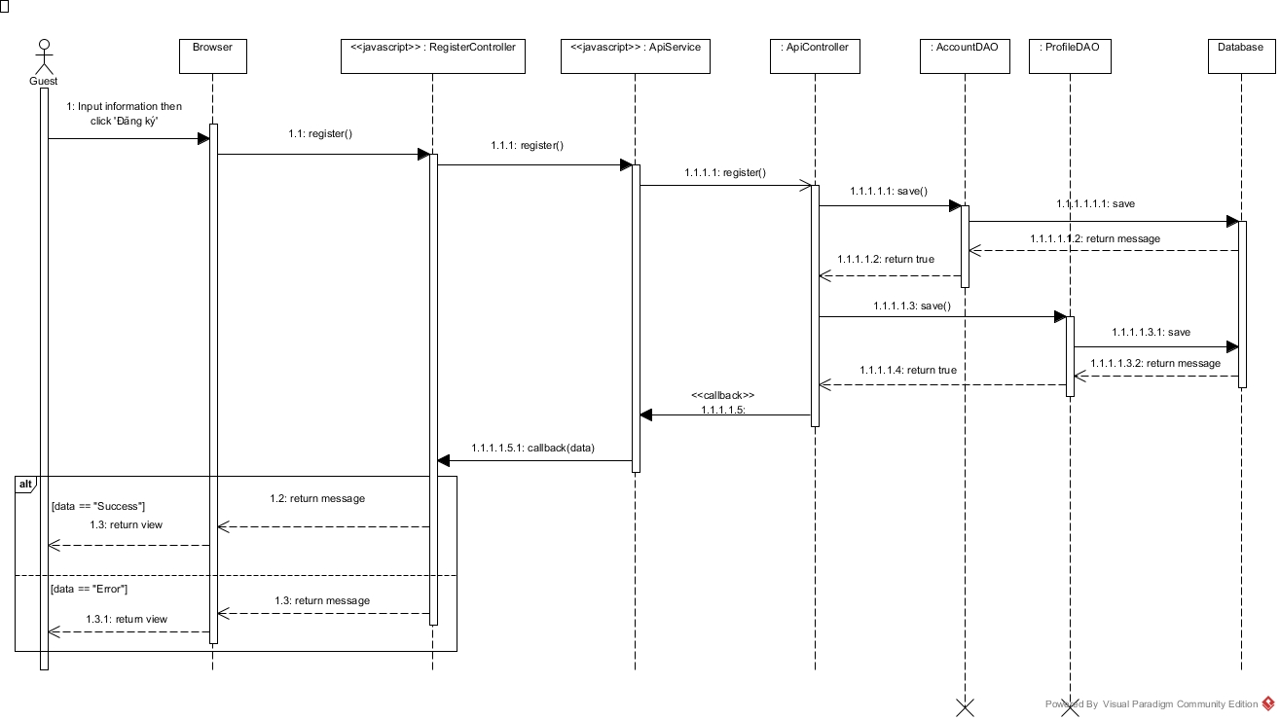

Figure 25: Register Sequence Diagram

##### <Guest, Customer> Search office

**Summary:** This diagram used to describe the process of guest search for offices

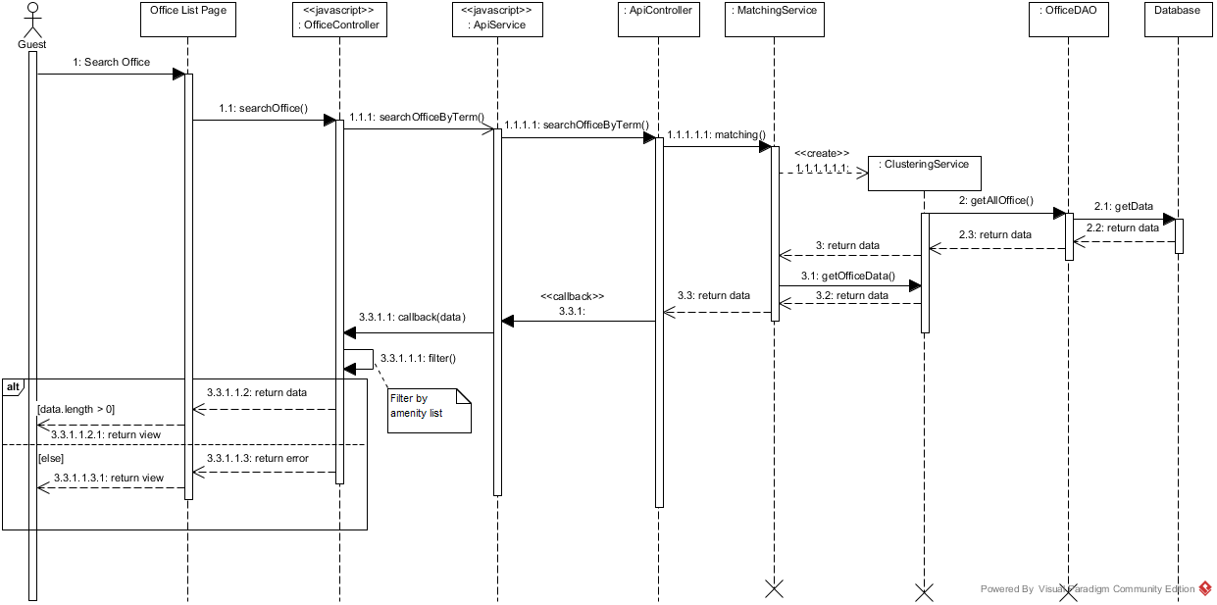

Figure : Search Office Sequence Diagram

##### <Guest, Customer > View office detail

<Refer CD:\Capstone_ORS\Full_report.docx>

#### Customer Sequence Diagrams

##### <Customer> Create Office Request

**Summary:** This diagram used to describe the process of customer create office request

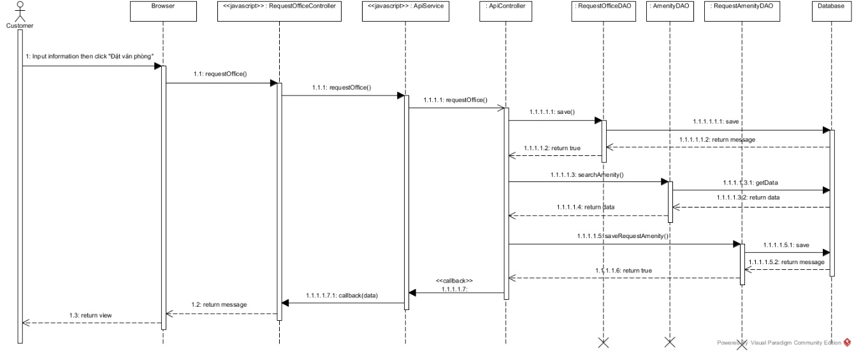

Figure 8: Create Office Request Sequence Diagram

##### <Customer> Request Repair

**Summary:** This diagram used to describe the process of customer request repair office

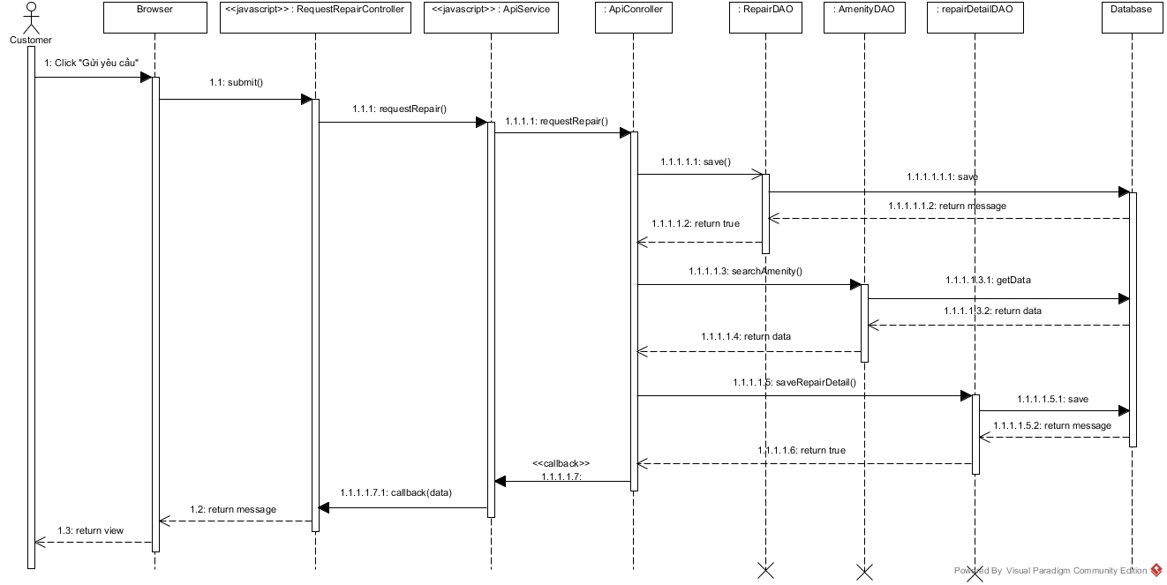

Figure : Request Repair Sequence Diagram

##### <Customer> View Contract Detail

**Summary:** This diagram used to describe the process of customer view contract detail

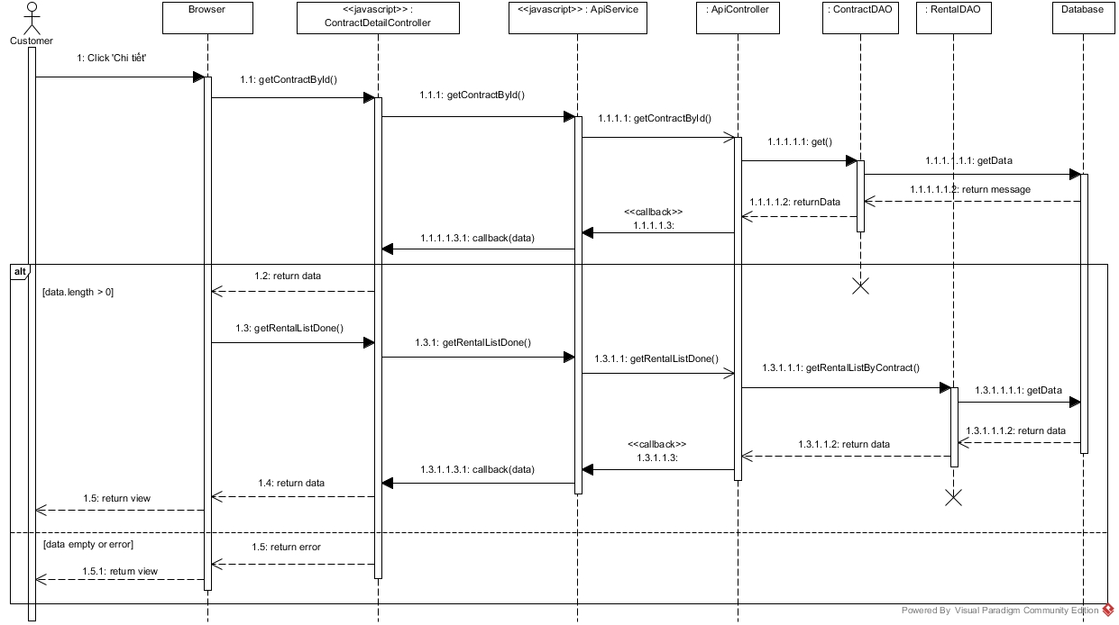

Figure 30: View Contract Detail Sequence Diagram

##### <Customer> View Result Request Office

**Summary:** This diagram used to describe the process of customer create office request

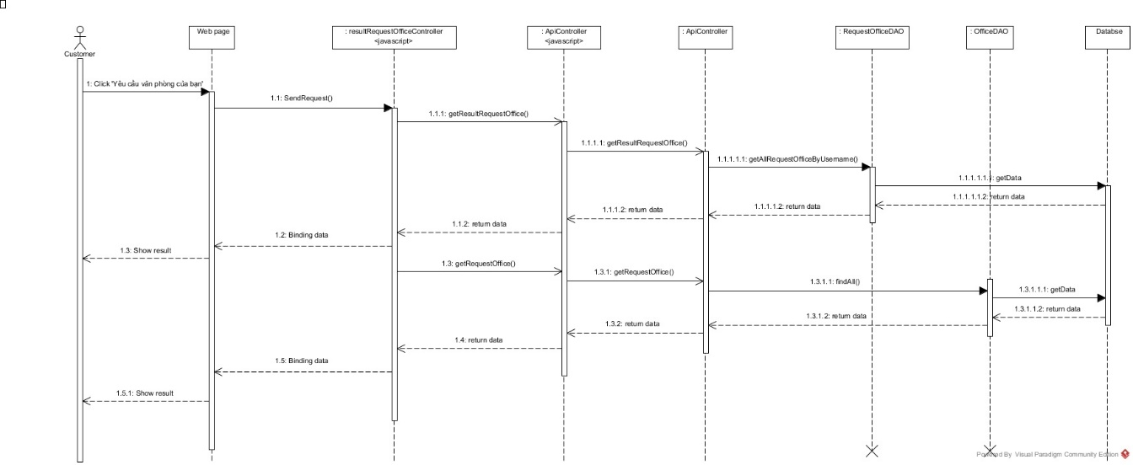

Figure 8: View Result Request Office Sequence Diagram

**The other sequence diagram of customer can be found at:** CD:\Capstone_ORS\ Full_report.docx:

* Create Appointment Request
* Request Extend Contract
* Request Return Contract
* Request Rental
* View Customer Info
* View List Contract
* View List Repair History
* View Rental Request List
* Change Password
* Edit Customer Info

#### Owner Sequence Diagram

##### <Owner> Create New Office

**Summary:** This diagram used to describe the process of owner create new office.

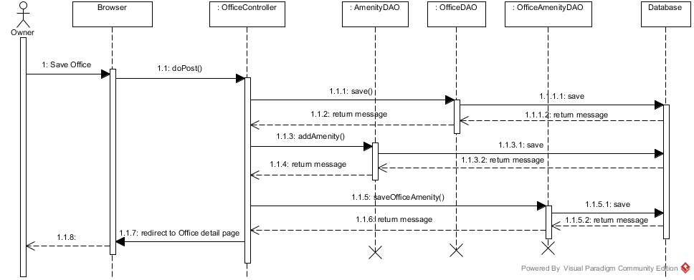

Figure : Create New Office Sequence Diagram

##### <Owner> Check Request Repair

**Summary:** This diagram used to describe the process of owner check request repair

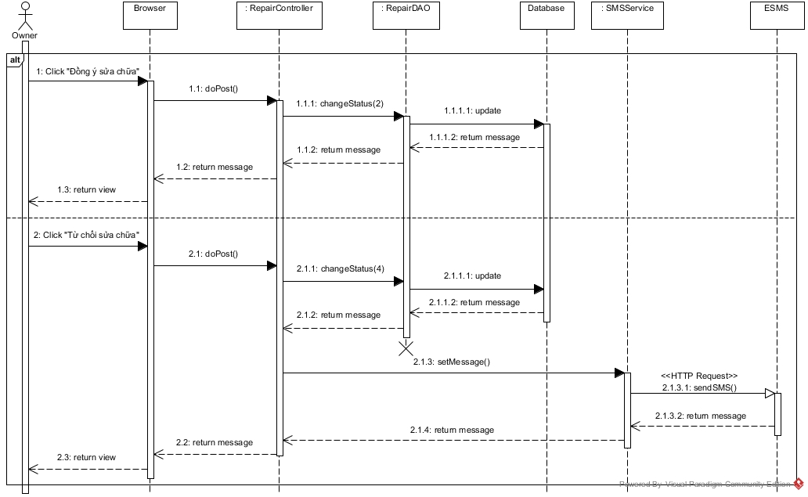

Figure : Check Request Repair Sequence Diagram

#### Staff Sequence Diagram

**The sequence diagram of staff can be found at:** CD:\Capstone_ORS\ Full_report.docx:

* View Assigned Repair Request List
* Change Repair Status
* View Assigned Rental Request List
* Change Rental Status
* View Assigned Appointment
* View customer profile

#### Manager Sequence Diagram

##### <Manager> Assign Appointment

**Summary:** This diagram used to describe the process of manager assign appointment requests to staff.

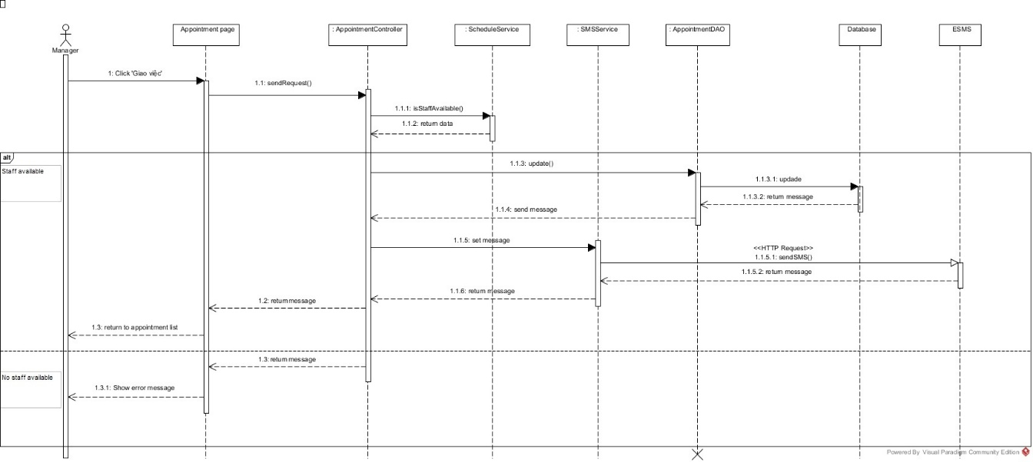

Figure : Assign Appointment Sequence Diagram

##### <Manager> Create Contract

**Summary:** This diagram used to describe the process of manager create contract

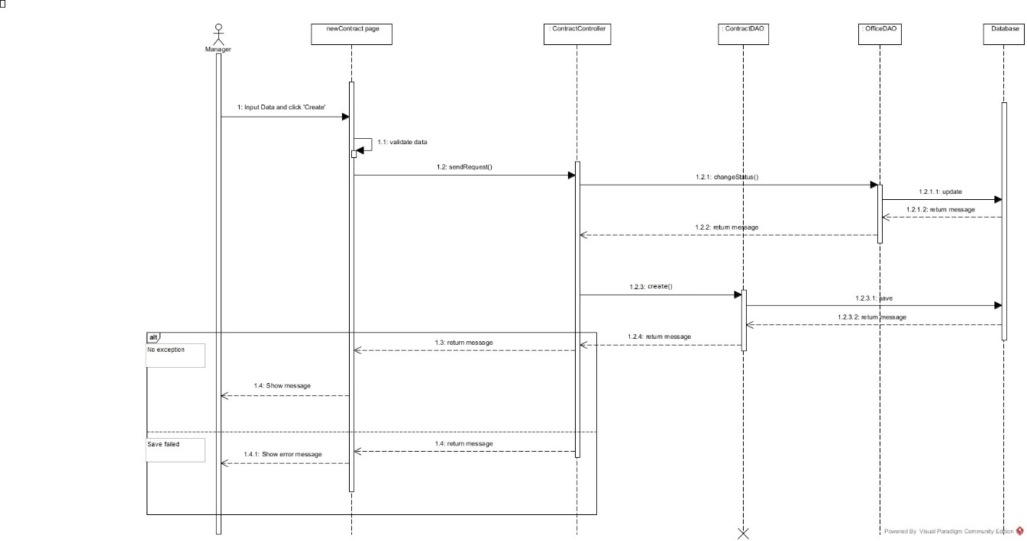

Figure : Create Contract Sequence Diagram

##### <Manager> View Calendar

**Summary:** This diagram used to describe the process of system suggest request office to customer.

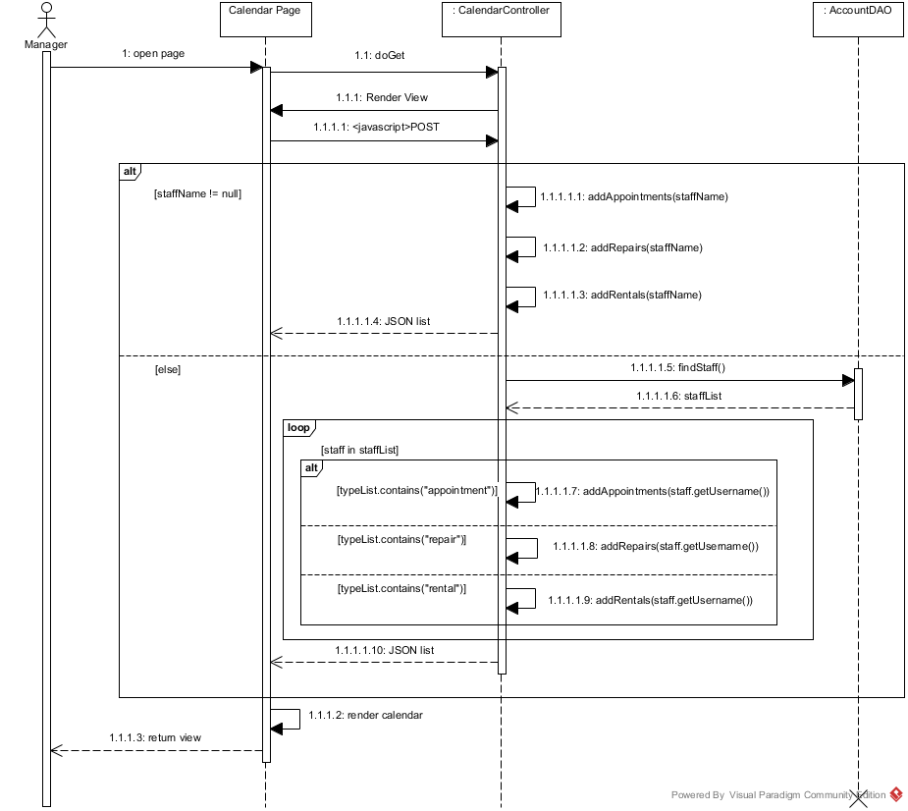

Figure : View Calendar Sequence Diagram

##### <Manager, Staff> Create Rental Item

**Summary:** This diagram used to describe the process of manager or staff create rental item

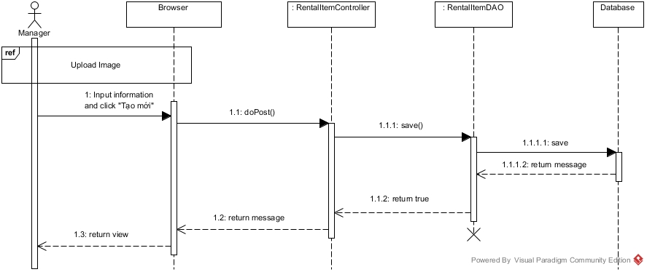

Figure : Create Rental Item Sequence Diagram

##### <Manager, Staff, Owner> Upload Image

**Summary:** This diagram used to describe the process of manager, staff and owner upload image.

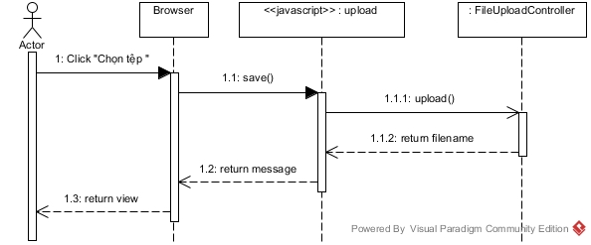

Figure 31: Upload Image Sequence Diagram

**The other sequence diagrams of manager can be found at:** CD:\Capstone_ORS\ Full_report.docx:

* Cancel Appointment Request
* View Contract List
* View Contract Detail
* Edit Contract
* View Request Extend List
* Accept/ Cancel Extend Request
* View Request Return Contract
* Accept/ Cancel Return Request
* Assign Repair
* Cancel Repair Request
* View Rental Request List
* Assign Rental
* Create Amenity Group
* Create Amenity
* View Staff Statistic
* View Income Statistic
* Edit Rental Item
* Logout

#### Admin Sequence Diagram

**The sequence diagrams of admin can be found at:** CD:\Capstone_ORS\ Full_report.docx:

* View Account List
* Create Account
* Delete Account
* Edit Account
* Ban Account
* Unban Account

#### System Sequence Diagram

##### <System> Check Contract Due Date

**Summary:** This diagram used to describe the process of system check contract due date.

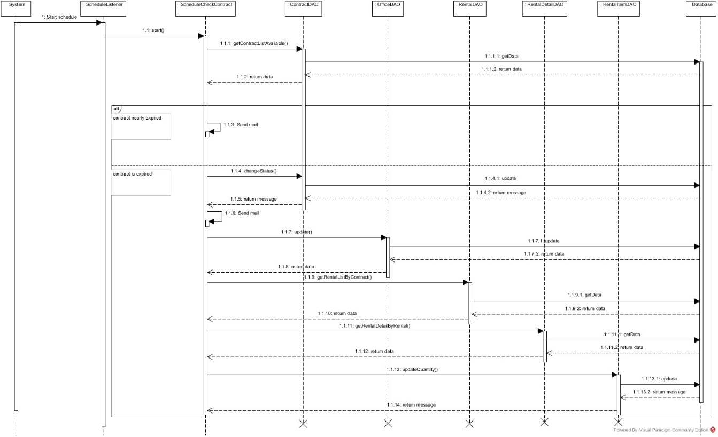

Figure : Check Contract Due Date Sequence Diagram

##### <System> Check Appointment Due Date

**Summary:** This diagram used to describe the process of system check contract due date.

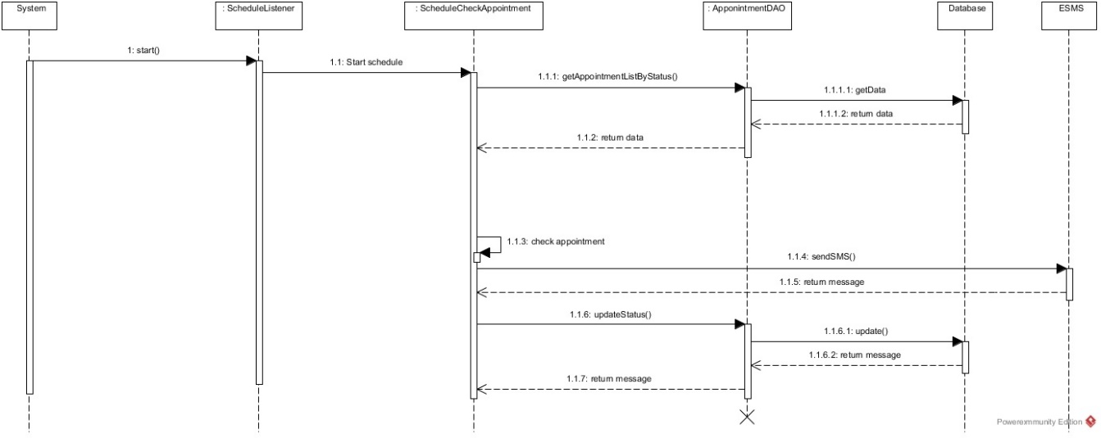

Figure : Check Appointment Due Date Sequence Diagram

##### <System> Check and send activate email

**Summary:** This diagram used to describe the process of system automatically send confirm and welcome email to newly registered customer.

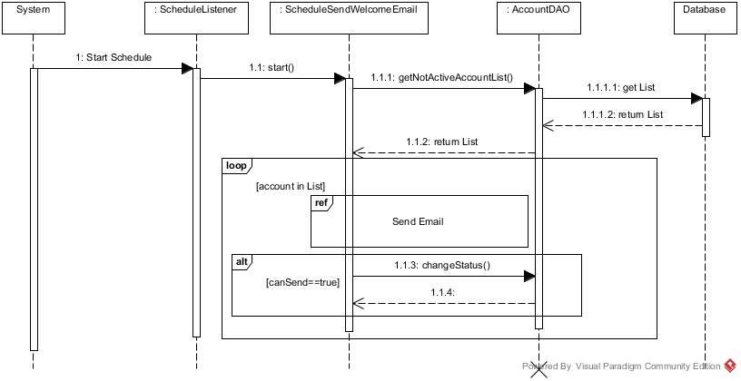

Figure : Check and send activate email

##### <System> Send email

**Summary:** This diagram used to describe the process of system send an email to the customer. The bellow diagram show the process of sending a welcome email only.

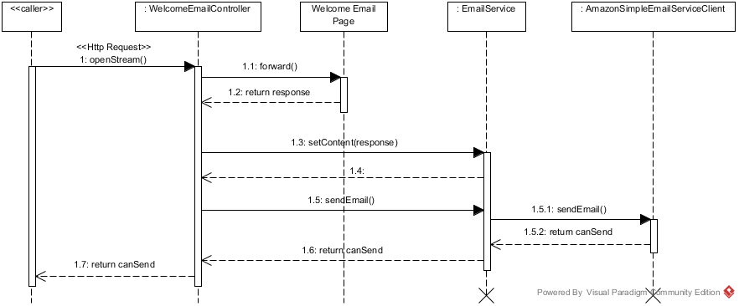

Figure : Send email

##### <System> Suggest Request Office

**Summary:** This diagram used to describe the process of system suggest request office to customer.

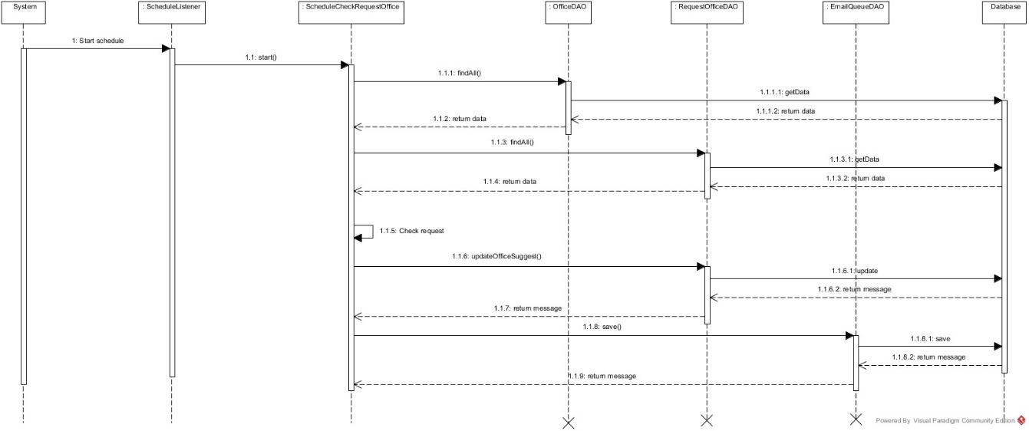

Figure : Suggest Request Office Sequence Diagram

##### <System> Clustering Office

**Summary:** This diagram used to describe the process of system clustering the office to group. The trigger of this is an office created or updated

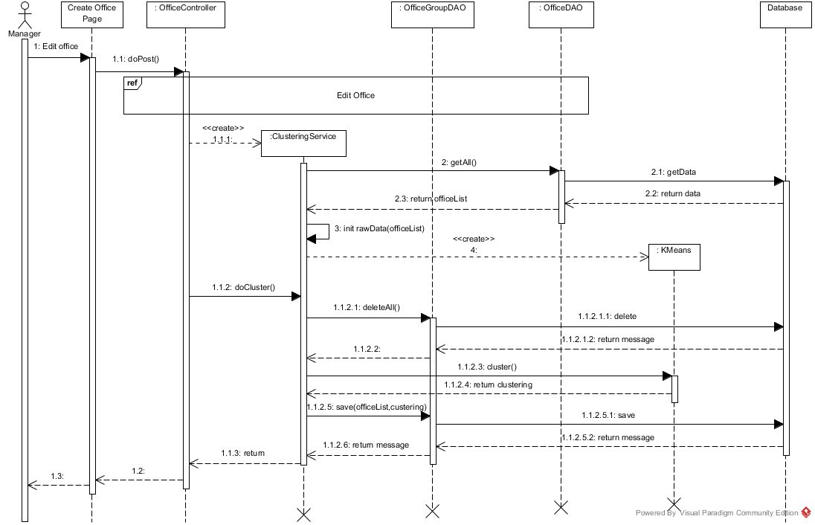

Figure : Clustering Office Sequence Diagram

##### <System> Suggest Assign Job

**Summary:** This diagram used to describe the process of system suggest request office to customer.

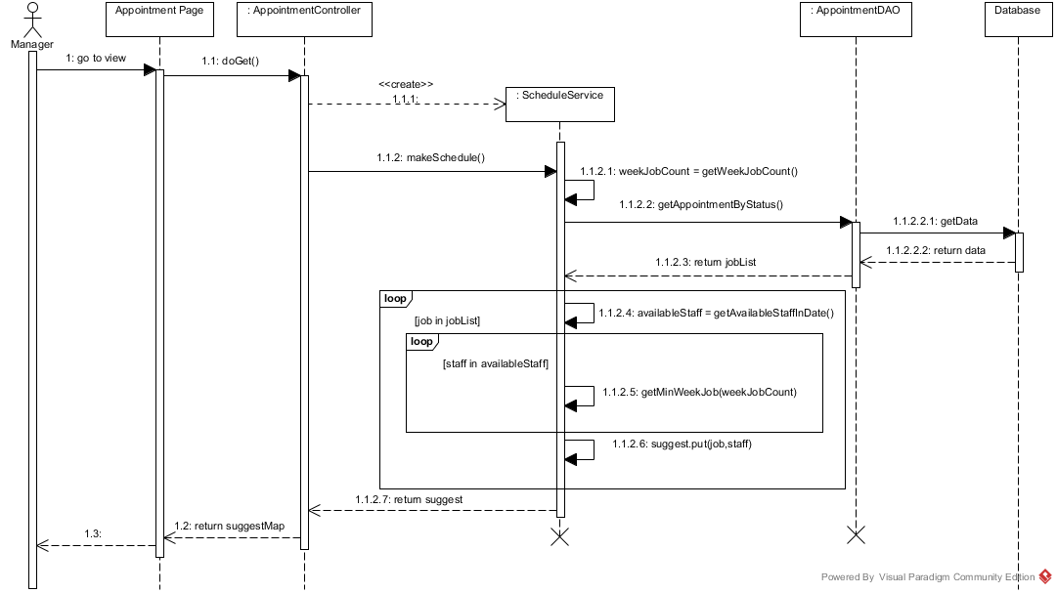

Figure : Suggest Assign Job Sequence Diagram

## User Interface Design

### Guest Interface Design

#### Login

<Refer CD:\Capstone_ORS\Full_report.docx>

#### Register

<Refer CD:\Capstone_ORS\Full_report.docx>

#### Home Page



Figure : Home Page

**Fields**

|  |  |  |  |  |  |  |  |
| --- | --- | --- | --- | --- | --- | --- | --- |
| **No** | **Field Name** | **Description** | **Read only** | **Mandatory** | **Control Type** | **Data Type** | **Length** |
| 4 | Address | Address of office for searching | No | Yes | Textbox | String | N/A |
| 5 | Price | Price of office for searching | No | Yes | Dropdown list | String | N/A |

**Buttons/Hyperlinks**

|  |  |  |  |  |
| --- | --- | --- | --- | --- |
| **No** | **Function** | **Description** | **Validation** | **Outcome** |
| 1 | N/A | Link to homepage | N/A | Transfer to home page |
| 2 | Login | Click to login into the system | Yes | Transfer to home page |
| 3 | Register | Click to register a new account | N/A | Transfer to register page |
| 6 | Search | Click to find office base on address and price | Yes | Transfer to office list page |
| 7 | Request Office | Click to create request office | N/A | Transfer to request office page |
| 8 | Office detail | Click to see office detail | N/A | Transfer to office detail page |

#### Search Office list



Figure : Search office list

**Fields**

|  |  |  |  |  |  |  |  |
| --- | --- | --- | --- | --- | --- | --- | --- |
| **No** | **Field Name** | **Description** | **Read only** | **Mandatory** | **Control Type** | **Data Type** | **Length** |
| 1 | Address | Address for search | No | Yes | Textbox | String | N/A |
| 2 | Price Range | Price range for search | No | No | Textbox number | Long | N/A |
| 4 | Office Info | Information of office | Yes | No | Image + Text field | N/A | N/A |

**Buttons/Hyperlinks**

|  |  |  |  |  |
| --- | --- | --- | --- | --- |
| **No** | **Function** | **Description** | **Validation** | **Outcome** |
| 3 | Search | Do the search again | Yes | Refresh the search list with the input info |
| 4 | Office Info | Link to office detail | N/A | Click on image, the title of office, “Chi tiết” button will transfer to office detail page |
| 5 | Paging | Paging for office list | N/A | Transfer between pages in office search list |

#### Office detail



Figure : Office detail

**Fields**

|  |  |  |  |  |  |  |  |
| --- | --- | --- | --- | --- | --- | --- | --- |
| **No** | **Field Name** | **Description** | **Read only** | **Mandatory** | **Control Type** | **Data Type** | **Length** |
| 1 | Office image | The image of the office | Yes | Yes | Image | N/A | N/A |
| 2 | Office name | The name of the office | Yes | Yes | Label | String | N/A |
| 3 | Category | The category of the office | Yes | Yes | Label | String | N/A |
| 4 | Price | The rent cost of the office in a month | Yes | Yes | Label | Integer | N/A |
| 5 | Floor | Number of floor in the office | Yes | Yes | Label | Integer | N/A |
| 6 | Area | Total area of the office | Yes | Yes | Label | Integer | N/A |
| 7 | Address | The address of the office | Yes | Yes | Label | String | N/A |
| 8 | Amenity | The amenity of the office | Yes | Yes | List | N/A | N/A |
| 9 | Description | Description of the office | Yes | Yes | Paragraph | String | N/A |
| 11 | Maps | Show office address on maps | Yes | Yes | Google map | N/A | N/A |
| 12 | Suggest office | List office that are the same this office | Yes | Yes | List | N/A | N/A |

**Buttons/Hyperlinks**

|  |  |  |  |  |
| --- | --- | --- | --- | --- |
| **No** | **Function** | **Description** | **Validation** | **Outcome** |
| 10 | Request appointment | Click to request appointment | N/A | Transfer to request appointment page |

**Suggest office include**

|  |  |  |  |  |  |
| --- | --- | --- | --- | --- | --- |
| **Field Name** | **Description** | **Read only** | **Control Type** | **Data Type** | **Length** |
| Office name | The name of the office | Yes | Textview | String | N/A |
| Description | The description of the office | Yes | Textview | String | N/A |
| Price | The rent cost of the office | Yes | Textview | Integer | N/A |

### Customer Interface Design

#### Request appointment

<Refer CD:\Capstone_ORS\Full_report.docx>

#### Contract list



Figure : Contract list

**Fields**

|  |  |  |  |  |  |  |  |
| --- | --- | --- | --- | --- | --- | --- | --- |
| **No** | **Field Name** | **Description** | **Read only** | **Mandatory** | **Control Type** | **Data Type** | **Length** |
| 4 | List contract | List contract of customer. | Yes | Yes | Table | N/A | N/A |

**Buttons/Hyperlinks**

|  |  |  |  |  |
| --- | --- | --- | --- | --- |
| **No** | **Function** | **Description** | **Validation** | **Outcome** |
| 1 | Contract detail | View contract detail of customer. | N/A | Transfer to contract detail page |
| 2 | List request repair | View list request repair of customer. | N/A | Transfer to list request repair page |
| 3 | List request rental | View list request rental of customer. | N/A | Transfer to list request rental page |

**List contract include**

|  |  |  |  |  |  |
| --- | --- | --- | --- | --- | --- |
| **Field Name** | **Description** | **Read only** | **Control Type** | **Data Type** | **Length** |
| Office name | Name of current office. | Yes | Label | String | N/A |
| Start date | The effect date of the contract | Yes | Label | Date | N/A |
| End date | The date that the contract expire | Yes | Label | Date | N/A |
| Price | The price that customer paid in one month | Yes | Label | Integer | N/A |
| Price term | The time that customer paid cyclically | Yes | Label | String | N/A |

#### Contract detail



Figure : Contract detail

**Fields**

|  |  |  |  |  |  |  |  |
| --- | --- | --- | --- | --- | --- | --- | --- |
| **No** | **Field Name** | **Description** | **Read only** | **Mandatory** | **Control Type** | **Data Type** | **Length** |
| 1 | Office name | Name of current office. | Yes | Yes | Label | String | N/A |
| 3 | Start date | The effect date of the contract | Yes | Yes | Label | Date | N/A |
| 6 | End date | The date that the contract expire | Yes | Yes | Label | Date | N/A |
| 7 | Price | The price that customer paid in one month | Yes | Yes | Label | Integer | N/A |
| 8 | List rental item | List rental item that customer are hiring | Yes | Yes | Table | N/A | N/A |

**Buttons/Hyperlinks**

|  |  |  |  |  |
| --- | --- | --- | --- | --- |
| **No** | **Function** | **Description** | **Validation** | **Outcome** |
| 2 | Request repair | Click to send request repair | N/A | Transfer to request repair page |
| 4 | Request return contract | Click to send request return contract | Yes | Show pop-up request return contract |
| 5 | Request extend contract | Click to send request extend contract | Yes | Show pop-up request extend contract |
| 9 | Request rental | Click to send request rental item | N/A | Transfer to request rental item page |

**List rental item include**

|  |  |  |  |  |  |
| --- | --- | --- | --- | --- | --- |
| **Field Name** | **Description** | **Read only** | **Control Type** | **Data Type** | **Length** |
| Rental item name | The name of the rental item | Yes | Textview | String | N/A |
| Description | Describe request repair of customer | Yes | Textview | String | N/A |
| Unit price | Rent cost of one item | Yes | Textview | Integer | N/A |
| Quantity | The number of item is hiring | Yes | Textview | Integer | N/A |
| Item price | The price of all hired item | Yes | Textview | Integer | N/A |
| Total price | The sum of item price | Yes | Textview | Integer | N/A |

#### Extend contract

<Refer CD:\Capstone_ORS\Full_report.docx>

#### Return contract

<Refer CD:\Capstone_ORS\Full_report.docx>

#### List request repair history

<Refer CD:\Capstone_ORS\Full_report.docx>

#### List request repair

<Refer CD:\Capstone_ORS\Full_report.docx>

#### Profile

<Refer CD:\Capstone_ORS\Full_report.docx>

#### Profile detail

<Refer CD:\Capstone_ORS\Full_report.docx>

#### Change password

<Refer CD:\Capstone_ORS\Full_report.docx>

#### Request repair

<Refer CD:\Capstone_ORS\Full_report.docx>

#### Rental page



Figure : Rental page

**Fields**

|  |  |  |  |  |  |  |  |
| --- | --- | --- | --- | --- | --- | --- | --- |
| **No** | **Field Name** | **Description** | **Read only** | **Mandatory** | **Control Type** | **Data Type** | **Length** |
| 1 | Cart | Show cart of customer | Yes | No | Textbox | String | N/A |
| 2 | Price | Price of rental item | Yes | No | Textview | String | N/A |
| 3 | Quantity | Number items customer buy | No | Yes | Textbox | Int | N/A |
| 4 | Image | Image of the rental item | Yes | Yes | Image | String | N/A |

**Buttons/Hyperlinks**

|  |  |  |  |  |
| --- | --- | --- | --- | --- |
| **No** | **Function** | **Description** | **Validation** | **Outcome** |
| 5 | AddToCart | Add item with quantity to customer’s cart | N/A | Show successful message |
| 6 | viewCart | Open rental cart page | N/A | Transfer to rental cart page |

#### Rental cart page



Figure : Rental cart page

**Fields**

|  |  |  |  |  |  |  |  |
| --- | --- | --- | --- | --- | --- | --- | --- |
| **No** | **Field Name** | **Description** | **Read only** | **Mandatory** | **Control Type** | **Data Type** | **Length** |
| 1 | Name | Name of items | Yes | Yes | Textview | String | N/A |
| 2 | Description | Description of items | Yes | No | Textview | String | N/A |
| 3 | Price | Price of one item | Yes | Yes | Textview | Int | N/A |
| 4 | Quantity | Number items customer buy | No | Yes | Textbox | String | N/A |
| 5 | Total price | Total price of items | Yes | Yes | Textview | Int | N/A |
| 6 | Comment | Comment of customer | No | No | Textbox | String | N/A |

**Buttons/Hyperlinks**

|  |  |  |  |  |
| --- | --- | --- | --- | --- |
| **No** | **Function** | **Description** | **Validation** | **Outcome** |
| 7 | RemoveFromCart | remove item from customer’s cart | N/A | Show successful message |
| 8 | Send Request | Send request | N/A | Transfer to home page |
| 9 | Hyperlinks | Return to rental page | N/A | Transfer to rental page |

#### Rental list page

<Refer CD:\Capstone_ORS\Full_report.docx>

#### Request office

<Refer CD:\Capstone_ORS\Full_report.docx>

#### Result request office page



Figure : Result request office page

**Fields**

|  |  |  |  |  |  |  |  |
| --- | --- | --- | --- | --- | --- | --- | --- |
| **No** | **Field Name** | **Description** | **Read only** | **Mandatory** | **Control Type** | **Data Type** | **Length** |
| 1 | Name | Name of office | Yes | Yes | Textview | String | N/A |
| 2 | Area | Area of office | Yes | No | Textview | float | N/A |
| 3 | Price | Price of office | Yes | Yes | Textview | int | N/A |
| 4 | Address | Address of office | Yes | Yes | Textbox | bigint | N/A |
| 5 | Create date | Date when customer create request | Yes | Yes | Textview | datetime | N/A |
| 6 | List office | List result office | Yes | No | Listview |  | N/A |

**Buttons/Hyperlinks**

|  |  |  |  |  |
| --- | --- | --- | --- | --- |
| **No** | **Function** | **Description** | **Validation** | **Outcome** |
| 7 | Unsubscribe | Remove request | N/A | Reload page and request has disappear |
| 8 | Office Detail | Show detail of office | N/A | Transfer to office detail page |

### Admin Interface Design

#### View user list

<Refer CD:\Capstone_ORS\Full_report.docx>

#### Add new user

<Refer CD:\Capstone_ORS\Full_report.docx>

#### Update user

<Refer CD:\Capstone_ORS\Full_report.docx>

### Manager, Staff Interface Design

#### View amenity group list

<Refer CD:\Capstone_ORS\Full_report.docx>

#### Add new amenity group

<Refer CD:\Capstone_ORS\Full_report.docx>

#### View user profile

<Refer CD:\Capstone_ORS\Full_report.docx>

#### View amenity list

<Refer CD:\Capstone_ORS\Full_report.docx>

#### Delete amenity

<Refer CD:\Capstone_ORS\Full_report.docx>

#### Create amenity

<Refer CD:\Capstone_ORS\Full_report.docx>

#### View user list

<Refer CD:\Capstone_ORS\Full_report.docx>

#### Add new user

<Refer CD:\Capstone_ORS\Full_report.docx>

#### View amenity group list

<Refer CD:\Capstone_ORS\Full_report.docx>

#### Add new amenity group

<Refer CD:\Capstone_ORS\Full_report.docx>

#### View retal item list

<Refer CD:\Capstone_ORS\Full_report.docx>

#### Add new rental item

<Refer CD:\Capstone_ORS\Full_report.docx>

#### View appointment request list



Figure : View appointment request list

**Fields**

|  |  |  |  |  |  |  |  |
| --- | --- | --- | --- | --- | --- | --- | --- |
| **No** | **Field Name** | **Description** | **Read only** | **Mandatory** | **Control Type** | **Data Type** | **Length** |
| 1 | Page title | Title of appointment request list | Yes | Yes | Label | N/A | N/A |
| 2 | Appointment list | List of request appointment list has been sent | Yes | Yes | Listview | N/A | N/A |

**Buttons/Hyperlinks**

|  |  |  |  |  |
| --- | --- | --- | --- | --- |
| **No** | **Function** | **Description** | **Validation** | **Outcome** |
| 3 | Assign staff | Auto assign staff | No | N/A |
| 4 | Information appointment request | Show information about appointment request and assign staff | No | Transfer to amenity page |

**Appointment request list includes**

|  |  |  |  |  |  |
| --- | --- | --- | --- | --- | --- |
| **Field Name** | **Description** | **Read only** | **Control Type** | **Data Type** | **Length** |
| Customer name | Name of customer | Yes | Textview | String | N/A |
| Office name | Description of office | Yes | Textview | String | N/A |
| Time meeting | Time to meet | Yes | Textview | Integer | N/A |
| Suggest staff | Suggest staff to assign | Yes | Dropbox | Integer | N/A |

#### View appointment request detail

<Refer CD:\Capstone_ORS\Full_report.docx>

#### View retal list

<Refer CD:\Capstone_ORS\Full_report.docx>

#### View retal detail



Figure : View rental detail

**Fields**

|  |  |  |  |  |  |  |  |
| --- | --- | --- | --- | --- | --- | --- | --- |
| **No** | **Field Name** | **Description** | **Read only** | **Mandatory** | **Control Type** | **Data Type** | **Length** |
| 1 | Page title | Title of rental detail | Yes | Yes | Label | N/A | N/A |
| 2 | Rental information | Information of rental detail | Yes | Yes | Label | N/A | N/A |

**Buttons/Hyperlinks**

|  |  |  |  |  |
| --- | --- | --- | --- | --- |
| **No** | **Function** | **Description** | **Validation** | **Outcome** |
| 3 | Assign staff | Assign rental for suggest staff | Yes | N/A |
| 4 | Cancel rental | Go to rental detail page | No | N/A |
| 5 | Back | Go to rental list page | No | N/A |

**Retal detail includes**

|  |  |  |  |  |  |
| --- | --- | --- | --- | --- | --- |
| **Field Name** | **Description** | **Read only** | **Control Type** | **Data Type** | **Length** |
| Id | Id of rental | Yes | Textview | String | N/A |
| Staff | Name of assigned staff | No | Dropbox | String | N/A |
| Assigned day | Create date of rental | No | Dropbox | String | N/A |
| Description | Description of rental | Yes | Textview | String | N/A |
| Status | Tool for auto assign staff | Yes | Textview | String | N/A |
| Rental item list | Table of rental item | Yes | Textview | String | N/A |
| Retal item name | Name of rental item | Yes | Textview | String | N/A |
| Price | Price of rental item | Yes | Textview | String | N/A |
| Number | Number of rental item | Yes | Textview | String | N/A |
| Total | Total price | Yes | Textview | String | N/A |

#### Repair list

<Refer CD:\Capstone_ORS\Full_report.docx>

#### Repair detail

<Refer CD:\Capstone_ORS\Full_report.docx>

#### View Calendar



Figure : View calendar

**Fields**

|  |  |  |  |  |  |  |  |
| --- | --- | --- | --- | --- | --- | --- | --- |
| **No** | **Field Name** | **Description** | **Read only** | **Mandatory** | **Control Type** | **Data Type** | **Length** |
| 3 | Current time | The current selection time | Yes | N/A | Label | String | N/A |
| 5 | Legends | The legends for staff with color | Yes | N/A | Label with color | String | N/A |

**Buttons/Hyperlinks**

|  |  |  |  |  |
| --- | --- | --- | --- | --- |
| **No** | **Function** | **Description** | **Validation** | **Outcome** |
| 1 | Navigation | Navigation the calendar | N/A | Go to next or previous period of time (select by (4) ) on calendar |
| 4 | Time period | The period to display the calendar in | N/A | Change the value will display the calendar with selected period of time |
| 6 | Job link | Link to selected job | N/A | Go to the job (appointment/ repair/rental) detail |

#### View office list

<Refer CD:\Capstone_ORS\Full_report.docx>

#### Add New Office

<Refer CD:\Capstone_ORS\Full_report.docx>

#### Office detail

<Refer CD:\Capstone_ORS\Full_report.docx>

#### Contract page

<Refer CD:\Capstone_ORS\Full_report.docx>

#### New contract page

<Refer CD:\Capstone_ORS\Full_report.docx>

#### Contract detail page

<Refer CD:\Capstone_ORS\Full_report.docx>

#### View request contract page

<Refer CD:\Capstone_ORS\Full_report.docx>

#### Extend contract page

<Refer CD:\Capstone_ORS\Full_report.docx>

#### Return contract page

<Refer CD:\Capstone_ORS\Full_report.docx>

#### Income statistic

<Refer CD:\Capstone_ORS\Full_report.docx>

#### Staff statistic

<Refer CD:\Capstone_ORS\Full_report.docx>

### Mobile Interface Design

#### Login



Figure : Login

**Fields**

|  |  |  |  |  |  |  |  |
| --- | --- | --- | --- | --- | --- | --- | --- |
| **No** | **Field Name** | **Description** | **Read only** | **Mandatory** | **Control Type** | **Data Type** | **Length** |
| 1 | Username | Username for staff to login | No | Yes | Textbox | String | [3-50] |
| 2 | Password | Password for login | No | Yes | Password | String | [1-50] |

**Buttons/Hyperlinks**

|  |  |  |  |  |
| --- | --- | --- | --- | --- |
| **No** | **Function** | **Description** | **Validation** | **Outcome** |
| 5 | Login | Login to app | Yes | Login and go to job page |

#### Home



Figure : Home

**Buttons/Hyperlinks**

|  |  |  |  |  |
| --- | --- | --- | --- | --- |
| **No** | **Function** | **Description** | **Validation** | **Outcome** |
| 1 | Appointment list | Go to the appointment list | N/A | Go to the appointment list |
| 2 | Repair list | Go to the repair list | N/A | Go to the repair list |
| 3 | Rental list | Go to the rental list | N/A | Go to the rental list |

#### Job list

<Refer CD:\Capstone_ORS\Full_report.docx>

#### Job detail

<Refer CD:\Capstone_ORS\Full_report.docx>

## Database Design

### Entity-Relationship Diagram

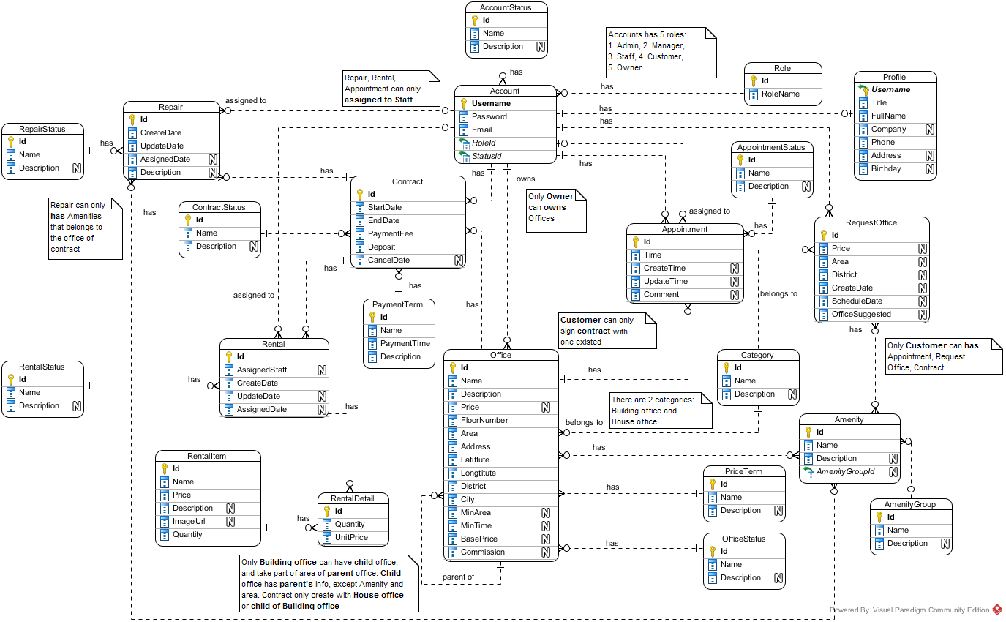

Figure : Entity-Relationship Diagram

*This page is intentionally left blank*

### Data Dictionary

|  |  |
| --- | --- |
| **Entity Data dictionary: describe content of all entities** | |
| **Entity Name** | **Description** |
| Account | Describe all accounts of users in the system. |
| Account Status | Describe status of account. One account has only one status. |
| Amenity | Describe all amenities in system. |
| Amenity Group | Describe groups of amenity. One amenity is only in one group. |
| Appointment | Describe all appointment requests of customer. |
| Appointment Status | Describe status of appointment request. One appointment has only one status. |
| Category | Describe category of office. One office is only in one category. |
| Contract | Describe all contracts in the system. |
| Contract Status | Describe status of contract. One contract has only one status. |
| Office | Describe all offices in the system. |
| Office Amenity | Describe all amenities in one office. One office can have more than one amenity. |
| Office Group | Describe group of the office for searching office. One office is only in one group |
| Office Status | Describe status of the office. One office has only one status. |
| Payment Term | Describe time for the payment |
| Price Term | Describe the way that money is calculated base on. |
| Profile | Describe information of the account |
| Rental | Describe all rental requests from customer |
| Rental Detail | Describe all rental items for one rental request |
| Rental Item | Describe all rental items in system |
| Rental Status | Describe status of rental request. One rental request has only one status. |
| Repair | Describe all repair requests from customer |
| Repair Detail | Describe all amenities need to repair for one repair request |
| Repair Status | Describe status of repair request. One repair request has only one status. |
| Request Amenity | Describe all amenities in one request office |
| Request Office | Describe all requests office from customer |
| Role | Describe role of account. One account has only one role. |

## Algorithms

### Clustering data

#### Definition

K-means is a prototype based clustering technique defining the prototype in terms of a centroid which is considered to be the mean of a group of points and is applicable to objects in a continuous n-dimensional space. (Refer website http://www.hypertextbookshop.com)

#### Define Problem

* Office in near location may have similarity in price range. But the location may vary and hard to define all location.
* Group the office by location and price range will make the user easier to find the similarity offices

#### Solution

To solve the problem, we use the well-known K-Means algorithm.

The step to perform the algorithm:

1. Defined the k number (number of cluster)
   * The k number is calculate by the square root of total of data (n). This make sure that there is $\sqrt{n}$ group, and each group has about $\sqrt{n}$ data
2. Normalize the data into the n-dimensions Euclidean space, all data based on [0, 1] distance. Each of office data is called “point”
   * In this problem, we use 3 statics: latitude, longitude and price range of the office for 3-dimensions
   * The price range is divided into 5 range: Call as 0, 100.000 VND – 200.000 VND as 1, etc., larger than 500.000 VND as 5
   * In each dimension, calculate the min and max. Then the normalize dimension data is calculate by:

$$\text{normalized}=\frac{data-min}{max-min}$$

normalize: dimension normalized data

data: the raw data in dimension

1. Select random point into k group, each group has at least 1 point
2. Calculate the mean points of each group
3. Calculate the distance of each data point to each group’s mean point, and change the group of data point to the group that has the nearest mean
   * The distance between A(a1, a2, … an) and X(x1, x2, … xn) is calculate by Euclidean distance:

$$d=\sqrt{{\left(a_{1}-x_{1}\right)}^{2}+{\left(a_{2}-b_{2}\right)}^{2}+…+{\left(a_{n}-b_{n}\right)}^{2}}$$

Where n is the number of dimension

1. Repeat step 4 until the group in step 5 is unchanged

#### Complexity

* In total, the complexity of this algorithm is NP-hard. But with current algorithm maximum complexity limit to n*10 (n is total of data)

#### Flow chart

Calculate K

Normalize data

Group data in K groups

Calculate the mean of each group

Group based on minimum distance to mean

Group changed?

End

Start

Yes

No

Figure : Clustering data flow chart

### Matching data

#### Definition

K-Nearest Neighbor algorithm (KNN) is a method for classifying objects based on the closest training examples in the feature space.  KNN is a type of instance-based learning, or lazy learning where the function is only approximated locally and all computation is deferred until classification. (Refer website http://www.datasciencecentral.com)

#### Define Problem

* The search office may be different from all of the office in system, and user want to make their decision with vary of result.

#### Solution

With the clustering data using K-Means, the best solution is KNN (K-Nearest-Neighbor) algorithm.

The steps to perform the algorithm:

1. Define k number. In this solution, we choose k at least by haft of the average office in each group of K-Means algorithm. Particular 2 $\sqrt{n}$* .
2. Normalize the query point (input data) to the same dimension of sample data (by above function)
3. Calculate the distance between query point and each of data in sample (all office) by Euclidean distance (as above).
4. Sort the calculated distance, select the minimum k distances for comparison.
5. The group of query point will be group that have the most frequent existence in above k distances. If there is more than 1 group that have largest existence, the selected group will be the group that have minimum total distance (in the k selected distances only)

#### Complexity

* In total, the complexity of this algorithm is O(n)

# System Implementation & Test (SIT)

## Introduction

### System Overview

This section provides in detail all necessary information about test plans, test cases, test result, test environments, pass/fail criteria and risks estimations as well as a checklist to cover all possible cases of ORS system.

### Test Approach

Goal: Check all the features in ORS system and record remain bug to fix.

Type:

* Algorithms: use white box testing
* Others: use black box testing

Size: System Component.

Technique: Check list.

## Database Relationship Diagram

### Physical Diagram

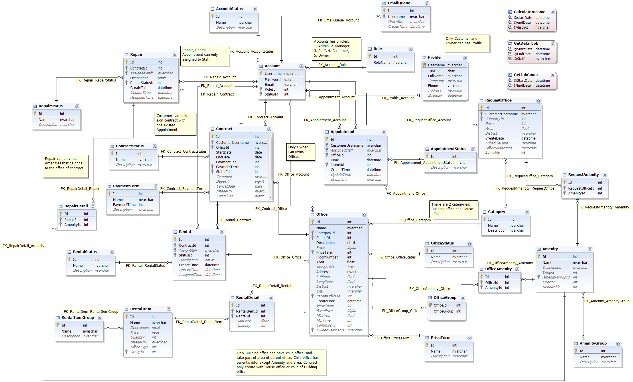

Figure : Physical Database Diagram

*This page is intentionally left blank*

### Data Dictionary

|  |  |
| --- | --- |
| **Entity Data dictionary: describe content of all entities** | |
| **Entity Name** | **Description** |
| Account | Describe all accounts of users in the system. |
| Account Status | Describe status of account. One account has only one status. |
| Amenity | Describe all amenities in system. |
| Amenity Group | Describe groups of amenity. One amenity is only in one group. |
| Appointment | Describe all appointment requests of customer. |
| Appointment Status | Describe status of appointment request. One appointment has only one status. |
| Category | Describe category of office. One office is only in one category. |
| Contract | Describe all contracts in the system. |
| Contract Status | Describe status of contract. One contract has only one status. |
| Email Queue | Describe all emails have to send to customer in the system. |
| Office | Describe all offices in the system. |
| Office Amenity | Describe all amenities in one office. One office can have more than one amenity. |
| Office Group | Describe group of the office for searching office. One office is only in one group |
| Office Status | Describe status of the office. One office has only one status. |
| Payment Term | Describe time for the payment |
| Price Term | Describe the way that money is calculated base on. |
| Profile | Describe information of the account |
| Rental | Describe all rental requests from customer |
| Rental Detail | Describe all rental items for one rental request |
| Rental Item | Describe all rental items in system |
| Rental Status | Describe status of rental request. One rental request has only one status. |
| Repair | Describe all repair requests from customer |
| Repair Detail | Describe all amenities need to repair for one repair request |
| Repair Status | Describe status of repair request. One repair request has only one status. |
| Request Amenity | Describe all amenities in one request office |
| Request Office | Describe all requests office from customer |
| Role | Describe role of account. One account has only one role. |

#### Table Account

|  |  |  |  |  |
| --- | --- | --- | --- | --- |
| **Entity name** | **Attributes** | **Description** | **Type** | **Null** |
| Account | Username{PK} | Unique identifier of an account, username for login to system | nvarchar(50) | No |
| Password | Password for login to system | varchar(50) | No |
| Email | Email of this account | varchar(50) | No |
| RoleId{FK} | Role of this account. | int | No |
| StatusId{FK} | Status of this account. | int | No |
| Unique Key: Email | | | | |
| Foreign key:   * RoleId: Foreign key references to table Role * StatusId: Foreign key references to table Account Status | | | | |

#### Table Account Status

|  |  |  |  |  |
| --- | --- | --- | --- | --- |
| **Entity name** | **Attributes** | **Description** | **Type** | **Null** |
| Account Status | Id{PK} | Unique identifier of an account status, automatically increase | int | No |
| Name | Name of this status | nvarchar(50) | No |
| Description | Description for this status | nvarchar(50) | Yes |

#### Table Amenity

|  |  |  |  |  |
| --- | --- | --- | --- | --- |
| **Entity name** | **Attributes** | **Description** | **Type** | **Null** |
| Amenity | Id{PK} | Unique identifier of an amenity, automatically increase | int | No |
| Name | Name of this amenity | nvarchar(50) | No |
| Description | Description for this amenity | nvarchar(250) | Yes |
| Weight | Weight of amenity in one group | int | Yes |
| AmenityGroupId{FK} | Group of this amenity. | int | Yes |
| Priority | Priority of amenity in one group | int | Yes |
| Unique Key: Name | | | | |
| Foreign key:   * AmenityGroupId: Foreign key references to table Amenity Group | | | | |

#### Table Amenity Group

|  |  |  |  |  |
| --- | --- | --- | --- | --- |
| **Entity name** | **Attributes** | **Description** | **Type** | **Null** |
| Amenity Group | Id{PK} | Unique identifier of an amenity group, automatically increase | int | No |
| Name | Name of amenity group | nvarchar(50) | No |
| Description | Description for amenity group | nvarchar(250) | Yes |

#### Table Appointment

|  |  |  |  |  |
| --- | --- | --- | --- | --- |
| **Entity name** | **Attributes** | **Description** | **Type** | **Null** |
| Appointment | Id{PK} | Unique identifier of an appointment, automatically increase | int | No |
| CustomerUsername{FK} | Username of customer. | nvarchar(50) | No |
| AssignedStaff{FK} | Staff who is responsibility for the appointment. | nvarchar(250) | Yes |
| OfficeId{FK} | Office where customer want to make appointment. | int | No |
| Time | Time for appointment | datetime | No |
| StatusId{FK} | Status of the appointment. | int | No |
| CreateTime | Time when customer create appointment | datetime | No |
| UpdateTime | Time when manager update the appointment | datetime | Yes |
| Comment | Comment for the appointment | nvarchar(250) | Yes |
| Foreign key:   * CustomerUsername: Foreign key references to table Account. * AssignedStaff: Foreign key references to table Account. * OfficeId: Foreign key references to table Office. * StatusId: Foreign key references to table appointment status. | | | | |

#### Table Appointment Status

|  |  |  |  |  |
| --- | --- | --- | --- | --- |
| **Entity name** | **Attributes** | **Description** | **Type** | **Null** |
| Appointment Status | Id{PK} | Unique identifier of an appointment status, automatically increase | int | No |
| Name | Name of appointment status | nvarchar(50) | No |
| Description | Description for appointment status | nvarchar(50) | Yes |
| Unique Key: Name | | | | |

#### Table Category

|  |  |  |  |  |
| --- | --- | --- | --- | --- |
| **Entity name** | **Attributes** | **Description** | **Type** | **Null** |
| Category | Id{PK} | Unique identifier of a category for office, automatically increase | int | No |
| Name | Name of category | nvarchar(50) | No |
| Description | Description for category | nvarchar(250) | No |
| Unique Key: Name | | | | |

#### Table Contract

|  |  |  |  |  |
| --- | --- | --- | --- | --- |
| **Entity name** | **Attributes** | **Description** | **Type** | **Null** |
| Contract | Id{PK} | Unique identifier of a contract, automatically increase | int | No |
| CustomerUsername{FK} | Username of customer. | nvarchar(50) | No |
| OfficeId{FK} | Office where customer want to make contract. | int | No |
| StartDate | Date when contract starts. | date | No |
| EndDate | Date when contract ends. | date | No |
| PaymentFee | Fee for the contract | int | No |
| PaymentTerm{FK} | Payment term for the contract. | int | No |
| StatusId{FK} | Status of the contract. | int | No |
| Comment | Comment for the appointment | nvarchar(250) | Yes |
| Deposit | Money for deposit of contract | bigint | Yes |
| CancelDate | Time when contract has been accepted to cancel | date | Yes |
| ImageUrl | Image for contract | nvarchar(150) | Yes |
| CancelFee | Fee return when contract return | bigint | Yes |
| Foreign key:   * CustomerUsername: Foreign key references to table Account. * OfficeId: Foreign key references to table Office. * PaymentTerm: Foreign key references to table Payment Term. * StatusId: Foreign key references to table contract status. | | | | |

#### Table Contract Status

|  |  |  |  |  |
| --- | --- | --- | --- | --- |
| **Entity name** | **Attributes** | **Description** | **Type** | **Null** |
| Contract Status | Id{PK} | Unique identifier of a contract status, automatically increase | int | No |
| Name | Name of contract status | nvarchar(50) | No |
| Description | Description for contract status | nvarchar(50) | Yes |
| Unique key: Name | | | | |

#### Table Email Queue

|  |  |  |  |  |
| --- | --- | --- | --- | --- |
| **Entity name** | **Attributes** | **Description** | **Type** | **Null** |
| Email Queue | Id{PK} | Unique identifier of an email queue, automatically increase | int | No |
| Username{FK} | Username of the customer. Foreign key references to table Account. | nvarchar(50) | No |
| OfficeIds | List office that system suggests to customer | nvarchar(50) | Yes |
| CreateTime | Time when customer create request | datetime | Yes |
| Foreign key:   * Username: Foreign key references to table Account. | | | | |

#### Table Office

|  |  |  |  |  |
| --- | --- | --- | --- | --- |
| **Entity name** | **Attributes** | **Description** | **Type** | **Null** |
| Office | Id{PK} | Unique identifier of an office, automatically increase | int | No |
| Name | Name of the office. | nvarchar(50) | No |
| CategoryId{FK} | Category of the office. | int | No |
| StatusId | Status of the office. Foreign key references to table Office Status. | int | No |
| Description | Description for the office | ntext | No |
| Price | Price of the office | bigint | Yes |
| PriceTerm{FK} | Price term of the office. | int | No |
| FloorNumber | Number of floor in the office | int | No |
| Area | Area of the office | float | No |
| ImageUrls | Link of the images of office | text | Yes |
| OtherDetail | Some detail of the office | ntext | Yes |
| Address | Address of the office | nvarchar(150) | No |
| Latitude | Latitude of the office | float | Yes |
| Longitude | Longitude of the office | float | Yes |
| District | District of the office | nvarchar(50) | Yes |
| City | City of the office | nvarchar(50) | Yes |
| ParentOfficeId{FK} | Parent Office ID of the office. | int | Yes |
| CreateDate | Date when office create in database | datetime | No |
| ViewCount | Number views when customer see detail of office | int | Yes |
| BasePrice | Base price for the office | bigint | Yes |
| MinArea | Minimum area when customer rent | float | Yes |
| MinTime | Minimum time when customer rent | int | Yes |
| OwnerName | Office’s owner name | nvarchar(150) | Yes |
| OwnerPhone | Office’s owner phone | nvarchar(15) | Yes |
| OwnerAddress | Office’s owner address | nvarchar(150) | Yes |
| Foreign key:   * CategoryId: Foreign key references to table Category. * PriceTerm: Foreign key references to table Price Term. * ParentOfficeId: Foreign key references to table Office. | | | | |

#### Table Office Amenity

|  |  |  |  |  |
| --- | --- | --- | --- | --- |
| **Entity name** | **Attributes** | **Description** | **Type** | **Null** |
| Office Amenity | Id{PK} | Unique identifier of a contract status, automatically increase | int | No |
| OfficeId{FK} | Id of the office. | int | No |
| AmenityId{FK} | Amenity of this office | int | No |
| Foreign key:   * OfficeId: Foreign key references to table Office. * AmenityId: Foreign key references to table Amenity. | | | | |

#### Table Office Group

|  |  |  |  |  |
| --- | --- | --- | --- | --- |
| **Entity name** | **Attributes** | **Description** | **Type** | **Null** |
| Office Group | OfficeId{PK, FK} | Id of office | int | No |
| OfficeGroup | Group after system run algorithm of this office | int | No |
| Foreign key:   * OfficeId: Foreign key references to table Office. | | | | |

#### Table Office Status

|  |  |  |  |  |
| --- | --- | --- | --- | --- |
| **Entity name** | **Attributes** | **Description** | **Type** | **Null** |
| Office Status | Id{PK} | Unique identifier of an office status, automatically increase | int | No |
| Name | Name of office status | nvarchar(50) | No |
| Description | Description for office status | nvarchar(250) | Yes |

#### Table Payment Term

|  |  |  |  |  |
| --- | --- | --- | --- | --- |
| **Entity name** | **Attributes** | **Description** | **Type** | **Null** |
| Payment Term | Id{PK} | Unique identifier of a payment term, automatically increase | int | No |
| Name | Name of term for payment | nvarchar(50) | No |
| PaymentTime | Number months of the payment | int | No |
| Description | Description for payment term | nvarchar(100) | Yes |
| Unique Key: Name | | | | |

#### Table Price Term

|  |  |  |  |  |
| --- | --- | --- | --- | --- |
| **Entity name** | **Attributes** | **Description** | **Type** | **Null** |
| Price Term | Id{PK} | Unique identifier of a price term, automatically increase | int | No |
| Name | Name of term for price | nvarchar(50) | No |
| Description | Description for price term | nvarchar(250) | Yes |
| Unique Key: Name | | | | |

#### Table Profile

|  |  |  |  |  |
| --- | --- | --- | --- | --- |
| **Entity name** | **Attributes** | **Description** | **Type** | **Null** |
| Profile | Username{PK, FK} | Unique identifier of an account. | nvarchar(50) | No |
| Title | Gender of the profile | char(4) | No |
| FullName | Full name of this profile | nvarchar(50) | No |
| Company | Company of this profile | nvarchar(100) | Yes |
| Phone | Phone of this profile | varchar(15) | No |
| Address | Address of this profile | nvarchar(150) | Yes |
| Birthday | Birthday of this profile | datetime | Yes |
| Foreign key:   * Username: Foreign key references to table Account. | | | | |

#### Table Rental

|  |  |  |  |  |
| --- | --- | --- | --- | --- |
| **Entity name** | **Attributes** | **Description** | **Type** | **Null** |
| Rental | Id{PK} | Unique identifier of a rental request, automatically increase | int | No |
| ContractId{FK} | Contract which customer send rental request. | int | No |
| AssignStaff{FK} | Username of staff who responsibility for this rental request. | nvarchar(50) | Yes |
| StatusId{FK} | Status of this rental request. | int | No |
| Description | Description of rental | ntext | Yes |
| CreateTime | Time when customer create this rental request | datetime | No |
| UpdateTime | Time when manger or staff change status | datetime | Yes |
| AssignedTime | Time when manager assign to staff | datetime | Yes |
| Foreign key:   * ContractId: Foreign key references to table Contract. * AssignStaff: Foreign key references to table Account. * StatusId: Foreign key references to table Rental Status. | | | | |

#### Table Rental Detail

|  |  |  |  |  |
| --- | --- | --- | --- | --- |
| **Entity name** | **Attributes** | **Description** | **Type** | **Null** |
| Rental Detail | Id{PK} | Unique identifier of a rental detail, automatically increase | int | No |
| RentalItemId{FK} | Item rental for the rental request. | int | No |
| RentalId{FK} | Id of Request rental. | int | No |
| UnitPrice | Price of one item | float | Yes |
| Quantity | Quantity of rental item for the rental request | int | Yes |
| Foreign key:   * RentalItemId: Foreign key references to table Rental Item. * RentalId: Foreign key references to table Rental. | | | | |

#### Table Rental Item

|  |  |  |  |  |
| --- | --- | --- | --- | --- |
| **Entity name** | **Attributes** | **Description** | **Type** | **Null** |
| Rental Item | Id{PK} | Unique identifier of a rental item, automatically increase | int | No |
| Name | Name of the item | nvarchar(150) | No |
| Description | Description for the item | ntext | Yes |
| Price | Price of the item | float | Yes |
| Quantity | Quantity of the item | int | Yes |
| ImageUrl | Link image of the item | nvarchar(250) | Yes |
| Unique key: Name | | | | |

#### Table Rental Status

|  |  |  |  |  |
| --- | --- | --- | --- | --- |
| **Entity name** | **Attributes** | **Description** | **Type** | **Null** |
| Rental Status | Id{PK} | Unique identifier of a rental status, automatically increase | int | No |
| Name | Name of rental status | nvarchar(50) | No |
| Description | Description for rental status | nvarchar(50) | Yes |
| Unique key: Name | | | | |

#### Table Repair

|  |  |  |  |  |
| --- | --- | --- | --- | --- |
| **Entity name** | **Attributes** | **Description** | **Type** | **Null** |
| Repair | Id{PK} | Unique identifier of a repair request, automatically increase | int | No |
| ContractId{FK} | Contract which customer send repair request. | int | No |
| AssignStaff{FK} | Username of staff who responsibility for this repair request. | nvarchar(50) | Yes |
| RepairStatusId{FK} | Status of this repair request. | int | No |
| Description | Description of repair | ntext | Yes |
| CreateTime | Time when customer create this repair request | datetime | No |
| UpdateTime | Time when manger or staff change status | datetime | Yes |
| AssignedTime | Time when manager assign to staff | datetime | Yes |
| Foreign key:   * ContractId: Foreign key references to table Contract. * AssignStaff: Foreign key references to table Account. * RepairStatusId: Foreign key references to table Repair Status. | | | | |

#### Table Repair Detail

|  |  |  |  |  |
| --- | --- | --- | --- | --- |
| **Entity name** | **Attributes** | **Description** | **Type** | **Null** |
| Repair Detail | Id{PK} | Unique identifier of a repair detail, automatically increase | int | No |
| RepairId {FK} | Id of repair request. | int | No |
| AmenityId{FK} | Amenity of this repair request. | int | No |
| Foreign key:   * RepairId: Foreign key references to table Repair. * AmenityId: Foreign key references to table Amenity. | | | | |

#### Table Repair Status

|  |  |  |  |  |
| --- | --- | --- | --- | --- |
| **Entity name** | **Attributes** | **Description** | **Type** | **Null** |
| Repair Status | Id{PK} | Unique identifier of a repair status, automatically increase | int | No |
| Name | Name of repair status | nvarchar(50) | No |
| Description | Description for repair status | nvarchar(50) | Yes |
| Unique key: Name | | | | |

#### Table Request Amenity

|  |  |  |  |  |
| --- | --- | --- | --- | --- |
| **Entity name** | **Attributes** | **Description** | **Type** | **Null** |
| Request Amenity | Id{PK} | Unique identifier of a request amenity, automatically increase | int | No |
| RequestOfficeId{FK} | Id of request office. | int | No |
| AmenityId{FK} | Amenity of this request. | int | No |
| Foreign key:   * RequestOfficeId: Foreign key references to table Request Office. * AmenityId: Foreign key references to table Amenity. | | | | |

#### Table Request Office

|  |  |  |  |  |
| --- | --- | --- | --- | --- |
| **Entity name** | **Attributes** | **Description** | **Type** | **Null** |
| Request Office | Id{PK} | Unique identifier of a request office, automatically increase | int | No |
| CustomerUsername {FK} | Username of customer. | nvarchar(50) | No |
| CategoryId{FK} | Category of the office. | int | Yes |
| Price | Price of the office. | int | Yes |
| Area | Area of the office | float | Yes |
| District | District of the office | nvarchar(50) | Yes |
| CreateDate | Time when customer create this request. | datetime | No |
| ScheduleDate | Date when system check this request | datetime | Yes |
| OfficeSuggested | List offices that are suitable with request | nvarchar(250) | Yes |
| Foreign key:   * CustomerUsername: Foreign key references to table Account * CategoryId: Foreign key references to table Category. | | | | |

#### Table Role

|  |  |  |  |  |
| --- | --- | --- | --- | --- |
| **Entity name** | **Attributes** | **Description** | **Type** | **Null** |
| Role | Id{PK} | Unique identifier of a role, automatically increase | int | No |
| RoleName | Name of role | nvarchar(50) | No |
| Unique Key: RoleName | | | | |

#### Store procedure CalculateIncome

|  |  |  |  |  |
| --- | --- | --- | --- | --- |
| **Name** | **Attributes** | **Description** | **Type** | **Null** |
| Calculate Income | startDate | The begin date for calculate income | datetime | No |
| endDate | The end date for calculate income | datetime | No |
| district | The district for calculate income | nvarchar(50) | Yes |
| *Return* | income | The income output | real | No |

#### Store procedure GetDetailJob

|  |  |  |  |  |
| --- | --- | --- | --- | --- |
| **Name** | **Attributes** | **Description** | **Type** | **Null** |
| GetDetailJob | startDate | The begin date for get detail job | datetime | No |
| endDate | The end date for get detail job | datetime | No |
| staff | The district for calculate income | nvarchar(50) | No |
| *Return* | id | The id of job | int | No |
| Time | The time of job | datetime | No |
| Kind | The kind of job (appointment/repair/rental) | int | No |

#### Store procedure GetWeekJobCount

|  |  |  |  |  |
| --- | --- | --- | --- | --- |
| **Name** | **Attributes** | **Description** | **Type** | **Null** |
| GetDetailJob | startDate | The begin date for get detail job | datetime | No |
| endDate | The end date for get detail job | datetime | No |
| *Return* | Staff | The username of staff | nvarchar(50) | No |
| JobCount | The number of job | int | No |

## Performance Measures

### Clustering Performance

* Clustering is performed by running K Mean Algorithm which has complexity of : O(n * k * i * d)
  + n : number of points
  + k : number of cluster ($\sim \sqrt{n}$)
  + i : number of iteration
  + d : number of attributes (3)
* Clustering take almost the time of process that we can ignore the time needed to load data from database, digitalize data. With current sample data of 30 offices, the average run time is about 1 second
* The speed of clustering will vary and increase dramatically when n increase. However, we will improve the performance by do the clustering periodically after create new office

### Matching Performance

* Matching is performed by running K Nearest Neighbor Algorithm which has complexity of O(n)
  + n : number of points
* Matching is performed each time user search for offices. With sample data of 30 offices, the average run time is less than 1 second

## Test Plan

The purpose of this section is to verify and ensure that ORS system will ensure the design specification and other requirements. The following part will describe which features to be tested and which will not.

### Features to be tested

We will carry out test based on core workflow of system. All main functions will be tested carefully and clearly following phases.

* Guest: Search office
* Customer: View office detail, Make appointment, Request repair/rental, Request return/extend contract, Request office
* Manager: Create/Edit office, Assign appointment/repair/rental, Cancel appointment/repair/rental, Create/edit contract, Extend/return contract, Create rental item, Statistics, Calendar
* Staff: Confirm appointment/rental/repair, Accept rental/repair
* System: Send email, Check expire contract, Check send SMS, Check request office

### Features not to be tested

* Login, Logout, Manage rental, Manage amenity, Manage user, View profile, Edit profile, Change password

## System Testing Test Case



HomePage

Office detail

Request

Search

1.1 View home page

1.2b Search office

1.2c View office detail

2.3b Request appointment



2.1 View home page

1.3b View office detail

ContractPage

3.1 View contract page

Request office

2.2a Send request office

Contract detail

3.2a View contract detail

Request repair

Request rental

View rental cart

3.3a-a Send request rental

3.3a-b Send

request repair

3.4a-a Add item

ResultRequestOffice page

4.1 View list requestOffice

Figure : Guest and Customer main flow

Figure : Manager main flow



SystemPage

List contract

List office

Approve office

3.2b View office list

3.3b-a Approve office

Repair list

Assign/Cancel repair

3.3c View repair detail

3.2c View repair list

Rental list

3.2d View rental list

3.3d View rental detail

Appointment list

3.2e View appointment list

Assign/Cancel Appointment

3.3e-b View appointment detail

Rental item list

3.2f View rental item list

New rental item

3.3f-b Add rental item

Request return contract list

Return contract

3.3g View request return contract detail

3.2g View request return contract

Request extend contract list

Extend contract

3.2h View request extend contract

3.3h View request extend contract detail

New Contract

3.3e-a New contract

Assign/Cancel rental

3.2b View contract list

View calendar

View income statistic

View staff statistic

3.2i View calendar

3.2j View calendar

3.2k View calendar

3.2 Login

Figure : Staff main flow

Mobile

Repair list

3.3c View repair detail

3.2c View repair list

Rental list

3.2d View rental list

3.3d View rental detail

Appointment list

3.2e View appointment list

Confirm Appointment

3.3e-b View appointment detail

Accept/Reject rental



Confirm repair

Confirm rental

Figure : System main flow

Schedule

1.1 Run schedule

1.1a Check contract

Send email

Check send SMS



Check expire contract

Check request office

System

1.1b Check appointment

1.1c Check request office

1.1c-a Send email

SystemPage

Office list

Create office

3.3a-a Create office

3.2a View office list

Repair list

3.2b View repair list

3.3b Check request repair

Income statistics

3.2c View statistics

Accept/Reject request repair

Delete office



3.3a-b Delete office

Figure 81: System main flow

*This page is intentionally left blank*

### Guest Test Case

#### Search office

|  |  |  |  |  |  |  |  |
| --- | --- | --- | --- | --- | --- | --- | --- |
| **ID** | **Test Case Description** | **Test Case Procedure** | **Expected output** | **Inter-test Case Dependence** | **Result** | **Test Date** | **Note** |
| S01 | Search office information with valid information | 1. Go to home page  2. Enter information  - Địa chỉ: Quận 12, then select “Quận 12, Hồ Chí Minh, Việt Nam” from drop down  - Khoảng giá: 200000  - Danh sách tiện nghi: Select “Bãi giữ xe, Cáp quang”  3. Click “Tìm kiếm” | When enter address into Địa chỉ textbox, should display exact address information where user can select.  Display search result page with office which have the information relate to the enter information. | N/A | Passed | 20/07/2015 |  |
| S02 | Search office information with invalid information | 1. Go to home page  2. Enter information  - Địa chỉ: “abc”  - Khoảng giá: NaN  - Danh sách tiện nghi: select “Cáp quang”  - Click tìm kiếm | Display error: “Mời nhập vào địa chỉ chính xác” and “Khoảng giá không hợp lệ”. | N/A | Passed | 20/07/2015 |  |

Table : Search office Test Case

### Customer Test Case

#### Make appointment

|  |  |  |  |  |  |  |  |
| --- | --- | --- | --- | --- | --- | --- | --- |
| **ID** | **Test Case Description** | **Test Case Procedure** | **Expected output** | **Inter-test Case Dependence** | **Result** | **Test Date** | **Note** |
| S01 | Make valid appointment | 1. Login as customer role  2. Go to an office detail page  3. Click “Đặt lịch hẹn xem văn phòng”  4. Enter date: 13/07/2015 10:07 AM  5. Click “Đặt lịch hẹn” | Cannot select date before today, not on Sunday and from 7AM to 6PM  Display message “Đặt lịch hẹn thành công” then go to home page. | N/A | Passed | 20/07/2015 |  |
| S02 | Make no time appointment | 1. Login as customer role  2. Go to an office detail page  3. Click “Đặt lịch hẹn xem văn phòng”  4. Click “Đặt lịch hẹn” | Display error: “Thời gian không hợp lệ”. | N/A | Passed | 20/07/2015 |  |
| S02 | Make invalid time appointment | 1. Login as customer role  2. Go to an office detail page  3. Click “Đặt lịch hẹn xem văn phòng”  4. Enter “aaa”  5. Click “Đặt lịch hẹn” | Auto correct to valid date, default 1 hour from current time | N/A | Passed | 20/07/2015 |  |

Table : Make appointment Test Case

#### Request Return Contract

|  |  |  |  |  |  |  |  |
| --- | --- | --- | --- | --- | --- | --- | --- |
| **ID** | **Test Case Description** | **Test Case Procedure** | **Expected output** | **Inter-test Case Dependence** | **Result** | **Test Date** | **Note** |
| RRC01 | Custom request return contract | 1 – On home page, click “**Hợp đồng của bạn**”  2 – Click “**Chi tiết**” on the screen  3 – Click “**Hủy hợp đồng trước hạn**” button  4 – Click “**Đồng ý**” button | - After step 1, go to list contract page  - After step 2, go to contract detail page  - After step 4, show message “**Đã gửi yêu cầu hủy hợp đồng trước hạn**” | N/A | Passed | 24/07/2015 |  |
| RRC02 | Custom can’t request return contract when contract expire | 1 – On home page, click “**Hợp đồng của bạn**” | - After step 1, go to list contract page  - The contract has expired will not appear in the list | N/A | Passed | 24/07/2015 |  |
| RRC03 | Custom can’t request return contract when contract is in the condition of being requested for return | 1 – On home page, click “**Hợp đồng của bạn**”  2 – Click “**Chi tiết**” on the screen | - After step 1, go to list contract page  - After step 2, go to contract detail page  - The screen show info “**Đang yêu cầu hủy hợp đồng trước hạn”** | N/A | Passed | 24/07/2015 |  |

Table : Request Return Contract Test Case

#### Request Extend Contract

|  |  |  |  |  |  |  |  |
| --- | --- | --- | --- | --- | --- | --- | --- |
| **ID** | **Test Case Description** | **Test Case Procedure** | **Expected output** | **Inter-test Case Dependence** | **Result** | **Test Date** | **Note** |
| REC01 | Custom request extend contract | 1 – On home page, click “**Hợp đồng của bạn**”  2 – Click “**Chi tiết**” on the screen  3 – Click “**Gia hạn hợp đồng**” button  4 – Click “**Đồng ý**” button | - After step 1, go to list contract page  - After step 2, go to contract detail page  - After step 4, show message “**Đã gửi yêu cầu gia hạn hợp đồng**” | N/A | Passed | 24/07/2015 |  |
| REC02 | Custom can’t request extend contract when contract expire | 1 – On home page, click “**Hợp đồng của bạn**” | - After step 1, go to list contract page  - The contract has expired will not appear in the list | N/A | Passed | 24/07/2015 |  |
| REC03 | Custom can’t request extend contract when contract is in the condition of being requested for extend | 1 – On home page, click “**Hợp đồng của bạn**”  2 – Click “**Chi tiết**” on the screen | - After step 1, go to list contract page  - After step 2, go to contract detail page  - The screen show info “**Đang yêu cầu gia hạn hợp đồng”** | N/A | Passed | 24/07/2015 |  |

Table : Request Extend Contract Test Case

#### Request Repair

|  |  |  |  |  |  |  |  |
| --- | --- | --- | --- | --- | --- | --- | --- |
| **ID** | **Test Case Description** | **Test Case Procedure** | **Expected output** | **Inter-test Case Dependence** | **Result** | **Test Date** | **Note** |
| RRP01 | Custom request repair | 1 – On home page, click “**Hợp đồng của bạn**”  2 – Click “**Chi tiết**” on the screen  3 – Click “**Yêu cầu sửa chữa**” button  4 – Fill in infomartion:   * Sửa chữa * Mô tả yêu cầu sửa chữa   5 – Click “**Gửi yêu cầu**” button | - After step 1, go to list contract page  - After step 2, go to contract detail page  - After step 3, go to request repair page  - After step 5, show message “**Đã gửi yêu cầu sửa chữa**” and return to contract detail page | N/A | Passed | 24/07/2015 |  |
| RRP02 | Custom can’t request repair when contract expire | 1 – On home page, click “**Hợp đồng của bạn**” | - After step 1, go to list contract page  - The contract has expired will not appear in the list | N/A | Passed | 24/07/2015 |  |
| RRP03 | Custom can’t request repair when contract is in the condition of being requested for return | 1 – On home page, click “**Hợp đồng của bạn**”  2 – Click “**Chi tiết**” on the screen | - After step 1, go to list contract page  - After step 2, go to contract detail page  - The screen doesn’t show “**Yêu cầu sửa chữa”** button. | N/A | Passed | 24/07/2015 |  |

Table : Request Repair Test Case

#### Request Rental

|  |  |  |  |  |  |  |  |
| --- | --- | --- | --- | --- | --- | --- | --- |
| **ID** | **Test Case Description** | **Test Case Procedure** | **Expected output** | **Inter-test Case Dependence** | **Result** | **Test Date** | **Note** |
| RRT01 | Custom request rental | 1 – On home page, click “**Hợp đồng của bạn**”  2 – Click “**Chi tiết**” on the screen  3 – Click “**Yêu cầu thuê thiết bị**” button  4 – Input the number  5 – Click “**Thuê**” button  6 – Click “**Xem giỏ hàng**” button  7 – Input request in “**Yêu cầu của khách hàng**”  8 – Click “**Gửi yêu cầu**” button | - After step 1, go to list contract page  - After step 2, go to contract detail page  - After step 3, go to rental item page  - After step 5, box “**Giỏ hàng**” will show information  - After step 6, go to request rental page  - After step 8, show message “**Gửi yêu cầu thành công**” and return to home page | N/A | Passed | 24/07/2015 |  |
| RRT02 | Custom can’t request rental when contract expire | 1 – On home page, click “**Hợp đồng của bạn**” | - After step 1, go to list contract page  - The contract has expired will not appear in the list | N/A | Passed | 24/07/2015 |  |
| RRT03 | Custom can’t request rental when contract is in the condition of being requested for return | 1 – On home page, click “**Hợp đồng của bạn**”  2 – Click “**Chi tiết**” on the screen | - After step 1, go to list contract page  - After step 2, go to contract detail page  - The screen doesn’t show “**Yêu cầu thuê thiết bị”** button. | N/A | Passed | 24/07/2015 |  |

Table : Request Rental Test Case

#### Request Office

|  |  |  |  |  |  |  |  |
| --- | --- | --- | --- | --- | --- | --- | --- |
| **ID** | **Test Case Description** | **Test Case Procedure** | **Expected output** | **Inter-test Case Dependence** | **Result** | **Test Date** | **Note** |
| RO01 | Send request office | 1. Choose “Đặt yêu cầu văn phòng” on home page. 2. Login as role customer. 3. Select “Loại văn phòng” is: “Tòa nhà văn phòng”. 4. Input “Giá” “310000” 5. Input “Diện tích”: 12 6. Input “Quận”: Quận 4 7. Input “Danh sách tiện nghi”: Thang máy 8. Click “Đặt văn phòng” button | * Show successful message ” 'Đặt yêu cầu thành công” * Transform to home page * Click to “Yêu cầu văn phòng của bạn” and request has been shown | * N/A | Passed | 8/8/2015 |  |

Table : Request Office Test Case

### Owner Test Case

#### Create office

|  |  |  |  |  |  |  |  |
| --- | --- | --- | --- | --- | --- | --- | --- |
| **ID** | **Test Case Description** | **Test Case Procedure** | **Expected output** | **Inter-test Case Dependence** | **Result** | **Test Date** | **Note** |
| 01 | Create office with valid inputted | 1- On admin page. Click “văn phòng”  2- On “Văn phòng” page. Click ‘Thêm mới văn phòng” icon  3- On “Thêm mới văn phòng” page, input valid data in the fields. | After step 3: office was created and display dialog message “Thêm văn phòng mới thành công” | N/A | Passed | 11/08/2015 |  |
| 02 | Create office with wrong inputted | 1- On admin page. Click “văn phòng”  2- On “Văn phòng” page. Click ‘Thêm mới văn phòng” icon  3- On “Thêm mới văn phòng” page, input wrong data in the fields. | After step 3: office was not created and display warning dialog message in wrong fields | N/A | Not Pass | 11/08/2015 |  |
| 03 | Create office with empty inputted | 1- On admin page. Click “văn phòng”  2- On “Văn phòng” page. Click ‘Thêm mới văn phòng” icon  3- On “Thêm mới văn phòng” page, do not input data in the fields. | After step 3: office was not created and display warning dialog message in wrong fields | N/A | Passed | 11/08/2015 |  |

Table : Create Office Test Case

### Manager Test Case

#### Approve office

|  |  |  |  |  |  |  |  |
| --- | --- | --- | --- | --- | --- | --- | --- |
| **ID** | **Test Case Description** | **Test Case Procedure** | **Expected output** | **Inter-test Case Dependence** | **Result** | **Test Date** | **Note** |
| 01 | Manager edits office when office has existed in database | 1- On admin page. Click “văn phòng”, selecte “Mới tạo” tab  2- On “Văn phòng” page. Click “Chi tiết” icon  3- On “Chi tiết văn phòng” page. Click “Chỉnh sửa”  4- On “Chỉnh sửa” page, manager edit information about office  5- Manager clicks “Xác nhận văn phòng” button | After step 5: office was updated and display dialog message “Cập nhật thành công”  The office can be view from customer page or office list page in tab “Tất cả văn phòng” | Create office test case | Passed | 11/08/2015 |  |
| 02 | Staff edits office when office has existed in database | 1- On admin page. Click “văn phòng”  2- On “Văn phòng” page. Click “Chi tiết” icon  3- On “Chi tiết văn phòng” page. Click “Chỉnh sửa”  4- On “Chỉnh sửa” page, manager edit information about office  5- Staff clicks “Cập nhật” button | After step 5: office was updated and display dialog message “Cập nhật thành công” | Create office test case | Passed | 11/08/2015 |  |

Table : Approve Office Test Case

#### Create Contract

|  |  |  |  |  |  |  |  |
| --- | --- | --- | --- | --- | --- | --- | --- |
| **ID** | **Test Case Description** | **Test Case Procedure** | **Expected output** | **Inter-test Case Dependence** | **Result** | **Test Date** | **Note** |
| 01 | Create contract | 1. Login as manager role 2. Click to “Lịch hẹn mới” on home page 3. Click to tab “chấp nhận” on tab bar 4. Click button “Đến ký/ Hủy hợp đồng” 5. Click “Tạo hợp đồng” button 6. Input “Ngày bắt đầu”: 08-08-2015 7. Input “Thời gian thuê”: 6 8. Select “Kỳ hạn thanh toán”: 3 tháng 9. Input “Giá thuê”: 250000 10. Input “Tiền đặt cọc”: 5000000 11. Click “Tạo mới” button | After step 4: Show detail appointment.  Transform to contract list page.  New contract has been shown in contract list page. | Confirm appointment | Passed | 8/8/2015 |  |

Table : Create contract Test Case

#### Edit Contract

|  |  |  |  |  |  |  |  |
| --- | --- | --- | --- | --- | --- | --- | --- |
| **ID** | **Test Case Description** | **Test Case Procedure** | **Expected output** | **Inter-test Case Dependence** | **Result** | **Test Date** | **Note** |
| 01 | Edit Contract | 1. Login as manager role 2. Click to “Tổng hợp đồng” on home page 3. Click to button “chi tiết” 4. Click “Chỉnh sửa” button 5. Click to tab “chấp nhận” on tab bar 6. Click button “Đến ký/ Hủy hợp đồng” 7. Click “Tạo hợp đồng” button 8. Input “Ngày bắt đầu”: 09-09-2015 9. Input “Thời gian thuê”: 12 10. Select “Kỳ hạn thanh toán”: 3 tháng 11. Input “Giá thuê”: 250000 12. Input “Tiền đặt cọc”: 7500000 13. Click “Tạo mới” button | * After step 3: show detail of the contract * Transform to contract list page * The contract has been update | * Create contract | Passed | 8/8/2015 |  |

Table : Edit contract Test Case

#### Assign Appointment

|  |  |  |  |  |  |  |  |
| --- | --- | --- | --- | --- | --- | --- | --- |
| **ID** | **Test Case Description** | **Test Case Procedure** | **Expected output** | **Inter-test Case Dependence** | **Result** | **Test Date** | **Note** |
| AA01 | Manager assign task appointment for staff (system suggest staff) | 1 – On admin page, click “**Lịch hẹn**”  2 – Click icon “**Giao việc**” on first task | - After step 1, go to appointment page  - After step 2, the page reload and that first task doesn’t appear in tab “**Cần giao việc**” and customer receive message “Lich hen cua ban da duoc chap nhan. Hen ban vao thoi gian: “ | N/A | Passed | 24/07/2015 |  |
| AA02 | Manager assign task appointment for staff (manger choose staff) | 1 – On admin page, click “**Lịch hẹn**”  2 – Click icon “**Chi tiết**” on first task  3 – Choose staff  4 – Choose date and time  5 – Click “**Giao việc**” button | - After step 1, go to appointment page  - After step 2, go to appointment detail page  - After step 5, go to appointment page and that first task doesn’t appear in tab “**Cần giao việc**” and customer receive message “Lich hen cua ban da duoc chap nhan. Hen ban vao thoi gian: “ | N/A | Passed | 24/07/2015 |  |
| AA03 | Manager reassign task appointment for staff | 1 – On admin page, click “**Lịch hẹn**”  2 – Click tab “**Đã giao**”  2 – Click icon “**Chi tiết**” on first task  3 – Choose staff  4 – Choose date and time  5 – Click “**Giao việc lại**” button | - After step 1, go to appointment page  - After step 2, show list assigned task  - After step 3, go to appointment detail page  - After step 5, go to appointment page, tab “**Đã giao**” and that task was updated time or staff and customer receive message “Lich hen cua ban da duoc chap nhan. Hen ban vao thoi gian: “ | N/A | Passed | 24/07/2015 |  |
| AA04 | Manager reassign task appointment for staff by view calendar | 1 – On home page, click “**Quản lý thời gian nhân viên**”  2 – Click “**Xem văn phòng**” on screen  3 – Choose staff  4 – Choose date and time  5 – Click “**Giao việc lại**” button | - After step 1, go to list calendar page  - After step 2, go to contract detail page  - After step 5, go to appointment page, tab “**Đã giao**” and that task was updated time or staff and customer receive message “Lich hen cua ban da duoc chap nhan. Hen ban vao thoi gian: “ | N/A | Passed | 24/07/2015 |  |

Table : Assign Appointment Test Case

#### Cancel Appointment

|  |  |  |  |  |  |  |  |
| --- | --- | --- | --- | --- | --- | --- | --- |
| **ID** | **Test Case Description** | **Test Case Procedure** | **Expected output** | **Inter-test Case Dependence** | **Result** | **Test Date** | **Note** |
| CA01 | Manager cancel task appointment | 1 – On admin page, click “**Lịch hẹn**”  2 – Click icon “**Chi tiết**” on first task  3 – Click “**Hủy lịch hẹn**” button  4 – Fill in “**Nhập lý do hủy**”  5 – Click “**Xác nhận hủy”** button | - After step 1, go to appointment page  - After step 2, go to appointment detail page  - After step 5, go to appointment page and that task appointment in tab “**Hủy**” and customer receive message “Lich hen cua ban khong duoc chap nhan. Ly do: " | N/A | Passed | 24/07/2015 |  |

Table : Cancel Appointment Test Case

#### Assign Repair

|  |  |  |  |  |  |  |  |
| --- | --- | --- | --- | --- | --- | --- | --- |
| **ID** | **Test Case Description** | **Test Case Procedure** | **Expected output** | **Inter-test Case Dependence** | **Result** | **Test Date** | **Note** |
| ARP01 | Manager assign task repair for staff (system suggest staff and time) | 1 – On admin page, click “**Sửa chữa**”  2 – Click icon “**Giao việc**” on first task | - After step 1, go to repair page  - After step 2, the page reload and that first task doesn’t appear in tab “**Cần giao việc**” | N/A | Passed | 24/07/2015 |  |
| ARP02 | Manager assign task repair for staff (manger choose staff and time) | 1 – On admin page, click “**Sửa chữa**”  2 – Click icon “**Chi tiết**” on first task  3 – Choose staff  4 – Choose date to repair  5 – Click “**Giao việc**” button | - After step 1, go to repair page  - After step 2, go to repair detail page  - After step 5, go to repair page and that first task doesn’t appear in tab “**Cần giao việc**” and customer receive message "Yeu cau sua chua cua ban da duoc chap nhan. Thoi gian du kien:” | N/A | Passed | 24/07/2015 |  |
| ARP03 | Manager reassign task repair for staff | 1 – On admin page, click “**Sửa chữa**”  2 – Click tab “**Đã giao**”  2 – Click icon “**Chi tiết**” on first task  3 – Choose staff  4 – Choose date to repair  5 – Click “**Giao việc lại**” button | - After step 1, go to repair page  - After step 2, show list assigned task  - After step 3, go to repair detail page  - After step 5, go to repair page, tab “**Đã giao**” updated time or staff and customer receive message "Yeu cau sua chua cua ban da duoc chap nhan. Thoi gian du kien:” | N/A | Passed | 24/07/2015 |  |
| ARP04 | Manager reassign task repair for staff by view calendar | 1 – On home page, click “**Quản lý thời gian nhân viên**”  2 – Click “**Sửa chữa**” on screen  3 – Choose staff  4 – Choose date to repair  5 – Click “**Giao việc lại**” button | - After step 1, go to list calendar page  - After step 2, go to contract detail page  - After step 5, go to repair page, tab “**Đã giao**” updated time or staff, and customer receive message "Yeu cau sua chua cua ban da duoc chap nhan. Thoi gian du kien:” | N/A | Passed | 24/07/2015 |  |

Table : Assign Repair Test Case

#### Cancel Repair

|  |  |  |  |  |  |  |  |
| --- | --- | --- | --- | --- | --- | --- | --- |
| **ID** | **Test Case Description** | **Test Case Procedure** | **Expected output** | **Inter-test Case Dependence** | **Result** | **Test Date** | **Note** |
| CRP01 | Manager cancel task repair | 1 – On admin page, click “**Sửa chữa**”  2 – Click icon “**Chi tiết**” on first task  3 – Click “**Từ chối sửa chữa**” button | - After step 1, go to repair page  - After step 2, go to repair detail page  - After step 3, go to repair page and that task repair in tab “**Hủy**” and customer receive message "Yeu cau sua chua cua ban khong duoc chap nhan” | N/A | Passed | 24/07/2015 |  |

Table : Cancel Repair Test Case

#### Assign Rental

|  |  |  |  |  |  |  |  |
| --- | --- | --- | --- | --- | --- | --- | --- |
| **ID** | **Test Case Description** | **Test Case Procedure** | **Expected output** | **Inter-test Case Dependence** | **Result** | **Test Date** | **Note** |
| ART01 | Manager assign task rental for staff (system suggest staff and time) | 1 – On admin page, click “**Thuê thiết bị**”  2 – Click icon “**Giao việc**” on first task | - After step 1, go to rental page  - After step 2, the page reload and that first task doesn’t appear in tab “**Cần giao việc**” and customer receive message "Yeu cau thue vat dung cua ban da duoc chap nhan. Thoi gian du kien: " | N/A | Passed | 24/07/2015 |  |
| ART02 | Manager assign task rental for staff (manger choose staff and time) | 1 – On admin page, click “**Thuê thiết bị**”  2 – Click icon “**Chi tiết**” on first task  3 – Choose staff  4 – Choose date  5 – Click “**Giao việc**” button | - After step 1, go to rental page  - After step 2, go to rental detail page  - After step 5, go to rental page and that first task doesn’t appear in tab “**Cần giao việc**” and customer receive message "Yeu cau thue vat dung cua ban da duoc chap nhan. Thoi gian du kien: " | N/A | Passed | 24/07/2015 |  |
| ART03 | Manager reassign task rental for staff | 1 – On admin page, click “**Thuê thiết bị**”  2 – Click tab “**Việc đã giao**”  2 – Click icon “**Chi tiết**” on first task  3 – Choose staff  4 – Choose date  5 – Click “**Giao việc lại**” button | - After step 1, go to rental page  - After step 2, show list assigned task  - After step 3, go to rental detail page  - After step 5, go to rental page, tab “**Việc đã giao**”, updated time or staff and customer receive message "Yeu cau thue vat dung cua ban da duoc chap nhan. Thoi gian du kien: " | N/A | Passed | 24/07/2015 |  |
| ART04 | Manager reassign task rental for staff by view calendar | 1 – On home page, click “**Quản lý thời gian nhân viên**”  2 – Click “**Thuê thiết bị**” on screen  3 – Choose staff  4 – Choose date to rental  5 – Click “**Giao việc lại**” button | - After step 1, go to list calendar page  - After step 2, go to contract detail page  - After step 5, go to rental page, tab “**Việc đã giao**”, updated time or staff and customer receive message "Yeu cau thue vat dung cua ban da duoc chap nhan. Thoi gian du kien: " | N/A | Passed | 24/07/2015 |  |

Table : Assign Rental Test Case

#### Cancel Rental

|  |  |  |  |  |  |  |  |
| --- | --- | --- | --- | --- | --- | --- | --- |
| **ID** | **Test Case Description** | **Test Case Procedure** | **Expected output** | **Inter-test Case Dependence** | **Result** | **Test Date** | **Note** |
| CRT01 | Manager cancel task rental | 1 – On admin page, click “**Thuê thiết bị**”  2 – Click icon “**Chi tiết**” on first task  3 – Click “**Từ chối**” button | - After step 1, go to rental page  - After step 2, go to rental detail page  - After step 3, go to rental page and that task rental in tab “**Hủy**” and customer receive message "Yeu cau thue vat dungcua ban khong duoc chap nhan” | N/A | Passed | 24/07/2015 |  |

Table : Cancel Rental Test Case

#### Extend contract

|  |  |  |  |  |  |  |  |
| --- | --- | --- | --- | --- | --- | --- | --- |
| **ID** | **Test Case Description** | **Test Case Procedure** | **Expected output** | **Inter-test Case Dependence** | **Result** | **Test Date** | **Note** |
| 01 | Extend rent time of office | 1- On “Hợp đồng” page, customer click contract that want to extend rent time  2- Customer click “gia hạn hợp đồng” button  3- Customer click “đồng ý” popup | -After step 3: Display dialog message “Đang yêu cầu gia hạn hợp đồng” | Crate contract test case | Passed | 11/08/2015 |  |

Table : Extend Contract Test Case

#### Return contract

|  |  |  |  |  |  |  |  |
| --- | --- | --- | --- | --- | --- | --- | --- |
| **ID** | **Test Case Description** | **Test Case Procedure** | **Expected output** | **Inter-test Case Dependence** | **Result** | **Test Date** | **Note** |
| 01 | Return contract of office | 1- On “Hợp đồng” page, customer click contract that want to extend rent time  2- Customer click “Huỷ hợp hợp đồng trước hạn” button  3- Customer click “đồng ý” popup | -After step 3: Display dialog message “Đang yêu cầu huỷ hợp đồng” | Crate contract test case | Passed | 11/08/2015 |  |

Table : Return Contract Test Case

#### Create rental item

|  |  |  |  |  |  |  |  |
| --- | --- | --- | --- | --- | --- | --- | --- |
| **ID** | **Test Case Description** | **Test Case Procedure** | **Expected output** | **Inter-test Case Dependence** | **Result** | **Test Date** | **Note** |
| 01 | Create rental item with valid inputted | 1- On admin page. Click ‘Quản lí thiết bị”  2- On ‘Quản lí thiết bị” page. Click ‘Thêm mới thiết bị” icon  3- On “Thêm mới thiết bị” page, input valid data in the fields. | After step 3: rental item was created and display dialog message “Thêm thiết bị mới thành công” | N/A | Passed | 11/08/2015 |  |
| 02 | Create rental item with wrong inputted | 1- On admin page. Click ‘Quản lí thiết bị”  2- On ‘Quản lí thiết bị” page. Click ‘Thêm mới thiết bị” icon  3- On “Thêm mới thiết bị” page, input wrong data in the fields. | After step 3: rental item was not created and display warning dialog message in wrong fields | N/A | Not Pass | 11/08/2015 |  |
| 03 | Create retal item with empty inputted | 1- On admin page. Click ‘Quản lí thiết bị”  2- On ‘Quản lí thiết bị” page. Click ‘Thêm mới thiết bị” icon  3- On “Thêm mới thiết bị” page, do not input data in the fields. | After step 3: rental item was not created and display warning dialog message in wrong fields | N/A | Passed | 11/08/2015 |  |

Table : Create Rental Item Test Case

#### Income statistic

|  |  |  |  |  |  |  |  |
| --- | --- | --- | --- | --- | --- | --- | --- |
| **ID** | **Test Case Description** | **Test Case Procedure** | **Expected output** | **Inter-test Case Dependence** | **Result** | **Test Date** | **Note** |
| 01 | Make income statistic with all district | 1- On admin page. Click ‘Thống kê”  2- On ‘Thống kê” submenu. Click “Doanh thu” icon  3- On “Thống kê doanh thu” page, choose make statistic income with all district | After step 3: display income statistic chart follow all district | N/A | Passed | 11/08/2015 |  |
| 02 | Make income statistic with random district | 1- On admin page. Click ‘Thống kê”  2- On ‘Thống kê” submenu. Click “Doanh thu” icon  3- On “Thống kê doanh thu” page, choose make statistic income with random district | After step 3: display income statistic chart follow random district | N/A | Passed | 11/08/2015 |  |

Table : Income Statistic Test Case

#### Staff statistic

|  |  |  |  |  |  |  |  |
| --- | --- | --- | --- | --- | --- | --- | --- |
| **ID** | **Test Case Description** | **Test Case Procedure** | **Expected output** | **Inter-test Case Dependence** | **Result** | **Test Date** | **Note** |
| 01 | Make staff statistic with all staff | 1- On admin page. Click ‘Thống kê”  2- On ‘Thống kê” submenu. Click “Doanh thu” icon  3- On “Thống kê công việc nhân viên” page, choose make statistic staff with all staff | After step 3: display staff statistic chart follow works of staff | N/A | Passed | 11/08/2015 |  |

Table : Staff Statistic Test Case

#### Calendar

|  |  |  |  |  |  |  |  |
| --- | --- | --- | --- | --- | --- | --- | --- |
| **ID** | **Test Case Description** | **Test Case Procedure** | **Expected output** | **Inter-test Case Dependence** | **Result** | **Test Date** | **Note** |
| 01 | Make calendar follow day | 1- On admin page. Click ‘Quản lí thời gian nhân viên”  2- On ‘Quản lí thời gian nhân viên” page. Click “Ngày” icon | After step 2: display calendar follow number of works of staff | Assigned staff test case | Passed | 11/08/2015 |  |
| 02 | Make calendar follow week | 1- On admin page. Click ‘Quản lí thời gian nhân viên”  2- On ‘Quản lí thời gian nhân viên” page. Click “Tuần” icon | After step 2: display calendar follow number of works of staff | Assigned staff test case | Passed | 11/08/2015 |  |
| 03 | Make calendar follow month | 1- On admin page. Click ‘Quản lí thời gian nhân viên”  2- On ‘Quản lí thời gian nhân viên” page. Click “Tháng” icon | After step 2: display calendar follow number of works of staff | Assigned staff test case | Passed | 11/08/2015 |  |

Table : Calendar Test Case

### System

#### Check request office

|  |  |  |  |  |  |  |  |
| --- | --- | --- | --- | --- | --- | --- | --- |
| **ID** | **Test Case Description** | **Test Case Procedure** | **Expected output** | **Inter-test Case Dependence** | **Result** | **Test Date** | **Note** |
| 01 | Check request office | 1. Create request office on customer role 2. Login as customer role 3. Select “Tòa nhà văn phòng” on “Loại văn phòng” 4. Input “Giá”: 350000 5. Input “Diện tích”: 150 6. Input “Quận”: Quận 10 7. Input “Danh sách tiện nghi”: Phòng vệ sinh 8. Click “Đặt văn phòng” | After one day, click to “Yêu cầu văn phòng của bạn”. The request has been shown and the office “RIVER VIEW TOWER” will be list at the bottom page | Create request office | Passed | 8/8/2015 |  |

Table : Check request office

#### Check contract due date

|  |  |  |  |  |  |  |  |
| --- | --- | --- | --- | --- | --- | --- | --- |
| **ID** | **Test Case Description** | **Test Case Procedure** | **Expected output** | **Inter-test Case Dependence** | **Result** | **Test Date** | **Note** |
| 01 | Check contract due date | 1. Change time of window to 01/05/2015 2. Create contract with “thời gian thuê”: 3 tháng 3. Click ”Tạo mới” button in new contract page 4. Change time of window to now | * After step 3: new contract has been created. * After one day, mail has been sent and contract has change status | * Create contract | Passed | 8/8/2015 |  |

Table : Check contract due date

#### Check send SMS

|  |  |  |  |  |  |  |  |
| --- | --- | --- | --- | --- | --- | --- | --- |
| **ID** | **Test Case Description** | **Test Case Procedure** | **Expected output** | **Inter-test Case Dependence** | **Result** | **Test Date** | **Note** |
| 01 | Check send SMS | 1. Change time of window to 04/08/2015 2. Create appointment with time: 10/08/2015 3. Click ”Gửi yệu cầu” button 4. Login admin page with manager role 5. Click “Lịch hẹn” on menu 6. Select “staff1” and assign to staff1 7. Change time of window to now | * After step 3: new appointment has been created. * After step 6: appointment request has change status and assign to staff1 * Customer will receive SMS about the appointment request | * Create appointment or rental or repair request | Passed | 8/8/2015 |  |

Table : Check send SMS

# Software User’s Manual

## Installation Guide

### Setting up environment at server side

The following software must be installed into the server machine:

#### Hardware requirements

Server computer for deploying with the minimum requirement:

* CPU Intel® Core 2 Duo
* 2GB RAM.
* 30GB of hard disk.
* Internet

#### Software requirements

* JDK version: 1.7 or above
* Web Server: Apache tomcat, version 7.0 or above.
* Operating system: Windows Server 2008 or above, or Ubuntu Linux 10.04 or above
* SQL Server 2008 or above: used to create and manage database of web application.

### Deployment at server side

#### Prepare deployment package

* Extract the deployment package to a folder on the server.
* For example: C:\Deploy (Windows) or /home/ubuntu/ORS_war_explode (Linux)



**Figure 82: Extract Deployment Package (Windows)**



**Figure 83: Extract Deployment Package (Linux)**

#### Database Deployment

* Open Microsoft SQL Server Management Studio and login with administration account.



**Figure 84: Extract Deployment Package (Linux)**

* Open “ORS_script.sql” in Microsoft SQL Server Management
* Change FILENAME to the directory of SQL Server Instance in your server.



**Figure 85: Open database script**

* Execute the script

#### Server configuration

* Check the Java and Tomcat version if meeting the minimum requirement version
  + On Windows:
    - Go to Tomcat Home folder, type input ‘java.exe -cp lib\catalina.jar org.apache.catalina.util.ServerInfo' and enter for Tomcat version
    - Enter ‘java.exe –version' for java version



**Figure 86: Configure Server (Windows)**

* + On Windows:
    - Go to Tomcat User (/usr/share/tomcat7) Share folder, type input ‘java -cp lib/catalina.jar org.apache.catalina.util.ServerInfo' and enter for Tomcat version
    - Enter ‘java.exe –version' for java version



**Figure 87: Configure Server (Linux)**

* + On Windows: If the server configuration does not meet minimum requirement, reinstall the Java and Tomcat

#### Deploy

* Change the user ID, password and data source parts of connection string in ‘WEB-INF\classes\hibernate.cfg.xml’ with installed sql server connection string



**Figure 88: Configure hibernate.cfg.xml**

* Copy unpacked folder to Tomcat Home -> webapps -> ROOT folder
  + On Windows:



**Figure 89: Copy Unpacked Folder (Windows)**

* + On Linux: Note: change the permission of deployment package after deploy to enable uploading image to server



**Figure 90: Copy Unpacked Folder (Linux)**

* Restart server
  + Windows: run command
    - net stop tomcat7
    - net start tomcat7



**Figure 91: Restart Server (Linux)**

* + Linux: run command
    - service tomcat7 restart



**Figure 92: Restart Server (Linux)**

* Open in <http://localhost:8080/>



**Figure 93: Deploy Web Application on Server**

* Configure firewall setting (Windows): Enable the installed port of tomcat (80 or 8080)
  + Open Windows Firewall with Advanced Security -> Inbound Rules -> New rule… -> Choose Port -> Press Next -> Choose TCP and type Specific local ports: (Example 80, 8080) -> Press Next -> Allow the connection -> Next -> Select all (default) -> Next -> Enter the name (example Web port 80) -> Finish



**Figure 94: Configure firewall setting**

### Client side environment setting

#### Setting up for computer

Client side should have one of these following browser that support HTML5 and CSS3:

* Safari 5 or above
* Google Chrome 25 or above
* Firefox 15 or above
* Opera 12 or above
* Internet Explorer 10 or above

#### Setting up for mobile application

* Enable install from Unknown sources: From Phone setting -> Security -> Accept Unknown sources install



Figure : Enable install from Unknown sources

* Copy the install package to phone



Figure : Enable install from Unknown sources

* Install the application



Figure : Enable install from Unknown sources

## User Guide

### Guide for customer

#### Login



**Figure 98: Customer Login Page**

|  |  |
| --- | --- |
| **Step** | **Description** |
| 1 | Enter “Tên tài khoản” and “Mật khẩu”  (E.g: Tên tài khoản: usera. Mật khẩu: 12345678) |
| 2 | Click “Đăng nhập” |

**Table 61: Login Step**

#### Search office



**Figure 99 : Search office**



**Figure 100 : Search office**

|  |  |
| --- | --- |
| **Step** | **Description** |
| 1 | Fill “Địa chỉ” or “Khoảng giá” or both. |
| 2 | Click “Tìm kiếm” button. |
| 3 | Show result |

**Table 62: Search office**

#### View office detail



**Figure 101 : View office detail**



**Figure 102 : View office detail**

|  |  |
| --- | --- |
| **Step** | **Description** |
| 1 | Click “Chi tiết” on office. |
| 2 | Show detail |

**Table 63: View office detail**

#### Create appointment



**Figure 103 : Create appointment**



**Figure 104 : Create appointment**

|  |  |
| --- | --- |
| **Step** | **Description** |
| 1 | Click “Gửi yêu cầu” on office detail page. |
| 2 | Fill “thời gian” information |
| 3 | Click “Đặt lịch hẹn” |

**Table 64: Create appointment**

#### Request office

##### Request Office – step 1



**Figure 105 : Request Office – step 1**

|  |  |
| --- | --- |
| **Step** | **Description** |
| 1 | Click “Đặt văn phòng” on menu bar |

**Table 65: Request Office – step 1**

##### Request Office – step 2



**Figure 106 : Request Office – step 2**

|  |  |
| --- | --- |
| **Step** | **Description** |
| 1 | Input info about “Loại văn phòng”, “Giá”, “Diện tích”, “Quận”, “Danh sách tiện nghi”. |
| 2 | Click “Đặt văn phòng” button |

**Table 66: Request Office – step 2**

#### Request repair



**Figure 107: Request Repair UI**

|  |  |
| --- | --- |
| **Step** | **Description** |
| 1 | Click the amenity tile that you want to repair  (E.g: Click “Phòng tắm”) |
| 2 | Fill in “Mô tả yêu cầu sửa chữa”  (E.g: Vòi nước hỏng) |
| 2 | Click “Gửi yêu cầu” |

**Table 67: Request Repair Step**

### Guide for manager on web application

#### Create contract

##### Create Contract – step 1



**Figure 108 : Create Contract – step 1**

|  |  |
| --- | --- |
| **Step** | **Description** |
| 1 | Click “Lịch hẹn mới” on admin home page |

**Table 68: Create Contract – step 1**

##### Create Contract – step 2



**Figure 109 : Create Contract – step 2**

|  |  |
| --- | --- |
| **Step** | **Description** |
| 1 | Click “Chấp nhận” tab on tab bar |
| 2 | Click Edit button on each row |

**Table 69: Create Contract – step 2**

##### Create Contract – step 3



**Figure 110 : Create Contract – step 3**

|  |  |
| --- | --- |
| **Step** | **Description** |
| 1 | Click “Tạo hợp đồng” button |

**Table 70: Create Contract – step 3**

##### Create Contract – step 4



**Figure 111 : Create Contract – step 4**

|  |  |
| --- | --- |
| **Step** | **Description** |
| 1 | Input info for new contract |
| 2 | Click “Tạo mới” button |

**Table 71: Create Contract – step 4**

#### Assign Appointment



**Figure 112 : Assign Appointment**

|  |  |
| --- | --- |
| **Step** | **Description** |
| 1 | Select staff or let it default |
| 2 | Click assign button |

**Table 72: Assign Appointment**

#### Assign Repair



**Figure 113 : Assign Repair**

|  |  |
| --- | --- |
| **Step** | **Description** |
| 1 | Select staff or let it default |
| 2 | Choose date for repairing |
| 3 | Click assign button |

**Table 73: Assign Repair**

### Guide for staff on mobile application

#### Login



**Figure 114 : Login on mobile**

|  |  |
| --- | --- |
| **Step** | **Description** |
| 1 | Open mobile app |
| 2 | Enter username, example ‘staff1’ |
| 3 | Enter password, example ‘123’ |
| 4 | Click “Đăng nhập” |

**Table 74: Staff login on mobile**

#### Check task detail

 

**Figure 115 : Check task list on mobile**

|  |  |
| --- | --- |
| **Step** | **Description** |
| 1 | Select a job category, example “Danh sách lịch hẹn” |
| 2 | Select a job detail |

**Table 75: Staff login on mobile**

#### Change status of appoinment

 

**Figure 116 : Change status of appoinment**

|  |  |
| --- | --- |
| **Step** | **Description** |
| 1 | Click “Mở trên ứng dụng bản đồ” to open the map application for current address |
| 2 | Click “Khách hàng muốn kí hợp đồng” |
| 2’ | (Alternative) Click “Không đông ý” |
| 3 | Enter customer comment |
| 4 | Click OK to accept change the status |

**Table 76: Change status of appoinment**

#### Change status of rental/repair

 

**Figure 117 : Change status of repair/rental**

|  |  |
| --- | --- |
| **Step** | **Description** |
| 1 | Click “Mở trên ứng dụng bản đồ” to open the map application for current address |
| 2 | Click “Đồng ý sửa chữa” if staff can effort the repair/rental request |
| 2’ | (Alternative) Click “Không đồng ý sửa chữa” if staff cannot effort the repair/rental request |
| 3 | After confirm, application will go back to task list. If staff has choosen accept repair/rental select the task again |
| 4 | Click “Khách hàng hài lòng” if customer sastisfied with the service |
| 4’ | Click “Khách hàng không hài lòng” if customer does not sastisfied with the service |

**Table 77: Change status of repair/rental**

# Appendix

1. Code Conventions for the Java TM Programming Language. [Online] <http://www.oracle.com/technetwork/java/codeconvtoc-136057.html>
2. Java SE Application Design With MVC. [Online] <http://www.oracle.com/technetwork/articles/javase/index-142890.html>
3. SDLC - Waterfall Model. [Online] <http://www.tutorialspoint.com/sdlc/sdlc_waterfall_model.htm>
4. Cluster Analysis, Session 2 K-Means. [Online] <http://www.hypertextbookshop.com/dataminingbook/public_version/contents/chapters/chapter004/section002/blue/page001.html>
5. Introduction to the K-Nearest Neighbor (KNN) algorithm. [Online] <http://www.datasciencecentral.com/profiles/blogs/introduction-to-the-k-nearest-neighbor-knn-algorithm>
6. Thuật toán K-Means với bài toán phân cụm dữ liệu. [Online] <http://bis.net.vn/forums/p/374/822.aspx>
7. Thuật toán K láng giềng gần nhất. [Online] <http://bis.net.vn/forums/t/370.aspx>
8. Documents Associated With UML Version 2.0 . [Online] <http://www.omg.org/spec/UML/2.0/>
9. Mẫu hợp đồng => HỢP ĐỒNG THUÊ VĂN PHÒNG. [Online] <http://thuvienphapluat.vn/hopdong/225/HOP-DONG-THUE-VAN-PHONG>